Draft 18.12.18

JINR Strategic Plan
on Neutron Research in Condensed
Matter and Neutron Physics
A) Executive Summary needed
B) Introduction (What is and has been done in the Laboratory of Condensed Matter and Neutron Nuclear Physics)

- Present status and trends in the fields of research. Open problems in which JINR can occupy its unique Position.

Neutrons are used for studying fundamental symmetries and interactions, structure and properties of nuclei, but nowadays neutrons are mostly required in investigations of condensed matter including solid states, liquids, biological systems, polymers, colloids, chemical reactions, engineering systems, etc. Our present-day quality of life depends upon our understanding and consequent control of the behaviour of materials. The neutron in many ways is an ideal probe for investigating materials, having significant advantages over other forms of radiation in the study of microscopic structure and dynamics.
Nobody can predict scientific challenges 20-30 years ahead. We can, however, extrapolate from the present and foresee where major advances might be possible.
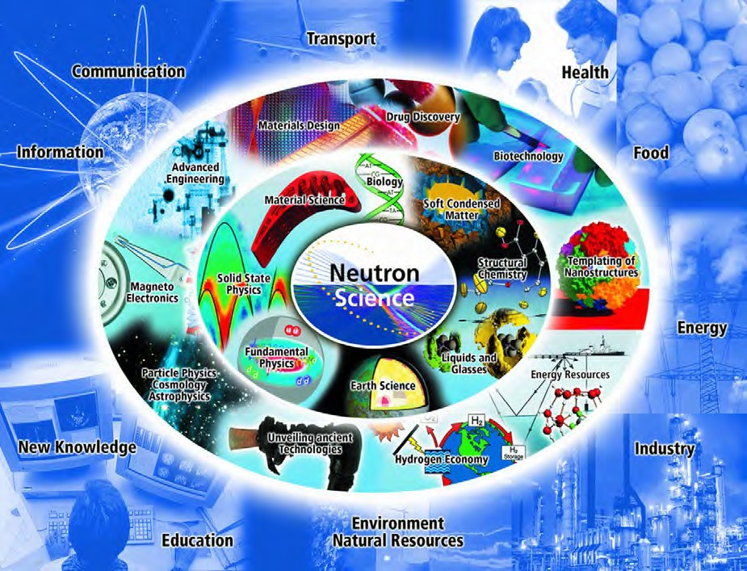
This figure (reference???) presents an idealized scheme showing the possible impact of neutron science with various branches of the economy and society. This scheme suggests that science nourishes technologies with its discoveries, and the economy poses challenges to science. In reality, science may go often its own way. Nevertheless large research centers on the basis of mega-facilities should take this scheme into consideration.
You need to show your expertise of today at this point here!

B1a) Condensed Matter Research. Nowadays, more than 90% of extracted neutron beams are used for condensed matter research related to a wide variety of scientific fields such as solid state physics, soft matter (complex liquids, non-crystalline solids, polymers), chemistry, molecular biology, materials sciences, and engineering sciences. New fields of research are constantly emerging. For example, one can mention the recently growing interest in the structure and properties of food and objects of cultural heritage. Over the past years, a number of new problems have appeared in all mentioned sciences where neutron scattering can provide very useful information on the structure and dynamics. Practically every new phenomenon and new material (especially in solid state physics) is probed by neutrons at an early stage of research. For example, a lot of possibilities are opening in the use of isotope substitution as illustrated in the picture.
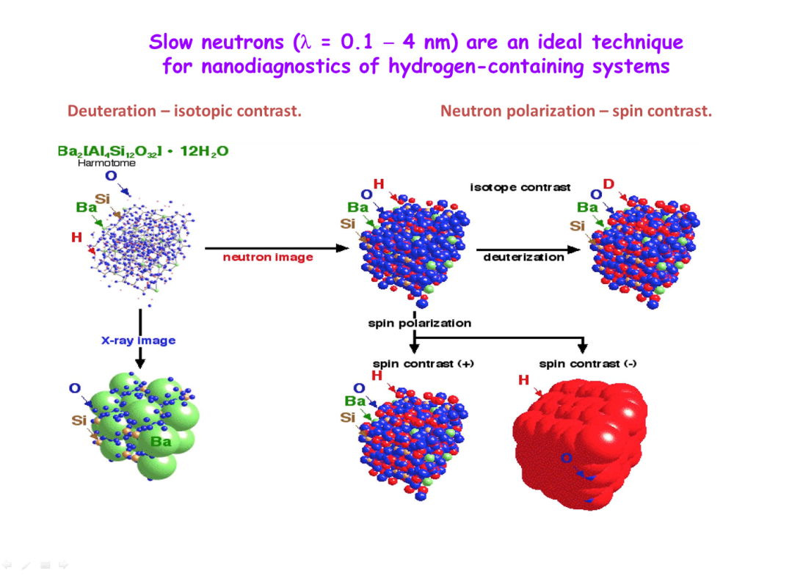

A special role in the study of condensed matter is played by polarized neutrons, which provide much more detailed information about the structure of matter not only in inorganic magnetic materials (as can be seen from the schematic drawing) but also in biological objects. In this case, the use of polarized neutrons makes it possible to enhance the contrast of the structure image, which is an important complementary technique to the widely used isotopic contrast method. The figure shows the difference in the small-angle neutron scattering spectra in magnetic colloids using polarized and non-polarized neutrons.

Condensed matter being a system with an infinite number of degrees of freedom similar to the particle world is a permanent source of new phenomena. From this point of view, the main strategy of any user research center based on a large facility consists of the development and construction of advanced experimental techniques and instruments to be ready for new challenges and to attract more scientists from different research centers with original proposals. The construction of a new-type neutron source in Dubna in 1960 led to the appearance of a lot of new experimental techniques. Time-of-flight (TOF) neutron diffractometry was born in Dubna in 1963. Later this method was developed in a number of neutron centers including FLNP. For example, the High Resolution Fourier Diffractometer (HRFD) and Real Time Diffractometer (RTD) at the IBR-2 reactor provide realization of such advanced methods. Both of them will have much more possibilities at a neutron source that will be more intense than the IBR-2 reactor. A very important method, inelastic neutron scattering, is very difficult for implementation at IBR-2. Investigations of atomic and molecular dynamics are an important tool for neutron scattering, and for full-scale experiments a neutron flux of one order higher than that at IBR-2 is crucial. Nowadays, small-angle scattering and reflectometry are becoming more and more popular. FLNP was among the leaders in the realization of these methods.

At the IBR-2 reactor, a user program is organized in full accordance with the generally accepted rules of the Institute.
There are two calls for proposals per year with deadlines on April 15 and October 15. Applications are collected via web-site http://ibr-2.jinr.ru

What are you going to do with the IBR-2 in the next 15 years? Why do you talk about a bigger neutron source but not specifying it?
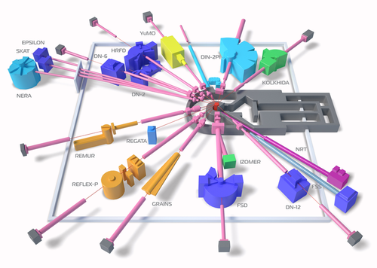 | 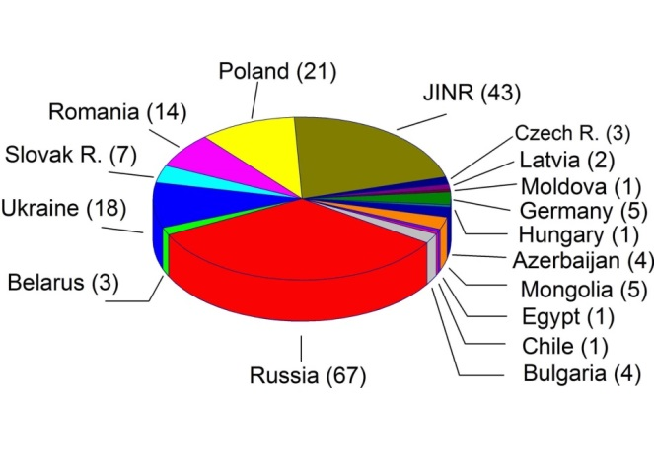
More than 200 applications from 18 countries were received in 2017.

A more intense neutron source will be a source of new scientific opportunities. Some of them are listed below. In solid state physics: nanocrystals, low-dimensional systems, magnetism and superconductivity. In chemistry: in situ real-time measurements for synthesis of novel materials. In Earth and environmental sciences: structural studies of complex minerals at high temperatures and high pressures for the understanding of basic geological processes. In engineering sciences: nondestructive control of engineering products and machine components to improve industrial technologies. In soft matter research: structural and real-time studies of polymers, colloids, liquid crystals, nanoliquids for a lot of industrial processes. Biology and biotechnology: structural studies of macromolecular complexes, kinetic measurements during DNA synthesis, drug delivery, etc.
During the last decades the focus of modern research has shifted towards the study of soft matter with attempts to investigate living matter. Living matter is the most complicated and interesting subject for the modern science. In fact, this field of research is at the limits and in some cases even beyond the possibilities of present-day physics. Living systems have a number of specific features. They have long-living, slow-relaxing structures which are far from equilibrium. The next important property is the irreversibility of many processes. We can explore some features of living matter such as kinetics, structure hierarchy, self-assembly by studying soft matter. From our point of view, one of the main directions of the research programme for a new neutron source could be related to the study of soft and living matter and key problems of biophysics with application in biomedicine and pharmacology, which is in line with the modern trends in the world science. In this respect, we need the advanced development of all experimental techniques which are available now.
But are you in building the new source?.
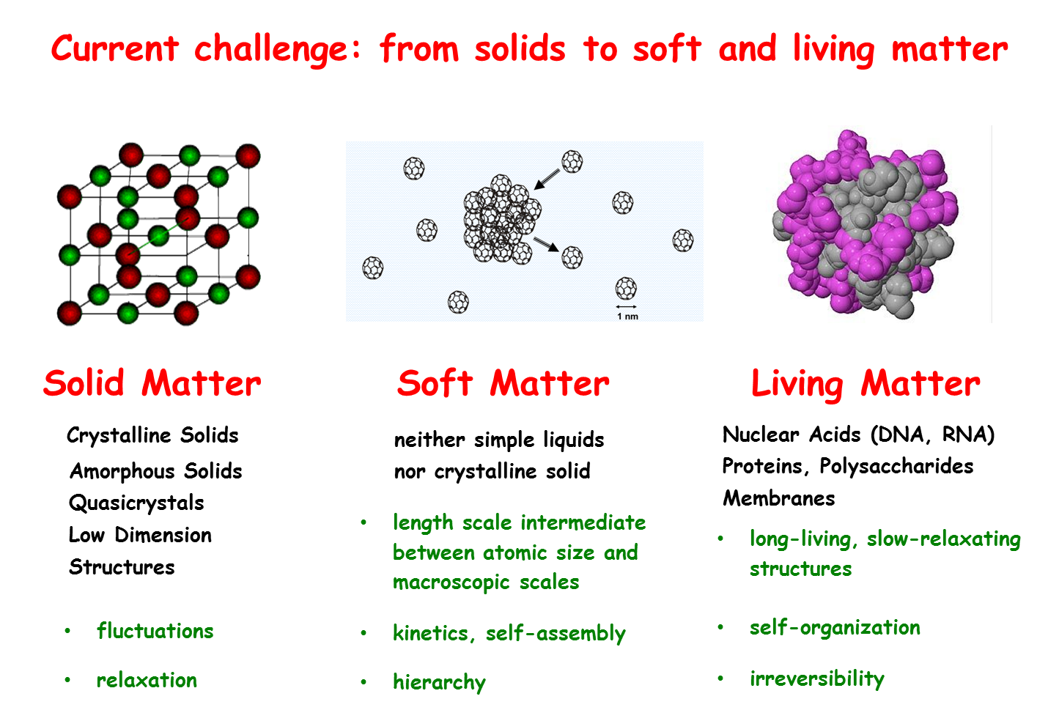
In the 21st century, bioscience will become one of the most rapidly developing areas of research, providing hopefully solutions to major challenges facing humankind. Today, we have considerable progress in deciphering the nature and the origin of problems concerning human health. One of the most important approaches is to make use of techniques that allow scientists to “see” the structure and dynamics of biologically significant materials at the atomic and molecular scale in the ideal case under conditions as close to physiological as possible. There are several complementary methods – X-ray and neutron scattering, nuclear magnetic resonance (NMR) and electron microscopy which are used together to determine the shape and internal structure of bioactive molecules such as proteins, as well as to understand the mechanisms of their functioning. By using X-ray crystallography, one can determine the positions of atoms in very small crystals containing large numbers of identical proteins. NMR methods allow one to obtain three-dimensional structures of proteins in solutions or in solid environment. Also, cryo-electron microscopy gives images of the overall shape of large complexes of biological molecules due to the possibility of measurements in water, the natural media for life objects.
Neutrons, like X-rays, reveal a microscopic structure through the scattering from the ensembles of atoms in a sample. Neutron beams are much less intense than X-ray beams produced at large-scale facilities, and neutron crystallography requires larger samples than in analogous X-ray experiments. Nevertheless, neutron methods play a unique role in life and health sciences, due to the possibility of measurements in water, the natural media for life objects.
B1b) Nuclear Physics. Since its emergence, neutron nuclear physics has demonstrated its effectiveness, becoming the basis of nuclear power engineering and a tool for studying the nuclear structure and properties of fundamental interactions. The tasks that this area of research faced in the early 21st century (V.L.Aksenov, Particles and Nuclei 31 (6), p. 1303 (2000)) are still of particular importance. They echo the questions that were formulated by the international scientific community when discussing the prospects for the development of nuclear physics (NuPECC, Long Range Plan 2017). High-precision determination of neutron properties, parameters of its decay and neutron cross sections, studies of neutron-induced fission and nuclear reactions with neutrons are valuable and sometimes unique sources of information for solving cosmology problems, studying the properties of the universe at an early stage of its formation, properties of nuclear matter and fundamental interactions. Nuclear neutron methods (such as activation analysis) have found wide application as a powerful analytical method in environmental, biological research and archeology. These methods are widely known to be used to study the surface of planets of the Solar System. The application of these methods in a number of industries holds much promise. The study of cross sections for interactions of neutrons with nuclei for the needs of nuclear power engineering is still of considerable significance.
Nuclei are collections of protons and neutrons. This can be plotted on a kind of nuclear landscape with a long valley of stability. On either side of the valley of stability are areas inhabited by unstable nuclei with an increasing number of protons and neutrons. These areas are bounded by the so-called driplines. It is known where the proton dripline is, but only the lower part of the neutron dripline has been investigated so far. Studies of extreme nuclei provide stringent tests for nuclear models and also for the theories of underlying nuclear forces. Nuclei
with high proton-to-neutron ratios can be obtained relatively straightforwardly with the help of accelerators. The obtaining of neutron-rich nuclei is more difficult, and only few facilities worldwide can produce their reasonable amounts.

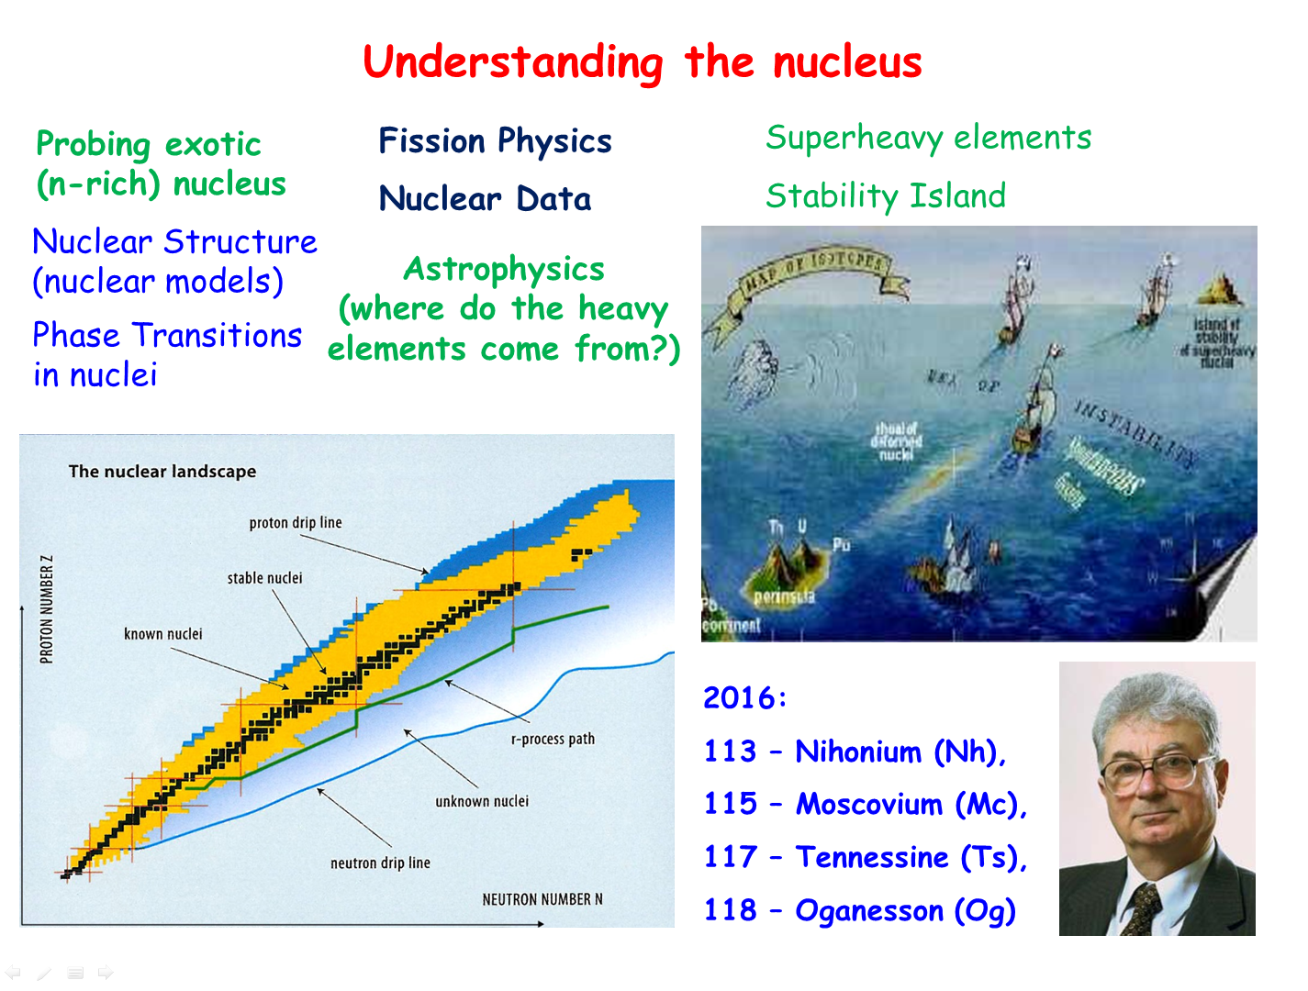
Neutron-rich nuclei located close to the r-process path can be created by nuclear fission. The fission itself is also a rich source of information: the abundances of fission fragments produced and their excited states depend on the nuclear structure. A high-flux neutron source can provide very exotic neutron-rich nuclides with very high production yields. The pathway of the r-process can be determined by mass measurements for a set of these nuclides.
B1c) Basic Research. The discovery of the Higgs boson opens up a new era in physics. The established theory describing weak, strong and electromagnetic interactions of all known particles is the Standard Model (SM) of particle physics. However, it does not seem to be a complete theory. What is new physics beyond SM? In this respect, precision experiments with low-energy neutrons can provide a great deal of new information. For example, the discovery of neutron-antineutron $(n\overline{n})$oscillations could answer crucial questions of particle physics and cosmology. Why do we observe more matter than antimatter in the Universe? Another related intriguing subject potentially accessible with this process concerns the mechanism responsible for neutrino mass generation. A high neutron flux combined with the progress made in neutron optics offers a remarkable opportunity to perform a sensitive experiment dedicated to search for such oscillations. The next flagship experiment could be direct measurement of neutron-neutron cross section.
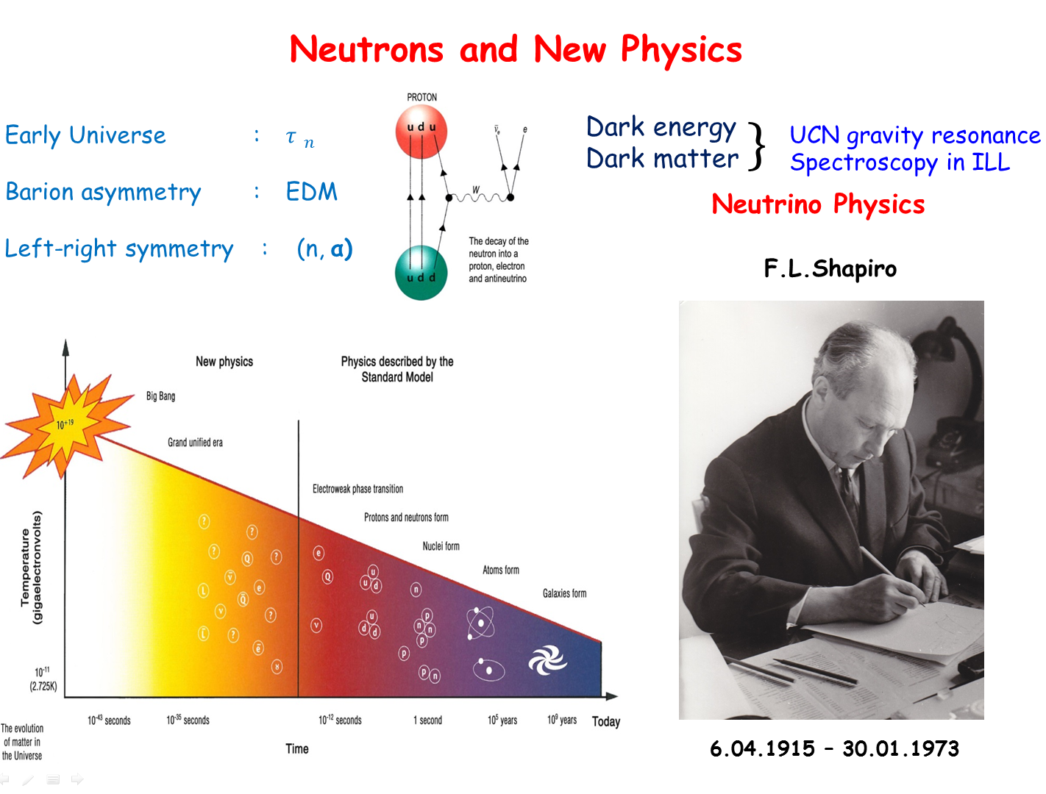
Very intriguing perspectives are arising in experiments on the problem of quantum measurements.
The extensive field of research is opened with the use of UCN (Ultra Cold Neutrons??. Traditional attempts are related to new physics beyond the SM through measurements of neutron lifetime τ_{n} and electric dipole moment (EDM). However, it seems that recent observations of UCN quantum states in a gravitational field have much prospect. Indeed, it is a new research field including the investigation of dark matter and dark energy and especially precise measurements of structure and dynamics of surfaces at nanoscale.
UCN physics is traditional for FLNP. Remember that UCN were discovered by F.L.Shapiro’s group in 1968. FLNP scientists take part in all leading experiments with UCN and have a number of new ideas for a new more intense neutron source.
1d) Flagship experiments of FLNP. A number of research areas mentioned above have a relatively long history and impose high requirements for the parameters of the neutron source, primarily for the high neutron intensity. The increase in intensity makes it possible not only to improve the rate of statistics collection, but also to study systematic effects at a new level, which is an important factor for high-precision experiments. New prospects for increasing the accuracy of experiments are also associated with the possibility of creating high-intensity sources of ultra-cold neutrons and very cold neutrons on the new neutron source. In combination with the pulsed mode of operation of the source, this opens up new methodological possibilities, for example, for measuring the neutron lifetime. At the stage of developing the source, a number of design solutions can be built in, which will allow measurements to be carried out in the optimal geometry (neutron-neutron scattering, neutron-antineutron oscillations) and during the construction of the source the necessary infrastructure can be prepared (for example, devices for polarization of nuclear targets and neutrons).

Thereffore we will formulate in a short table the scientific opportunities with the DNS-IV superbooster.

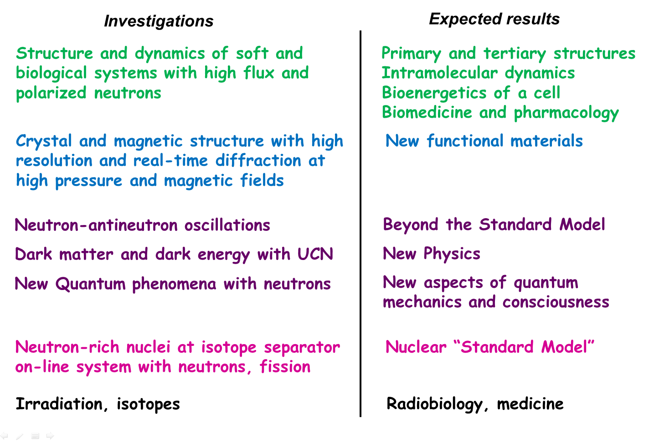
References
Aksenov V.L. Neutron physics Entering to XXI Centure. Particle and Nucl. Phys. (Физика ЭЧАЯ), V.31, N 6, P. 1304 – 1342 (2000).
Aksenov V.L. A 15 years forward look at neutron facilities in JINR. JINR Communications E-3-2017-12, Dubna, 2017.

D) Design and Construction of a state of the art accelerator based neutron Source at Dubna (LongTermProject)

D 1) WORLD NEUTRON LANDSCAPE
The following two schematic figures (after Th. Brückel from Jülich Forschungszentrum) illustrate the changing European landscape of neutron sources.
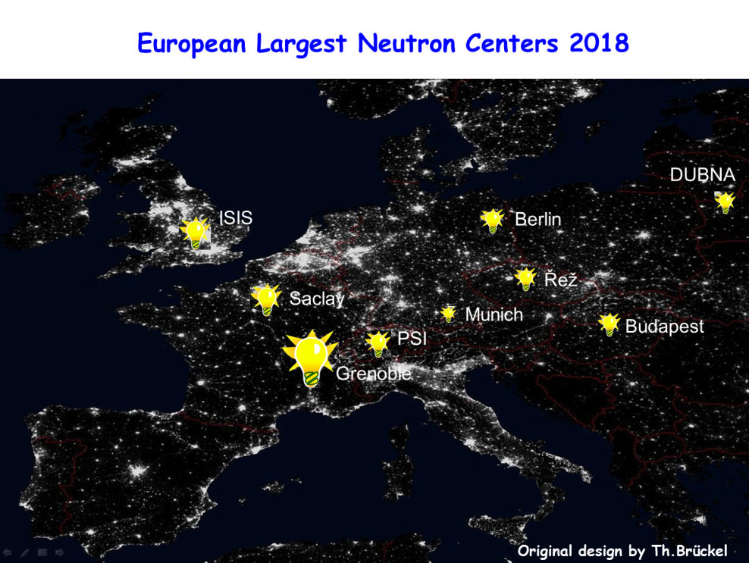
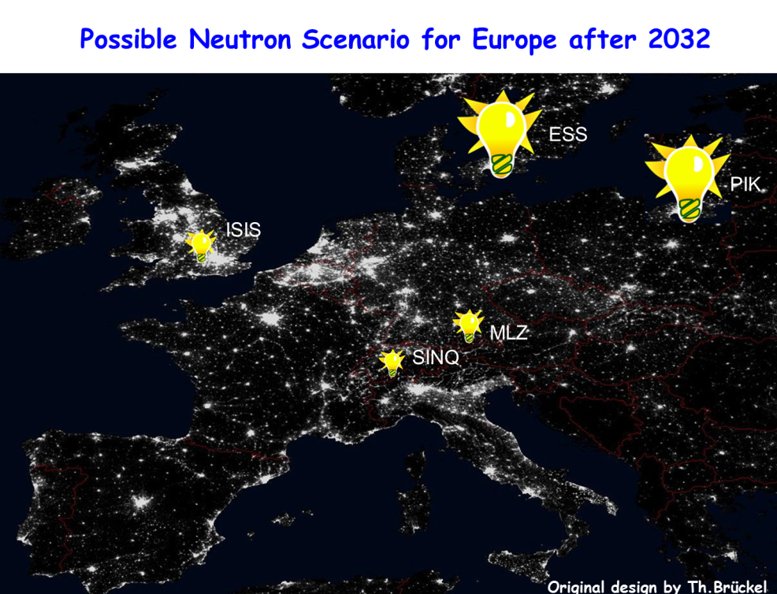

In Europe, there are only ten leading neutron centers with a developed user systems.

Source | Commissioned,  year | Thermal  energy,  MW | Average  neutron flux, cm⁻¹s⁻¹ | Peak neutron flux, cm⁻¹s⁻¹ | Operation number of days per year | Number of stations | Possible number  of stations | Number of users per year | Operating costs,  10¹⁶ euros
FRM II,  Münich | 2005 | 20 | 8 × 10¹⁴ |  | 240 | 23 in operation,  7 under construction | 35 | 1000 | 55
BER II,  Berlin | 1991 | 10 | 1.2 × 10¹⁴ |  | 220 | 16 in operation | 20 | 400 | 25
ILL,  Grenoble | 1975/1995 | 58 | 1.3 × 10¹⁵ |  | 200 | 27 + 10 CRG∗ | >40 | 1400 | 80 + CRG
ESS,  Lund | 2019, planned | 5,  LP |  | 4 × 10¹⁶ | 200 | 20  after 2025 | >20 |  | 103
PIK,  Gatchina | 2019, planned | 100 | 5 × 10¹⁵ |  | 200 | 22  after 2022 | >40 |  | 30
LLB,  Saclay | 1985 | 14 | 3 × 10¹⁴ |  | 200 | 22 | 25 | 600 | 25
SINQ,  Villigen | 1996 | 1 | 1.5 × 10¹⁴ |  | 200 | 15 | 20 | 600 | 30
ISIS/ ISIS-II,  Abingdon | 1985/2009 | 0,2,  SP |  | 4.5 × 10¹⁵ | 180 | 34 | 41 | 1500 | 55
IBR-2,  Dubna | 1984/2012 | 2,  LP |  | 6 × 10¹⁵ | 108 | 14 | 14 | 200 | 1
WWR,  Budapest | 1959/1993 | 10 | 2.1 × 10¹⁴ |  | 140 | 14 | 14 | 100 | 10
∗CRG – abbr. for Collaborative Research Group instruments.

Leading user centers in Europe (after ENSA report).

Considering the present-day tendency, after 2030 only five sources will be available including three currently operating facilities: ISIS (Didcot, UK), SINQ (PSI, Villigen, Switzerland), FRM II (TU Munich, FRG), and two new sources (ESS (Lund, Sweden) and steady-state reactor PIK in the Petersburg Nuclear Physics Institute of the National Research Center “Kurchatov Institute” (Russia)) which are under construction at the moment. Over the last years this situation has sparked lively discussions on new neutron sources in Europe. A medium-power source (which is much cheaper compared to ESS) on the basis of a deuteron linear accelerator with a Be target has recently been proposed to be constructed at the Jülich Research Center. Similar sources for Saclay and Bilbao are under consideration.

The Table below (see V.L.Aksenov, A.M.Balagurov, Physics – Uspekhi, v. 59 (3), 2016) shows only the world's leading pulsed sources as reference points.

State, city | Name, start of operation/  refurbishment | Target power, MW | Neutron  flux in pulse  10¹⁴ cm⁻¹s⁻¹ | Thermal neutron pulse duration, μs; frequency, s⁻¹ | Averaged in time neutron flux  10¹² cm⁻¹s⁻¹ | Number of beams/cold moderators | Experimental stations
 |  |  |  |  |  |  | Diffraction | Small angle | Reflectometer | Inelastic | Other
England  Chilton | ISIS I, 1985  ISIS II, 2009 | 0,2 | 10  45 | 20÷30; 50  20÷30; 5 | 1,5  0,7 | 16/ 2  13/ 1 | 10  6 | 2  4 | 3  5 | 7  2 | 1  2
USA  Los-Alamos  Oak-  Ridge | MLNSC, 1985  SNA, 2006  STS, project | 0,1  1  0,5 | 7  12  50 | 20÷30; 20  20÷50; 60  50÷200; 10 | 0,4  4  10 | 16/ 2  14/ 1 | 4  7 | 2  2 | 3  3 | 2  7 | 2  3
Japan  Ibaraki | JSNS,  2009, plan | 1 | 20/ 65 | 20÷50; 25 | 10/ 30 | 21/ 1 | 7 | 1 | 2 | 3 | 7
China  Donguan | CSNS  2018, plan | 0,1 | ~5 | 20÷50; 25 | ~1 | 20
Russia  Dubna | IBR-2,  1984/2012 | 2 | 60 | 310; 5 | 10 | 14/ 2 | 6 | 1 | 3 | 2 | 2
Sweden  Lund | ESS  2019, plan | 5 | 50÷75 | 2800; 14 | 200÷300 | 16/ 1  first phase | 5 | 2 | 2 | 6 | 1

Worlds leading pulsed sources.

D 2) Design Specifications
The need for a next-generation neutron source is driven by a growing interest in these investigations against the background of a steadily decreasing number of neutron sources in the world, as evidenced by the analysis of a specially established ESFRI Physical Sciences and Engineering Strategy Working Group (ESFPI Scripta, Univ. Milano, 2016).
To balance the world neutron landscape, one more intense pulse neutron source of the fourth generation is needed in Russia. Watch out, you are to convince the Dubna Member States to go along. Some of them are in ESS!! For the advanced research programme outlined in the previous Sec., we need the following parameters for the neutron flux density: in pulse cm⁻²⋅s⁻¹ and averaged in time cm⁻²⋅s⁻¹.
The pulsed neutron sources discussed above are used mainly for neutron scattering as we can see in the Table. Remember that neutron sources for beam research can be either steady-state (mostly reactors) or pulsed (mostly accelerators). The latter sources vary in pulse width: Δt < 10 μs, (very short pulse), 10< Δt < 50 μs (short pulse), Δt > 100 μs (long pulse). For traditional neutron spectroscopy in nuclear physics where resonance neutrons are used, for the most part, very short pulses are needed. For neutron spectroscopy in condensed matter where thermal neutrons are used predominantly short pulses are required. The successful experience of the IBR-2 reactor operation (Δt = 320 μs) has drawn the attention of neutron society to long-pulse sources (LPS). ESS, for example, will have Δt = 2800 μs. The main advantage of LPS is high neutron flux and, as a result, a possibility to perform not only scattering experiments on condensed matter but also experiments on fundamental physics and nuclear physics. We can conclude that a new neutron source will be particularly high in demand being a long-pulse source. For JINR with its IBR-2 experience a long-pulse source would be suitable. It would also be highly preferable to have a short-pulse option. In this case, all possibilities of neutrons can be used.
Neutron source  (laboratory) | <I_{n}>,  10¹⁵ n/s | Δt,  ns | Q,  10³⁰ n/s³ | Number of instruments for nuclear physics experiments
LANSCE (LANL, USA) | 10 | 1-125 | 0.64* | 8 (total, partial cross sections) +ICE House test facility
n_TOF (CERN, Switzerland) | 0.4 | 10 | 4 | 6 (total, capture, fission, scattering, (n,α))
ORELA (ORNL, USA) | 0.13 | 2-30 | 0.14* | 5 (total, partial cross sections)
GELENA (IRMM, Belgium) | 0.025 | 1 | 25 | 5 (total, partial cross sections)
GNEIS (PNPI, Gatchina) | .3 | 10 | 3 | 3 (total, capture, fission)  + ISNP/GNEIS test facility
IREN (JINR, Dubna, project) | 1.0 | 400 | 0.0062 | under construction
<I_{n}> – average intensity of neutrons emitted in 4π solid angle;
Δt – neutron pulse width;
Q = <I_{n}>/(Δt)² – quality coefficient of the neutron source;
* – present value corresponding to the maximum pulse width.

Very short pulsed neutron sources for nuclear physics.

D3) International and national context of the new JINR Neutron Source
The problem of neutron sources is particularly acute in Russia. The diagram shows the neutron sources that can be used for research on extracted beams. At present, only the IBR-2 reactor is used in the format of international standards. After the IBR-2 reactor is put out of service, there will remain only one research reactor in Russia – reactor PIK in NRC “Kurchatov Institute” (Gatchina). Other sources will be decommissioned due to the expiration of their expected service life.

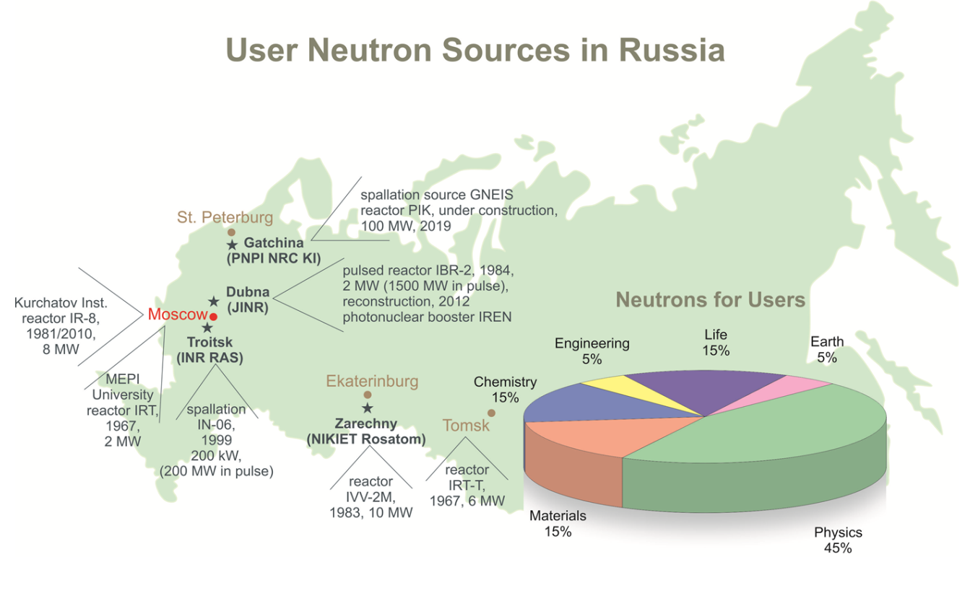
Device | Organization | Commissioned, year | Power, MW | Neutron flux,  10¹⁴ cm⁻¹s⁻¹ | Number of stations
IR-8 | NRC KI, Moscow | 1957/1981/2012 | 2/5/8 | 1 | 4 + 5
WWR-M reactor | PNPI NRC KI, Gatchina | 1959/1978  Prolonged  shutdown  since 2016 | 5/18 | 4.5 | 12
WWR-Ts reactor | Branch of RIPC, Obninsk | 1964 | 13 | 1 | 3
IWW-2M reactor | IRM, Zarechnyi | 1966/1983 | 15 | 2 | 5
IRT-T reactor | RI TPI, Tomsk | 1967/1977 | 6 | 1.2 | −
IPT reactor | NRU MEPhI, Moscow | 1967/1975  Prolonged  shutdown  since 2013 | 2.5 | 0.3 | 4
GNEIS (pulsed)  Δt₀ = 10 ns | PNPI NRC KI, Gatchina | 1973/1983 | 3 × 10⁻³ | 1 | 3
IN-06 sources (pulsed)  Δt₀ = 100 – 200 μs | INR RAS, Troitsk | 1999 | 3 × 10⁻¹ | 1 | 7 + 2
IREN (pulsed)  Δt₀ = 30 ns | JINR, Dubna | 2010 | 4 × 10⁻³ | 0.1 | 3
PIK reactor | PNPI NRC KI, Gatchina | 2019, planned | 100 | 45 | 22  after 2022

Characteristics of neutron sources in Russia for studies with extracted beams.

A new intense neutron source of the fourth generation is required on the territory of Dubna for its member states. This source will be complementary to the PIK reactor as these two sources will give the possibility to use the whole spectra of neutron scattering methods in traditional fields of research as well as in new ones such as living matter research. It is especially important for nuclear physics, the scientific basis for nuclear power engineering. And Dubna is the most appropriate place due to the long-term development of neutron research here.

References
Aksenov V.L., Balagurov A.M., Physics Uspekhi (Uspekhi Physicheskih Nauk) V. 186, N 3, 293 (2016).
Aksenov V.L., Ananiev V.D., Komyshev G.G., Rogov A.D., Shabalin E.P. Phys. Part. Nucl. Lett. V. 14, N 5, 788 (2017).

D4) Recommendations, Plans and Resources

- The vector (in 2π) neutron flux density in the range of (1÷2)⋅10¹⁴ n/cm²/s at 10÷15 MW is taken as the key parameter of DNS-IV.
- In cooperation with the Chief Designer (NIKIET), work on the conceptual project of DNS-IV should be carried out in two directions:
а) pulsed periodic reactor IBR-3;
b) pulsed neutron source driven by a proton accelerator with a multiplying target.
- The fast neutron pulse duration in the range of 150÷200 µs with 10 Hz repetition is considered to satisfy the majority of experimental research areas: diffraction, small-angle scattering, reflectometry, tomography.
- Provision should be made in the design of the source for a system of choppers to suppress background between pulses and to form an optimal pulse length.
- It is suggested that proposals for the creation of a factory of ultracold and very cold neutrons be developed.
- Nuclear-physics-oriented proposals are welcome.
- The development of the concept of neutron moderators on DNS-IV for experiments on scattering and experiments with very cold neutrons should be considered as a top-priority task for 2019. Deadline for proposals is January 15, 2019.
- It is necessary to develop and provide a cost estimate of experimental stations including infrastructure and personnel costs.
- For a proton-accelerator-driven source, it is necessary to investigate the effect of unscheduled interruptions in the operation of the accelerator on the safe operation of the multiplying target and, taking this into consideration, determine the parameters of the accelerator.
- To justify the proton-accelerator-driven source, it is necessary to expand the scientific program to include the application of proton beams.
This Section provides conclusions for the presented short description of the DNS-IV conceptual research. It was carried out in the Frank Laboratory of Neutron Physics of JINR in cooperation with the Dollezhal Research and Development Institute of Power Engineering, which performed the engineering design of all reactors in Dubna.
The next steps for the realization of DNS-IV are as follows:
- technical study;
- R&D phases;
- engineering design;
- construction phase;
- start of facility operation.
The following timetable is suggested:
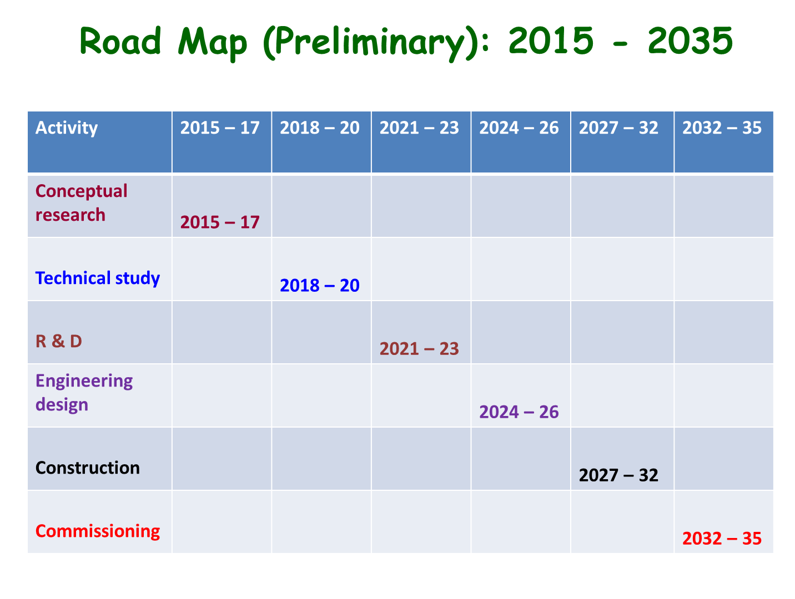
The technical study has identified several areas at the frontiers of existing technology where R&D is needed. High-priority areas involve the development of a target station, neptunium nitride fuel elements, thermal stress and radiation effects in target materials, moderators, accelerators, neutron instruments.
The goals of the R&D phase are to provide the database for the engineering design and prepare the technical and economic basis for a final conclusion about the construction of the DNS-IV which would minimize costs and technical risks.
The main expected results of the R&D phase will be:
- resolution of key technical issues which have been identified;
- validated database for the engineering design;
- accurate cost estimate;
- determination of site requirements and safety aspects, including licensing issues;
- timetable and budget profile for construction.

It is an important point to make a site-independent (green field) cost estimate for construction and operation of the DNS-IV. The preferable place for the new neutron source would be nearby the IBR-2 reactor as it will make it possible to use the existing engineering infrastructure and reduce the total cost. We should add to the total cost the above-mentioned staff costs for construction and development phases. It will account for some 20% of this total.
The annual running costs are estimated on the basis of exploitation experience of the IBR-2 reactor and JINR accelerators. The estimate amounts to 30 MEu including 500 staff and power consumption costs.
An initial cost estimate of the project and the construction of an accelerator-driven source can be made on the basis of already implemented projects in other scientific centers such as ISIS, SNS, JSNS, as well as ESS (under construction).
 | M€
Proton accelerator of 1.2 GeV with a peak current of 50 mA | 200??
Target station | 150
Complex of cold moderators | 50
Neutron beam instrumentation | 100
R&D | 20
Engineering infrastructure | 50
Total: | 570

The construction of DNS-IV will bring new opportunities and challenges for industries of JINR Member States, especially related to nuclear power industry sectors. We believe that the return for science and technology which DNS-IV can deliver during 40 years of its expected service life will be more than sufficient to justify the commitment of funds.

References
Shabalin E.P., Aksenov V.L., Komyshev G.G., Rogov A.D. JINR P13-2017-57, Dubna, 2017; Atomic Energy (2018).
Vinogradov A.V., Pepelyshev Yu.N., Rogov A.D., Sidorkin S.F., JINR P13-2018-40, Dubna, 2018.

- Interaction with other fields of Science and socially significant applications

The construction of the Dubna neutron source of the fourth generation (DNS-IV) which will have parameters higher than IBR-2 reactor will give new possibilities in the use of neutron scattering in other fields of science such as chemistry, molecular biology, material and engineering sciences.
Besides this will get great opportunities socially significant applications such as medico-biological investigations, pharmacology, neutron diagnostic of cultural heritage and archaeometry.

References
Lychagin E.V., Kozlenko D.P., Sedyshev P.V., Shvetsov V.N., Physics Uspekhi, V. 186, N 3, P.265 (2016).
Aksenov V.L., Balagurov A.M., Kozlenko D.P., Phys. Part. Nucl., V. 47, N 9, P. 627 (2016).

- Training of young scientists and spacialists

JINR has a well-developed and active Training centre for JINT member states which trains specialists in many areas of science.
On the base of Frank Laboratory of neutron physics the chair on neutron scattering of Lomonosov Moscow State University train young scientists and specialists during last decades.

Co-chair
of the Workshop “Advanced ideas and experiments
for the new Dubna Neutron Source (DNS-IV).
Related moderators and infrastructure” Prof. V.L.Aksenov

