STRATEGIC LONG RANGE PLAN FOR NUCLEAR PHYSICS

**Executive Summary:**

# Since its foundation and up to now, the main direction of scientific research of the Laboratory of Nuclear Reactions (FLNR) of JINR has been and is the World-wide recognized synthesis of new elements of the Mendeleev's Periodic table, the study of their properties, via nuclear spectroscopy (α-, β-, γ-spectroscopy) and via chemical analysis.

The pursuit of this research will be also the main part of FLNR’s program for the next decade: Looking for the limits of the existence of nuclear matter by focusing on the boundaries of the island of stability of Super Heavy Elements (SHE). For that endeavour, a SHE-Factory is planned based on the DC-280 heavy-ion cyclotron, the world's top accelerator among others of the same type. Substantial increase (dozen times higher) in the efficiency of experiments is needed for the synthesis of the heaviest elements 119 and 120 and for the study of nuclear and chemical properties of already known elements. On the detection side, the new Gas-filled recoil separator (DGFRS-II) and other future set-ups installed at the SHE Factory will play an important role. The construction of a specialized building complex comprising radiochemical laboratories of Class 1 for the manufacture and regeneration of highly radioactive targets as well as a new 28 GHz ECR source is foreseen, completing the SHE-Factory.

FLNR’s research program has been expanded into the region of neutron-rich isotopes of Super Heavy Elements near the island of stability, since the neutron shell N=184 should have a stabilizing effect on the nuclear life-time. In addition, the hypothetical closed shell at Z = 114 should also be of maximum support for the synthesis of nuclei with the number of neutrons close to 184. We propose to reach the neutron excess not by using beams of neutron-rich radioactive nuclei, because of their low intensity, but rather by using more neutron rich target nuclei (e. g., 251Cf). In target production, our international collaboration is of great importance and will be pursued further.

Another ambitious scientific goal is measuring the masses of SHE and this laboratory is planning for a special mass detection system, consisting right after the target of a pre-separator, followed by a cryogenic gas ion catcher and a time-of-flight mass-spectrometer.

The FLNR JINR experimental programme in the field of SHE for 2024–2030 is aimed at studying the properties of the radioactive decay and the structure of isotopes of heavy and super-heavy elements as well as chemical properties of SHE using the new DC-280 accelerator, the DGFRS-3 setup, and corresponding detections systems.

Multi-nucleon transfer reactions in near-barrier collisions of actinides are promising in synthesizing new neutron-rich isotopes of heavy and superheavy elements. These reactions can lead to the formation of neutron-rich superheavy nuclei, inaccessible via fusion reactions. This method allows the synthesis of a number of new isotopes of light Super Heavy Elements, up to the beta-stability line. Unfortunately, no universal detector concept exits, however, our laboratory is looking into use our existing detectors like SHELS, MAVR, and CORSET as well as development new ones.

Radioactive ion beam (RIB) facilities allow the study of exotic nuclear systems remote from the β-stability line. At low energies, the FLNR is pursuing an experimental program on relatively light exotic nuclear systems at the fragment-separators ACCULINNA-1 [Gri16] and COMBAS, installed on the primary beam line of the U400M cyclotron. Recently, the new generation separators, ACCULINNA-2 and MAVR, were put into operation. ACCULINNA-2 is a fragment-separator, installed at the U400M cyclotron to produce in the “in-flight” mode secondary beams of radioactive exotic nuclei. This allows studies of nuclear haloes, neutron skins, cluster states, of exotic multi-neutron decays (2-nucleon virtual states, 2n- and 4n-radioactivity), two- proton radioactivity, search for new magic numbers and spectroscopy of exotic nuclei, reactions with halo nuclei. Further development of the RIBs research program is seen in extension of available primary beams.

With this long-range program, FLNR intends to stay at the forefront of nuclear physics and wants to provide state of the art research in nuclear physics for the member-states of JINR and the international nuclear physics community.

International context !

**A The main areas of nuclear research at FLNR**

The research program of the Flerov Laboratory for Nuclear Research is - one side- continuing on the successful Past, on the other side it takes on the challenge to stay at the forefront of nuclear physics research by strengthening its existing program and by opening up for great opportunities in nuclear physics research.

The main areas of nuclear research at FLNR are and will be the following:

* Synthesis of heavy and Super Heavy elements and study of their properties;
* Study of the properties of light exotic nuclei near the borders of nucleon stability;
* Analysis of nuclear reaction mechanisms leading to the formation of heavy and Super Heavy Elements and the analysis of reactions with radioactive nuclei;

The development of the FLNR experimental infrastructure under the Seven-Year Plan (2017-2023) foresees the construction of three main accelerator complexes equipped with modern experimental set-ups meeting the goals of the FLNR research program. Each of the accelerator complexes will focus on the following physics tasks:

* Factory of Super Heavy Elements based on the DC280 accelerator: synthesis of heavy and super heavy nuclei and the study of their properties:
* U400M accelerator: study of light exotic nuclei;
* U400R accelerator: study of nuclear reactions;

**B) Synthesis of heavy and super heavy nuclei and study of their properties**

The main direction of scientific research of the Laboratory of Nuclear Reactions (FLNR) of JINR since its foundation and up to now is the synthesis of new elements of the Mendeleev's Periodic table and the study of their properties. Particular attention was given to the synthesis of Super Heavy elements (SHE) as well as their search in nature. These studies are primarily interwoven with the question of the limits of the existence of nuclear matter as well with the determination of the boundaries of the *Island of stability of SHE*, a hypothetical region of the nuclear map where long-lived isotopes of SHE could be found.

One of the greatest JINR achievements of last years was the discovery of six heaviest elements of the Mendeleev's periodic table in hot fusion reactions using the 48Ca beam and actinide targets (see review [Yu.Ts. Oganessian and V.K. Utyonkov // Rep. Prog. Phys. **78,** 036301(2015)] and references therein). The priority for the discoveries of five of them was assigned to an international collaboration involving JINR and Livermore and Oak Ridge National Laboratories (USA). These include 114-Flerovium, 115-Moscovium, 116-Livermorium, 117- Tennessine, and 118-Oganesson.

As was found, due to the deviation of the -stability line towards nuclei with a large neutron excess, only proton-rich nuclei can generally be synthesized in fusion reactions of stable nuclei.  Thus, all the known nuclei for elements of the second hundred (Z>102) are located to the left of the -stability line, and the known Super Heavy nuclei located near the island of stability are 6–10 neutrons away from its centre.

Although the hypothesis of the existence of the island of stability has been experimentally confirmed, a number of key questions remain open. Where is the centre of the island of stability? How long do Super Heavy nuclei live? Are SHE found in nature? How far at the present level of development of experimental technology can we advance to detect heavier elements – elements of the 8th row of the D. Mendeleev’s periodic table? The properties of Super Heavy Elements (both nuclear and chemical) have not been investigated thoroughly enough either for answering these questions. These tasks require a substantial increase (tenfold) in the detection efficiency of experiments.

Another issue of current importance in the study of SHE is finding new reactions leading to the formation of, e.g., the most stable SHE.

Substantial increase (dozen times higher) in the efficiency of experiments is needed for the synthesis of the heaviest elements Z=119 and Z=120 and for the study of nuclear and chemical properties of already known elements. A big step fore-ward in this research will be made possible through the construction of the world's first Factory of Super Heavy Elements (SHE Factory) at JINR. The Factory will become a world base for future studies of super heavy nuclei and will reinforce the priority of all the JINR member states as leaders in the field of synthesis and study of Super Heavy Elements.

A key element of the SHE Factory is the DC-280 heavy-ion cyclotron, the world's top accelerator among others of the same type. The accelerator was designed at JINR. Its components were manufactured with the participation of many JINR member states. The design beam intensity of accelerated 48Ca ions is 10–20 particle-µA, which is ten times higher than those attained at currently existing accelerators.

The first experimental set-up of the SHE Factory is a new gas-filled DGFRS-2 separator. A key feature of the set-up is the high efficiency of the collection of Super Heavy nuclei (over 60%), which is twice the one attained in previous generation separators. The separator was designed at JINR and manufactured by SIGMAPHI (France). The commissioning of the new accelerator and the new separator along with the highly efficient detecting equipment will boost by a factor of ten the efficiency of experiments. Further development of the SHE Factory will expand the capacity of the acceleration complex.

The synthesis of new Super Heavy Elements with numbers 119 and 120—first elements of the 8th row of the Mendeleev's periodic table—is one of the key tasks to be fulfilled using the new acceleration complex, scheduled for the second half of 2019. Unique targets of transuranium elements of Berkelium and Californium required for the synthesis of these elements will be manufactured at and delivered from the Oak Ridge National Laboratory (Tennessee, USA). Promising studies in the synthesis and study of SHE were discussed at a number of conferences and workshops: 3rd International Symposium on Super Heavy Elements (14–20 September 2017; Kazimierz Dolny, Poland); three workshops on atomic and chemical properties of SHE (years 2017–2019, Dubna); spontaneous and induced fission of very heavy and super heavy nuclei (9–13 April 2018, Trento, Italy); RAS Board Meeting on heavy-ion physics (26–27 October 2018, Dubna) and others. The main tasks in SHE research were addressed during the discussions:

* Elements beyond *Z*=118; expansion of the Periodic table
* Nuclides beyond 294Og; expansion of the chart of the nuclides
* Connecting “hot-fusion” and “cold-fusion” regions
* Chemistry (well) beyond the standard Periodic table
* Excursion into the *N*=184 region of longer-lived Super Heavy Elements
* Pinning down the presence of exotic topologies
* Delineating the role of super heavy nuclei in the Cosmos

The bulk of the open issues can be successfully resolved at the SHE Factory in JINR.

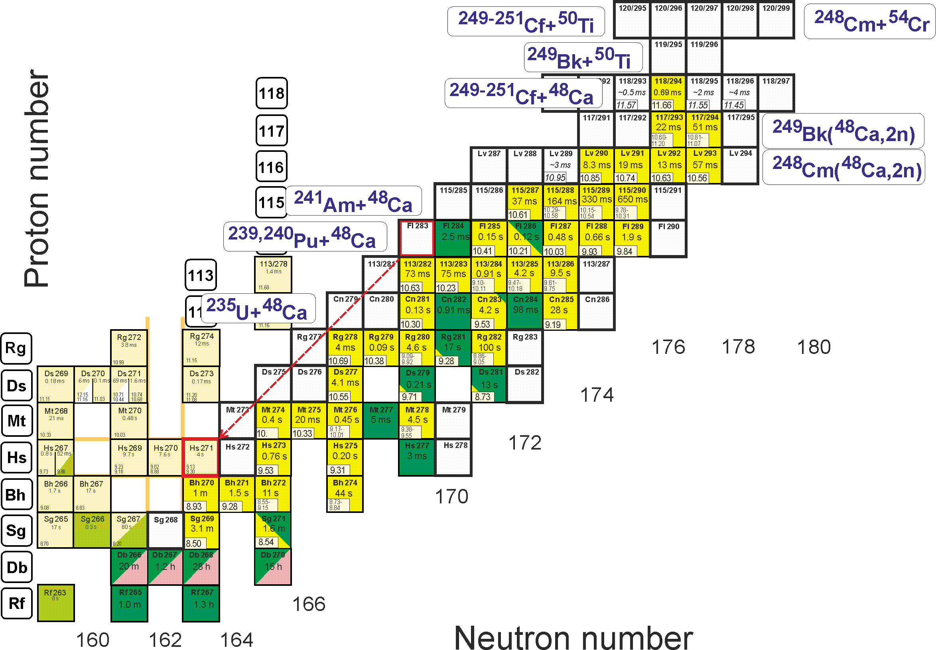

# B.1 Synthesis of New Elements



Fig. 1.1 Upper part of the nuclide chart. New nuclides that can be synthesized in the above reactions are marked with white squares. 283Fl decay results in the known 71Hs isotope.

Among the above mentioned research directions, synthesis of new elements 119 and 120 is a task of the highest importance and will certainly become the SHE Factory's top priority. According to theoretical predictions, the 249Bk+50Ti→299119*, 249-251Cf+50Ti→299-301120*, and 248Cm+54Cr→302120* reactions are most promising for the synthesis of elements 119 and 120 (Fig. 1.1).

The expected cross-sections are of several dozens of picobarns. The experimental programme aimed at synthesizing even heavier elements will be tailored to the results of experiments on the synthesis of elements 119 and 120 planned for the next seven years.

Required experimental equipment: The task can be fulfilled at the SHE Factory using Gas-filled recoil separator (DGFRS-II).

**B.2 Synthesis of new isotopes of already known Super Heavy Elements (Expansion of the chart of nuclides)**

The expansion of the region of known nuclei towards both neutron excess and neutron deficiency is extremely promising and crucial to understanding the properties of Super Heavy nuclei located near the island of stability. An interesting region of the nuclei map is located among isotopes synthesized in "cold" and "hot" fusion reaction. This part of the nuclear map was shown [1] to be filled through "ordinary" fusion reactions with a48Ca beam and more neutron-deficient targets than those that have already been used (233*,*235U, 239*,*240Pu, 241Am, 243Cm, and others). Cross-sections (see examples in Fig. 2.1) were proved to be higher than 1 pb, which is fair enough for an experimental study.

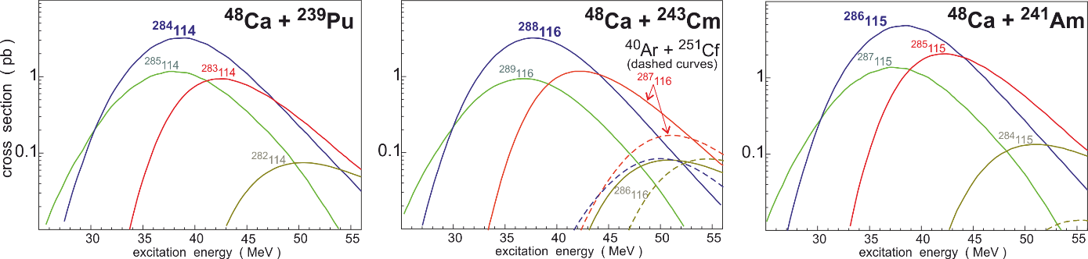

Fig. 2.1 Cross-sections of neutron-deficient isotopes of superheavy elements [1].

Experimental studies of the region have already been commissioned at FLNR JINR [2]. First experiments however showed that predicted cross-sections were 20-fold higher than those estimated experimentally. The main decay mode for 284Fl turned out to be spontaneous fission rather than alpha-decay as it was assumed in [1]. This is evidence of a much faster decrease of fission barriers with a shift towards the proton excess compared to the model used in calculations of cross-sections and lifetimes [3]. Systematic experimental studies of nuclei in this region are certain to contribute substantially to our knowledge of their properties and to improve accuracy of further predictions.

Required experimental equipment: The task can be fulfilled at the SHE Factory using Gas-filled recoil separator (DGFRS-II).

[1] V. Zagrebaev, A. Karpov, W. Greiner // Phys. Rev. C**85**, 014608 (2012).

[2] V.K. Utyonkov et al., // Phys. Rev. C**92**, 034609 (2015).

[3] P. Moeller, et al., // At. DataNucl. Data Tables, (1995).

# B.3 Synthesis of neutron-rich isotopes of Super Heavy Elements (Journey towards the region of longer-lived super heavies)

Expansion into the region of neutron-rich isotopes of Super Heavy Elements in the vicinity of the island of stability is of great importance. The properties of neutron-rich nuclei are of particular interest as they should most strongly manifest the stabilizing effect of the neutron shell N=184. In addition, the effect of the hypothetical shell Z = 114 should also be at its maximum for nuclei with the number of neutrons close to 184. Studying systems with higher neutron excess can be achieved through:

Use of beams of neutron-rich radioactive nuclei:

Today, the use of radioactive beams for these purposes seems not to be very promising due to their low intensity compared with the intensities of beams of stable nuclei, on one side, and because of the lack of the increase in the fusion-survival cross-section during the transition to radioactive beams, on the other side [1]. This is why we propose:

* ***Use of more neutron-rich targets***

The shift of 1-2 neutrons to the right is still possible in fusion reactions with the use of more neutron-rich targets (for example, 251Cf). The cross-sections for the formation of a new isotope 296118 calculated in [2] in a 3n channel of the 48Ca+251Cf fusion reaction were of about 1 pb.

Required experimental equipment: The task can be fulfilled at the SHE Factory using Gas-filled recoil separator (DGFRS-II) and neutron rich targets.

* ***2n channel of fusion-fission reactions***

Another way for possible shifting of 1 neutron to the right is the synthesis of Super Heavy nuclei in projectile-target combinations employed earlier, but focussing onto the 2n evaporation channel instead. According to the calculations, this should lead to a several-fold (~2-4) reduction in the cross-section (compared to the one in the 3n-4n channel), which is however still within the capacities of the experimental infrastructure. For instance, the cross-sections of *2n* channels of the 248Cm(48Ca,2*n*)294Lv178, and 249Bk(48Ca,2*n*)295117178 reactions, leading to the neutron-rich isotopes of elements 116 and 117, can reach 0.3-0.4 pb [18,19] (see Fig. 3.1с).

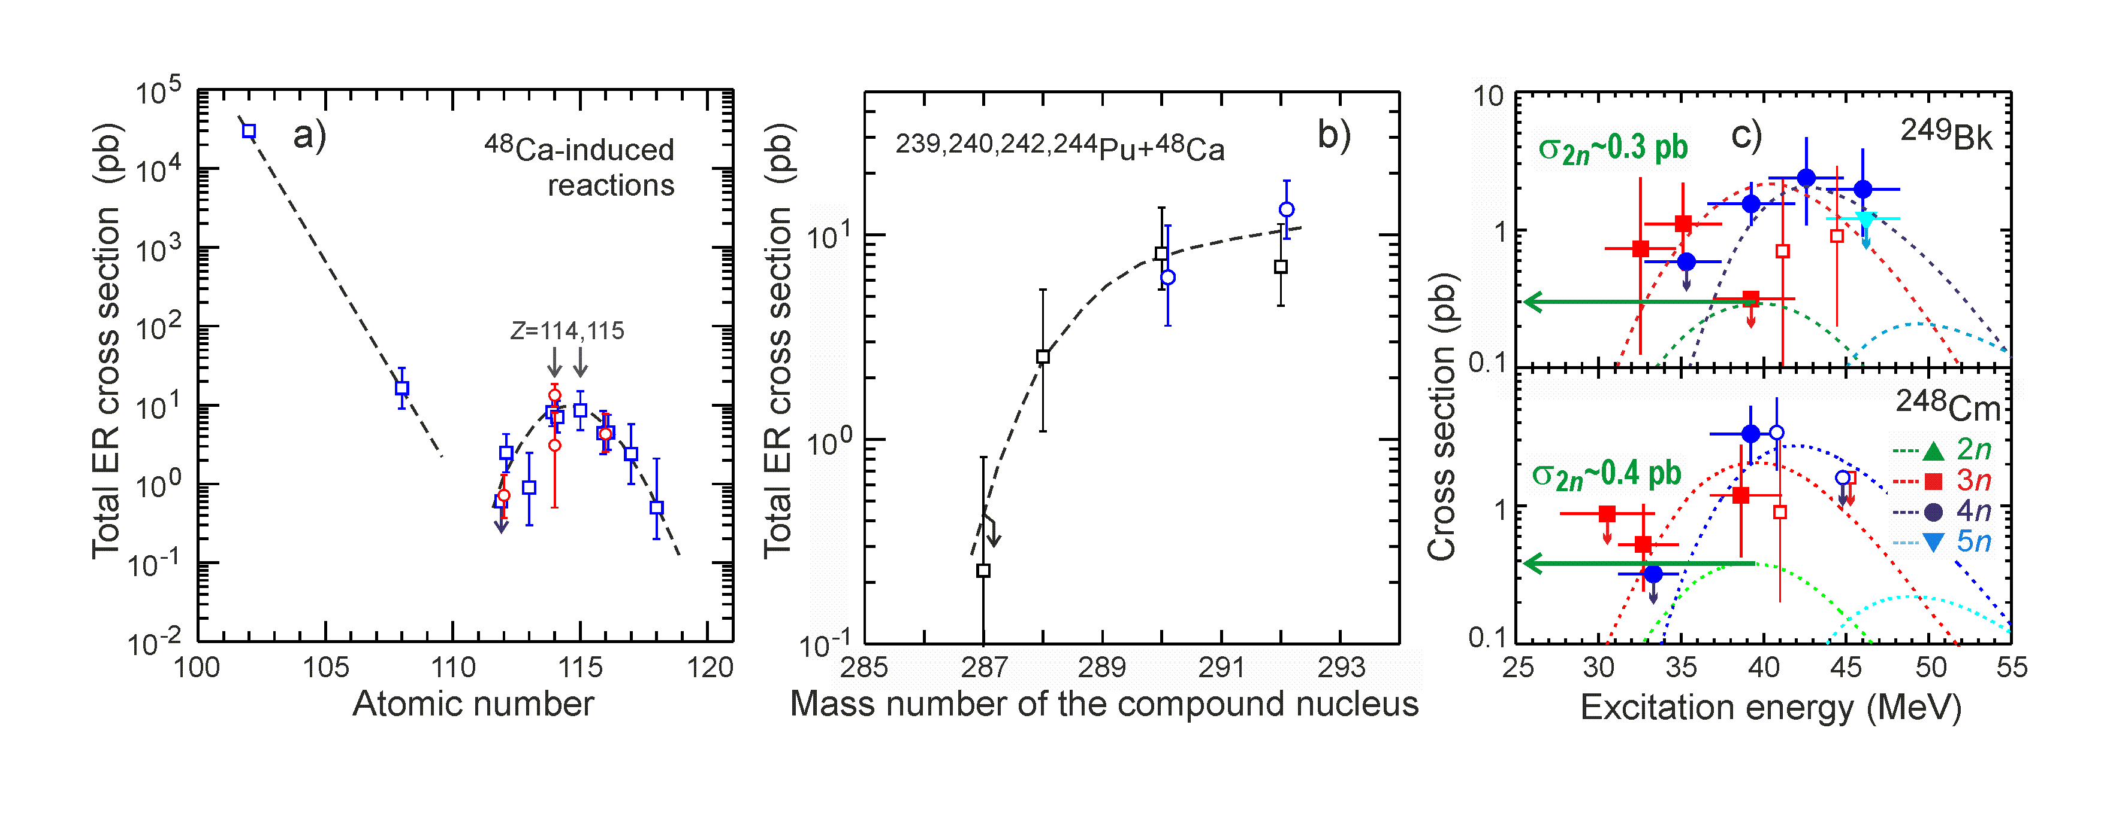

Fig. 3.1. a) Maximal cross-sections of the 208Pb–249Cf+48Ca complete fusion reactions, depending on the atomic number of the compound nucleus; b) Maximal cross-sections of the 239244Pu+48Ca reactions, depending on the mass number of the compound nucleus [17]. c) Excitation functions of the 249Bk+48Ca and 248Cm+48Ca reactions (symbols show the experimental data, dashed lines indicate calculations [18, 19], and the horizontal arrow depicts cross-sections of the 2*n* channel of the reactions).

A new and unexpected approach was suggested for the production of neutron-rich nuclei (up to the centre of the island of stability) on the basis of calculated decay times and modes of super heavy nuclei [3]. One of the main decay modes of the isotopes of Super Heavy Elements located to the right from those synthesized earlier was predicted to be via electron capture. This is due to the close proximity to the closed shell N=184 and, as a consequence, to a drastic increase in the half-lives of spontaneous fission and alpha-decay (Fig. 3.2 and 3.3).

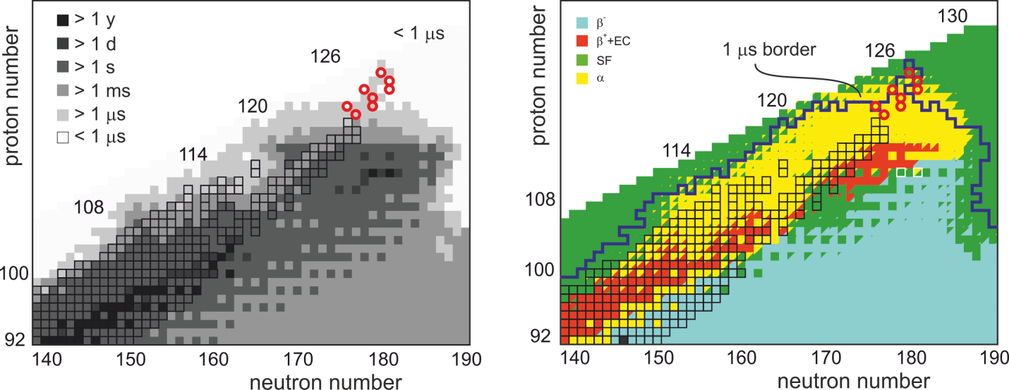

Fig. 3.2. Calculated [3] lifetimes (on the left) and decay modes (on the right) of superheavy nuclei. The squares highlight the known nuclei. Red circles indicate nuclei that can be synthesized in the 3n evaporation channel in the 50Ti+249Bk,249Cf reactions as well as in 54Cr, 58Fe +248Cm, 249Bk, and 249Cf. The line corresponds to the microsecond half-life boundary.

For example, the most long-living Super Heavy nuclei in the calculations [3], i.e., nuclei forming the centre of the island of stability turned out to be 2 isotopes of Copernicium—291Cn and 293Cn—with the lifetimes of about 100 years. One of them can theoretically be produced following, for example, three sequences of electron captures of 291Mc.

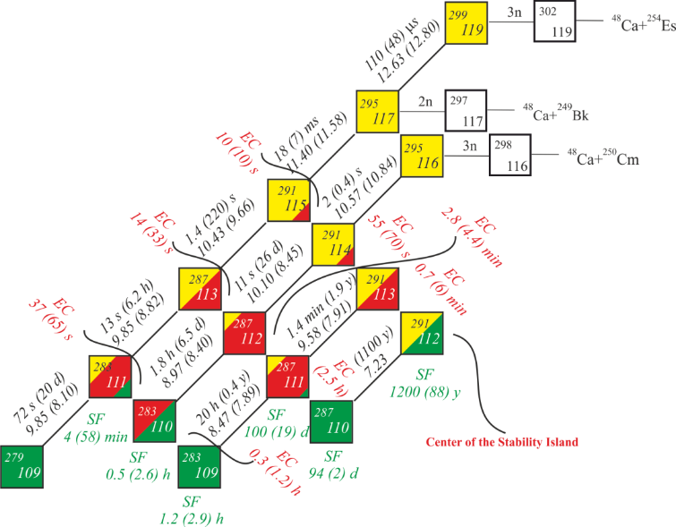

Fig. 3.3. The path to the island of stability via electron capture (EC) of the 291Mc and 291Fl nuclei.

The nucleus, in turn, is produced subsequently to the alpha-decay of 295Ts synthesized in the 2n channel of the 48Ca+249Bk reaction with a cross-section of about 0.3 pb. Obvious difficulties in the experimental identification of electron capture events impede the immediate implementation of this scheme in full. However, the possibility of producing neutron-rich Super Heavy nuclei (due to the decay of protons into neutrons) and even (!) approaching the centre of the island of stability—one of the most crucial objectives of SHE studies—makes experiments aimed at searching for not-yet-observed electron capture in this region of the nuclear map quite promising.

Required experimental equipment: The task can be fulfilled at the SHE Factory using Gas-filled recoil separator (DGFRS-II) and neutron rich targets...

* ***pxn and xn channels of fission-fusion reactions***

One of the ways of advancing in the region of neutron-rich SHE can be based on the registration of evaporation residues produced during the emission of a charged particle (proton or alpha-particle) and several neutrons. Thus, during the irradiation of actinide targets 248Am, 248Cm, and 249Bk with 48Ca in p2n and p3n channels, neutron-rich isotopes of Moscovium (292-294Mc) can be produced (see Fig. 3.4 [4])

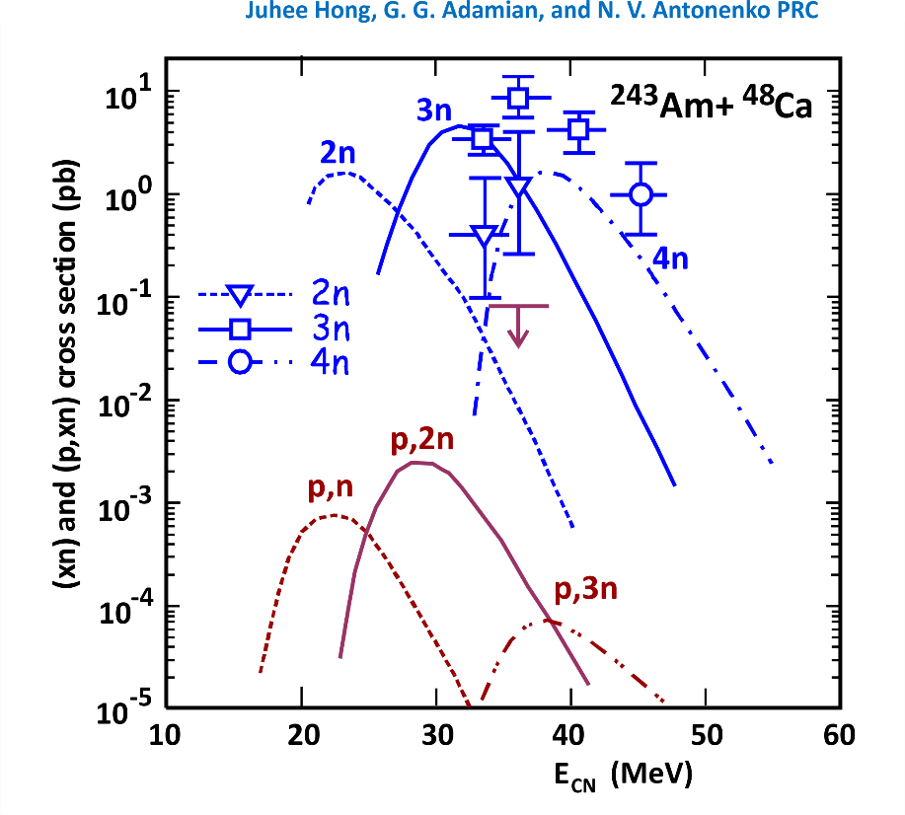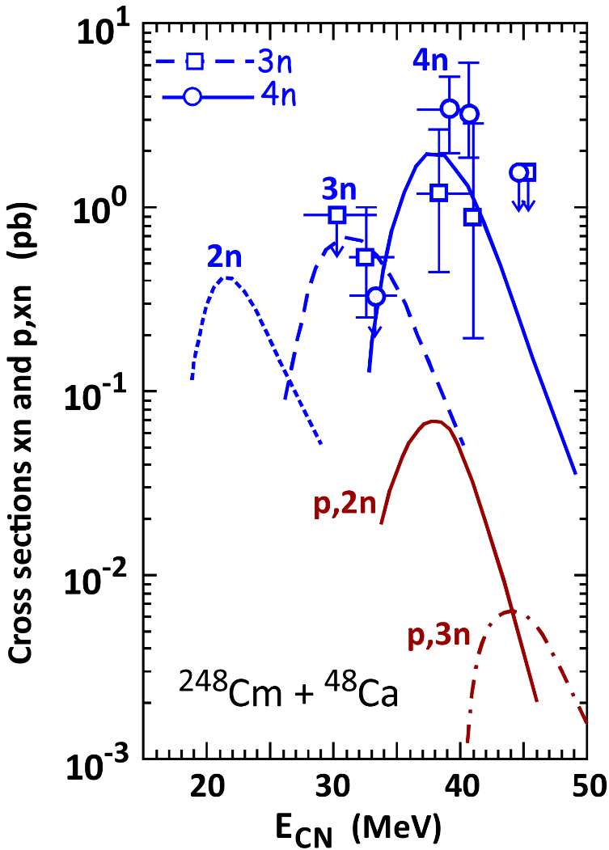

Fig. 3.4. The calculated production cross-sections of the isotopes of Super Heavy Elements in pxn and axn evaporation channels in the 48Ca + 248Cm, 243Am fusion reactions.

Such experiments will allow the determination of the boundaries of the island of stability. The registration of pxn channels with low cross-sections will also demand a substantial increase in the experiment sensitivity.

First experiments on the registration of survival products in pxn channels conducted for the 50Ti + 209Bi reaction proved the efficiency of the method [5].

The conclusions on the survival cross-sections in pxn and xn channels can be drawn from a mere comparison of the survival probabilities of the Super Heavy system in xn evaporation channels and pxn (xn) channels The ratio of the total probability of survival in channels with the evaporation of a charged particle to the survival probability in channels with the emission of only neutrons,  and , approximately equals the ratio of the corresponding cross-sections (Fig. 3.5) [6].

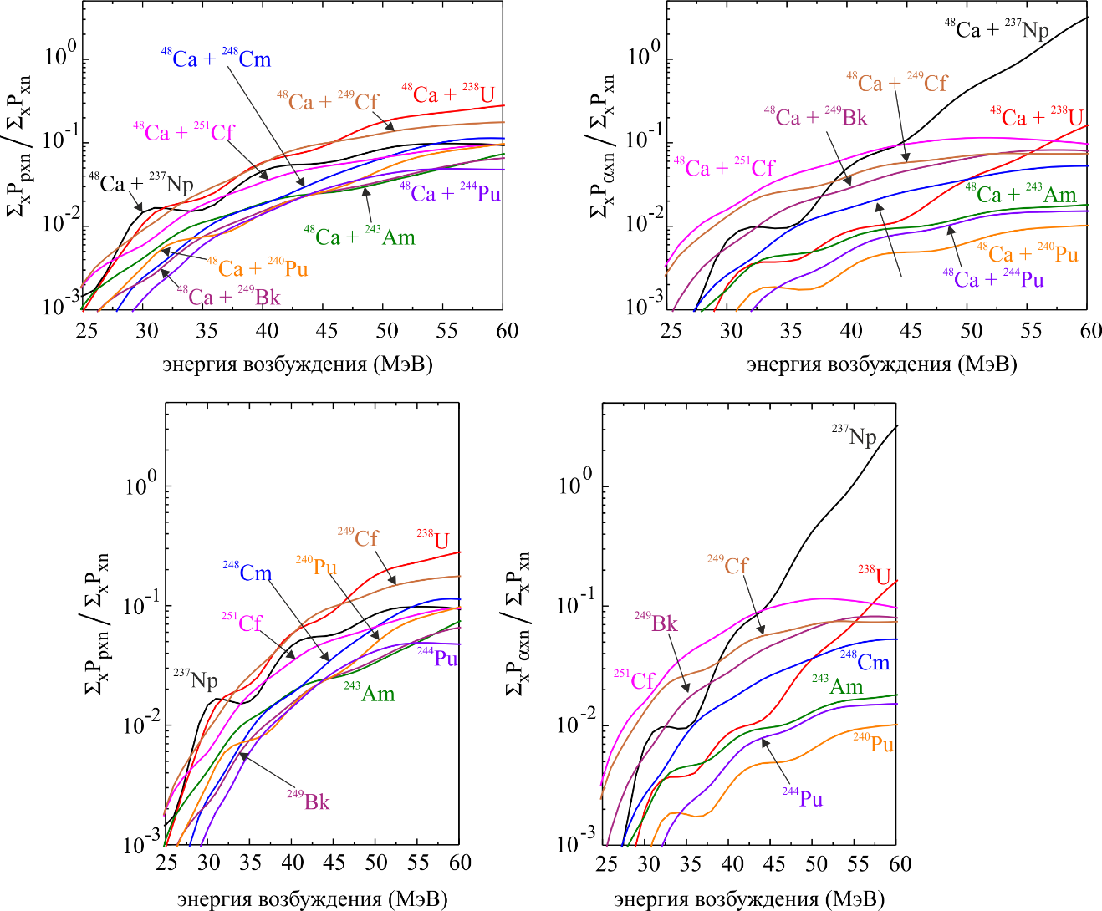Fig. 3.5. Survival probabilities of a compound nucleus in pxn and xn evaporation channels relative to the survival probabilities in xn channels in the 48Ca + 238U, 237Np, 240,244Pu, 243Am, and 248Cm, 249Bk and 249,251Cf fusion reactions.

In the region of excitation energies from 40 to 45 MeV, survival cross-sections for channels with proton evaporation vary from 1 to 10% of the cross-section for the production of evaporation residues in xn channels, depending on the reaction. For xn channels, the values vary from 0.3 to 10%. The corresponding cross-sections can be obtained experimentally using high-intensity beams of 48Ca at the SHE Factory.

* ***Multi-nucleon transfer reactions***

An important field of application of nucleus–nucleus collisions of heavy ions is the production and study of nuclei enriched in neutrons. One of the main objectives of the study of such nuclei is a detailed understanding of the astrophysical r-process, which proceeds through neutron-rich nuclei far from the line of -stability. Such nuclei located in the vicinity of closed neutron shells form the so-called waiting points of the r-process. Knowledge of the properties of these nuclides plays a key role in modeling the r-process.

One of the least studied regions of the nuclide map is located near the neutron spherical shell *N* = 126. This is due to the low values ​​of the cross sections for fragmentation reactions, the only method for the synthesis of neutron-enriched nuclei in this area that has been used to date (Fig. 3.6). Since the fragmentation cross sections rapidly decrease with each step in the direction of the neutron excess, the search and study of alternative effective methods for producing these nuclei is an urgent task.

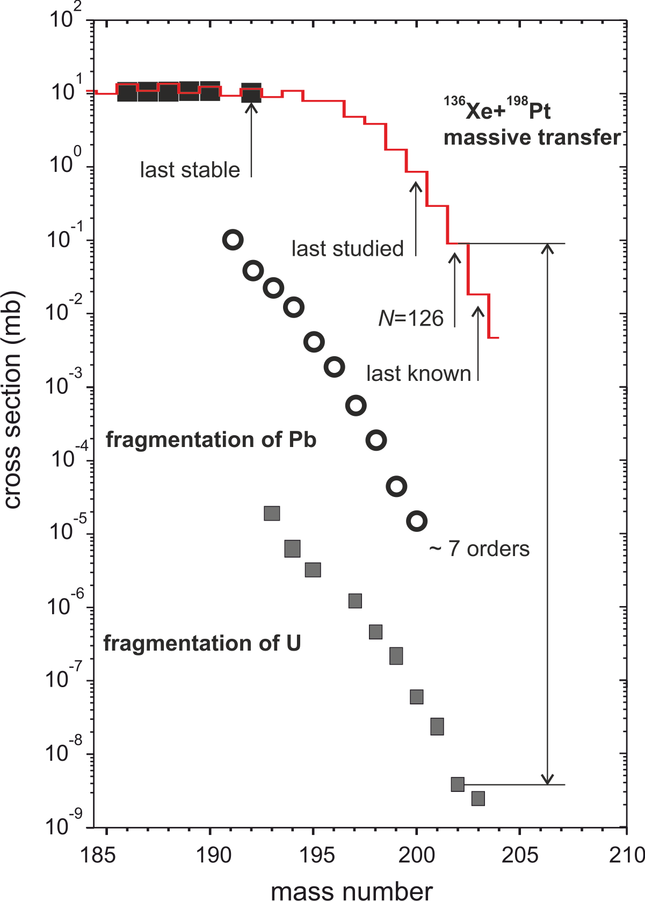

Fig. 3.6 Comparison of the calculated cross sections for formation of osmium isotopes in multinucleon transfer reactions (in the 136Xe+198Pt reaction at *E*c.m.=643 MeV) [8] with measured fragmentation cross sections of 208Pb [14] and 238U [15].

The reactions of multi-nucleon transfers during deep inelastic collisions of heavy ions with energies near the Coulomb barrier were considered as a method for producing new nuclei since the discovery of this type of nuclear reaction in 1966 by Volkov et al. The interest in deep inelastic transfer processes that has grown in recent years is caused, first of all, by the widely discussed possibility of synthesizing unknown neutron-rich medium-mass nuclei, as well as heavy and superheavy nuclei. A number of experimental studies have already been carried out aimed at testing this idea and studying the characteristics of the reactions of multinucleon transfers in this mass field.

A possibility of synthesis of yet-unknown neutron-rich nuclides around the N = 126 neutron shell with quite large cross sections was predicted in a number of theoretical model. One of examples of such the calculations shown in Fig. 3.6 clearly demonstrate how productive multi-nucleon transfer reactions can be in this region. The predicted seven orders of magnitude larger cross sections in transfer reaction comparing to the uranium fragmentation make detailed study of deep-inelastic collisions to be a rather hot topic in nuclear physics.

Multi-nucleon transfer reactions in near-barrier collisions of actinides are promising in synthesizing new neutron-rich isotopes of Super Heavy Elements. In these collisions, the formation of compound nuclei is certainly impossible, but the time of contract can be long enough to cause transfer of a large number of nucleons. Of paramount importance are potential energy shell effects, which make the formation of one of the fragments near double magic lead and a corresponding Super Heavy nucleus quite beneficial. In this approach, production cross-sections of primary (excited) Super Heavy fragments can exceed dozens of picobarns, even for nuclei located near the centre of the island of stability of Super Heavy Elements. Please note that experimental studies of near-barrier multi-nucleon transfer reactions that have resumed within the past few years, have shown [7] that transfer of a large number of nucleons (about 50) with cross-sections exceeding 1 μb are in line with predictions. De-excitation of such nuclei in most cases leads to their separation into fragments, and only a small number of the initially formed Super Heavy nuclei survive (Fig. 3.7).

Cross-sections for the formation of cold nuclei [8] thus exceed a threshold value at 1 pb only in the region of light Super Heavy nuclei (*Z*=104–108). An important feature of multi-nucleon transfer reactions is that they lead to the formation of neutron-rich Super Heavy nuclei inaccessible via fusion reactions, which allows the synthesis of a number of new isotopes of light Super Heavy Elements, up to the beta-stability line.

Yields of heavy nuclei were measured using radiochemical methods in works [9, 10] for the 238U + 238U, and 238U + 248Cm reactions. It is of interest to study low-energy collisions of actinides because of the possibility to observe spontaneous electron-positron emissions when forming a nuclear molecule possessing an overcritical electric field. The fundamental process of quantum electrodynamics was predicted over thirty years ago [11] but has not yet been experimentally confirmed. Another interest phenomenon expected for these reactions is triple quasi-fission forming two strongly coupled fragments in the lead region [12, 13].

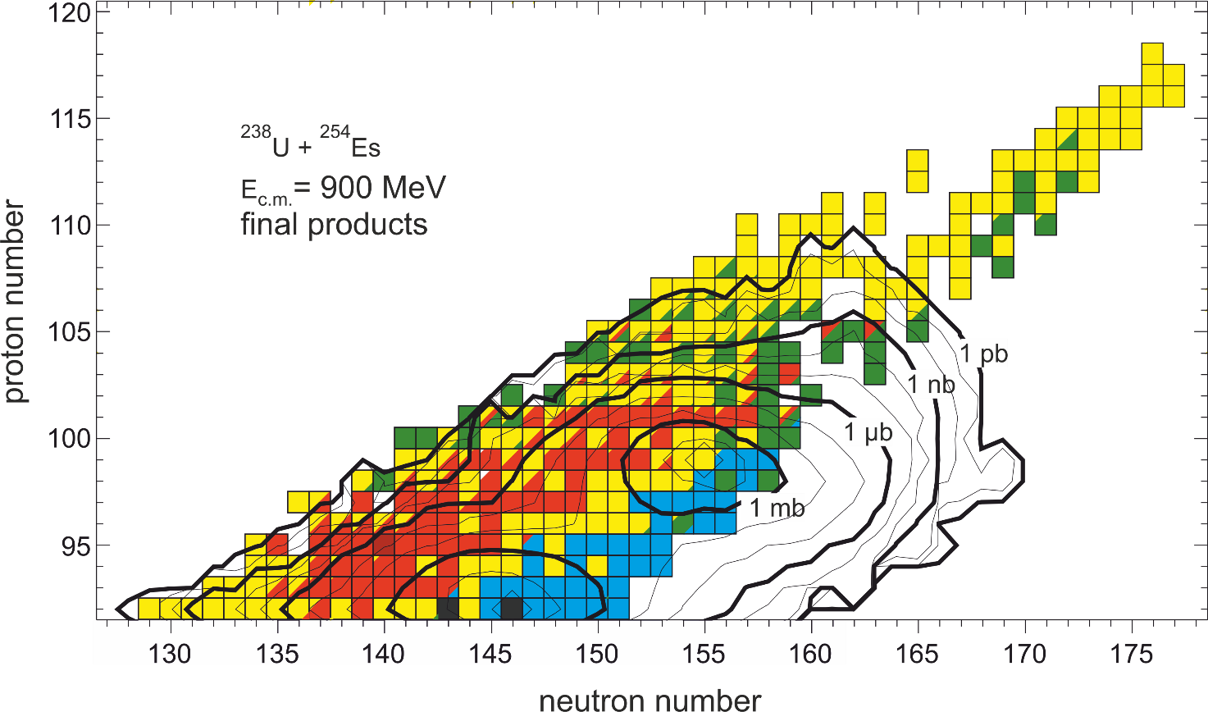

Fig. 3.7 Cross-sections for the synthesis of nuclei in the 238U + 254Es reaction at the energy *E*c.m. = 900 MeV. The contour lines are drawn over each order of magnitude down to 1 pb.

The experimental study of multi-nuclear transfer reactions involves a fair number of difficulties owning to a great variety of reaction channels and special features of their kinematics (wide angular and energy distributions of products). Existing setups worldwide used for the study of nuclear reactions with heavy ions have severe capacity limitations. A complete study of multi-nucleon transfer reactions should comprise: the determination of the energies of reaction products, their charges, masses, and angles of scattering. The register of corresponding particles (neutron, gamma) is also desired.

The complete picture of the process illustrated in a single experiment is hampered by lack of cutting-edge experimental setups. Maybe the design should follow philosophies well established in high-energy experiments. R&D programs should be started to develop and define a dedicated detector set-up for heavy-ion reactions at these low energies, covering most of the phase space of the reaction products. The following FLNR setups can be used for starting such an R&D programme:

1. ACCULINNA-2, SHELS, DGFRS-1, 2 for the measurement of reaction product yields at forward angles;
2. MAVR for the measurement of yields of light reaction products in wide angular and energy ranges;
3. GALS for the measurement of integral cross-sections for the production of fragments when the data on their emission angles and energies are lacking;
4. CORSET for the study of the kinematics of reactions allowing the determination of the masses of primary fragments formed in reactions in wide angular and energy ranges. The main limitations of the setup: it cannot measure the charge of the fragment; uncertainty in mass measurements (about 4 a.m.u.), and the lack of information on survived reaction products.

In addition, new setups can be constructed, such as telescopes for measuring time-of-flight, energy and angles of the products of binary reactions of heavy ions and for the identification of daughter nuclei after the beta-decay. Fig. 3.8 depicts a schematic drawing of the telescope. Each arm of the telescope comprises two time-of-flight sensors based on micro-channel plates, a silicon double-sided strip detector (double-sided detector 60×60 mm with the number of strips 60+60), and a segmented germanium detector (like the international Ge-detector array AGATA). Time-of-flight measurements along with the energy measurements allow the determination of fragment masses reaching a precision of 2–3 mass units. Following the beta-decay of fragments implanted into a silicon detector, gamma-radiation in daughter nuclei is measured. Beta-gamma coincidences allow the identification of daughter nuclei. The lifetimes of registered nuclei can be measured using a beam interruption technique and by measuring a time interval between fragment implantation into the silicon detector.



Fig. 3.8 Schematic drawing of the telescope for the study of nuclear reactions.

The described telescope will allow the register of fragment masses with a precision of 2–3 mass units, energy resolution being ≈ 1%, angular resolution – 17 millirad, and lifetime will be measured with a precision of 0.1 µsec.

Time scale ?

[1] V. Zagrebaev and W. Greiner, // Physical Review, **C78**, 034610 (2008).

[2] V. Zagrebaev, A. Karpov, and W. Greiner // Phys. Rev. C**85**, 014608 (2012).\

[3] A.V. Karpov, V.I. Zagrebaev, Y. Martinez Palenzuela, L. Felipe Ruiz, and Walter Greiner // International Journal of Modern Physics E, 21, No.2 (2012) 1250013.

[4] Juhee Hong, G. G. Adamian, N. V. Antonenko // Phys. Rev. C 96, 014609, 2017/

[5] A. Yeremin, A. Popeko, O. Malyshev et al.//Int. Symp. on Exotic Nuclei, EXON16, p. 397 (2017).

[6] A.V. Karpov, V.A. Rachkov, and V.V. Saiko // Phys. of Part. Nucl. Lett. Vol. 15, No. 3, pp. 247–256, 2018

[7] S. Heinz, et al., // Eur. Phys. J. A **51,** 140 (2015).

[8] A.V. Karpov and V.V. Saiko, //Phys. Rev. C **96,** 024618 (2017); V.V. Saiko and A.V. Karpov, //Phys. Rev. C **99,** 014613 (2019).

[9] M. Schädel, J. V. Kratz, H. Ahrens, W. Brüchle, G. Franz, H. Gäggeler, I. Warnecke, G. Wirth, G. Herrmann, N. Trautmann, and M. Weis // Phys. Rev. Lett. 41, 469 (1978).

[10] M. Schädel, W. Brüchle, H. Gäggeler, J. V. Kratz, K. Sümmerer, G. Wirth, G. Herrmann, R. Stakemann, G. Tittel, N. Trautmann, J. M. Nitschke, E. K. Hulet, R. W. Lougheed, R. L. Hahn, and R. L. Ferguson // Phys. Rev. Lett. 48, 852 (1982).

[11] J. Reinhardt, U. Müller, B. Müller, W. Greiner // Zeitschrift für Physik A Atoms and Nuclei 303, 173 (1981).

[12] A. V. Karpov, V. I. Zagrebaev,and Walter Greiner //Phys. Rev. C **81,** 044608(2010).

[13] A. V. Karpov, V. I. Zagrebaev,and Walter Greiner // EPJ Web of Conferences 17, 10002 (2011).

[14] T. Kurtukian-Nieto, et al. // Phys. Rev. C **89**, 024616 (2014).

[15] J. Kurcewicz, et al. // Phys. Lett. B **717**, 371 (2012).

**C**  **Nuclear SHE spectroscopy**

Once Super Heavy Elements are synthesised and detected, more detailed information on their properties, like mass, decay channels, etc. are to be gathered. This will be possible by detailed studies of their decay properties (α-, β-, γ-spectroscopy) and by accurate mass measurements.

In addition, the region of heavy neutron-rich nuclei plays a key role in studying astrophysical nucleo-synthesis, as the r-process of the formation of heavy elements occurs in this region. There, the last "waiting point" is located, a closed neutron shell near N=126 and Z~70-80 responsible for a wide peak in the vicinity of A~195 when looking at the abundance curve of elements in nature. Lifetimes and other characteristics of these nuclei are crucial for understanding the r-process mechanism during supernova explosion, or the merging of neutron stars. The study of the structural properties of nuclei located along the neutron shell N=126 can also help shed light on shell effect suppression (due to the weakening of spin-orbital interaction) as neutron excess increases.

The only spectroscopic data on isotopes of transuranium elements available at present are shown in Fig. 4.1.

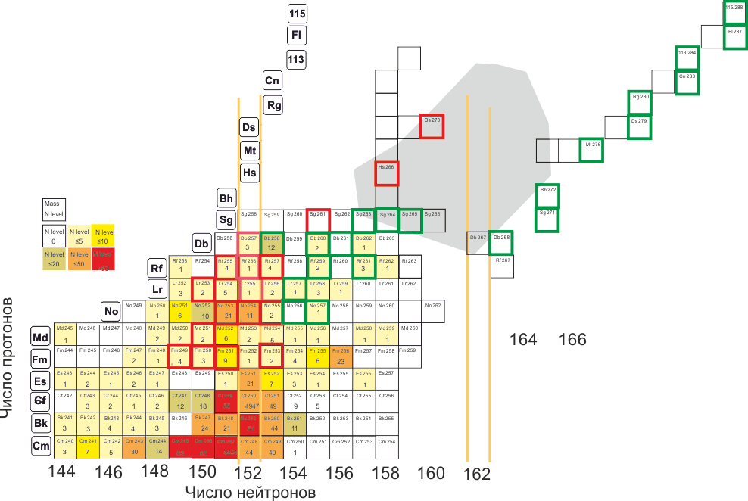

Fig. 4.1. Spectroscopic data on isotopes of transuranium elements.

The number of measured levels is shown by figures and is highlighted with colours. A small number of isotopes have been thoroughly studied to date (marked with red colour). Green colour is used to indicate isotopes whose spectroscopic properties are to be studied in scheduled experiments.

The spectroscopy of the isotopes of transuranium elements in the focal plane of the spectrometer (registration of alpha-particles, gamma- and X-ray quanta, and conversion electrons) allows us to determine transitions from mother nucleus (ground state) to daughter nucleus (ground, excited and isomeric states), and transitions of isomeric states to ground and excited states in the mother nucleus.

To study the structure of heavy and Super Heavy Elements (SHE), stopped in the focal plane, only one method for registration of nuclear radiation is applicable, which follows from the cross-sections for the formation of nuclei at the pico-barn level, i.e., detection with high-energy resolution of alpha particles and gamma-quanta from the decays of ground and low-lying excited and isomeric states of both the recoil nuclei, implanted into the focal detectors of kinematic separators and their daughter products.

The main experiments for studying the properties of the radioactive decay and the structure of isotopes of heavy and Super Heavy Elements under the FLNR JINR experimental programme for 2024–2030 will be conducted using the new DC-280 accelerator, the DGFRS-3 setup, and the detecting system GABRIELA.

Using a cryogenic gas ion catcher is another promising approach to studying SHE properties. Such a catcher for separation of nuclei of Super Heavy Elements has its limits only in terms of separation time that is ~30 ms or longer. On the chart of isotopes of elements with Z≥110 (Fig. 4.2), isotopes with lifetimes of 30 ms or longer are shown with squares (red borders). There are 31 such nuclei while the overall number of the known isotopes is 45.



Fig. 4.2. Chart of isotopes of superheavy elements.

When studying nuclei undergoing alpha-decay using a time-of-flight mass-separator, separation of synthesized nuclei according to mass is lacking. Identification of nuclei is thus difficult, and alpha-particle energies measured with highest resolution are needed. Alpha-spectra of nuclei varying according to their masses by ±3% are registered in the focal plane of the MASHA mass-spectrometer. Fig. 4.3 a) shows the dependence of the energies of registered alpha particles on the position in the focal plane (mass) of mercury isotopes synthesized in the 40Ar+144Sm→184-xnHg+xn reaction. Fig. 4.3 b) shows a one-dimensional spectrum for mass A=179 where the 179Hg alpha-decay (E=6285 keV) and the 175Pt daughter product (E=5948 keV) are reliably identified. Spatial separation by mass of isotopes greatly facilitates identification and simplifies the processing of experimental results. The background level in model experiments, which amounted to no more than one alpha particle with the energy exceeding 6 MeV per hour and heavy ions bombarding the target at ~3×1012 s-1, allows work with fusion cross-sections up to ~3×1012 с-1 without interrupting the beam.

Not only does the ion gas catcher help to study the properties of nuclei (alpha-decay), but also supports studies on the beta-decay (K-capture).

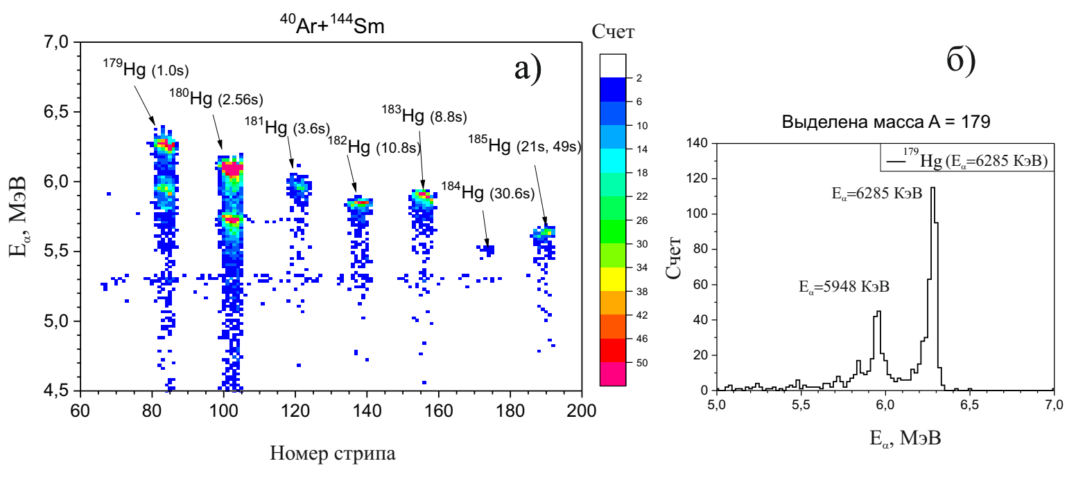

Fig. 4.3. a) Dependence of the energy of alpha particles on the strip number (atomic mass) of the focal-plane detector of the mass-spectrometer MASHA; b) One-dimensional spectrum of alpha-particles for mass А=179.

All the isotopes of nuclei with Z≥110 synthesized and studied up till now are in the neutron-deficient region and thus can undergo β+-decay and electron capture. Electron capture can be observed by registering characteristic X-rays emitted when outer-shell electrons fill a vacancy (essentially a K-shell). As noted above, electron capture can both help synthesize unknown nuclei and advance into the region of a larger number of neutrons in these nuclei.

The picture size 1,5×1,5 mm for a mass in the focal plane of the MASHA mass-spectrometer and low physical background—all these factors acting jointly, create favourable conditions for the registration of X-ray radiation accompanying electron capture. The optimal detector to fulfil this task is a co-axial germanium detector shown in Fig. 4.4. Ions of Super Heavy Elements can be implanted into the detector, as is shown in the figure. The geometric registration efficiency will be at least 90%. The geometric efficiency of such detectors (manufactured e.g. by ORTEC) approaches 4π; the energy range of recorded photons extends from 10 keV to 10 MeV, and the volume of the active area is 400 cm3.



Fig. 4.4. Co-axial well-type germanium detector.

# E Study of the chemical properties of Super Heavy Elements

Relatively high stability of new Super Heavy nuclei opens up new avenues of enquiry in the study of the chemical behaviour of Super Heavy Elements (SHE). It is interesting to compare the properties of SHE with the properties of their light analogues from the Mendeleev's periodic table, thus evaluating a hypothesis about the influence of relativistic effects on the law of periodicity of chemical properties in the SHE region. The answer to this fundamental question is extremely important for the chemical identification of synthesized elements.

First results on the chemical identification and study of the properties of SHE with Z = 112 – 114 in the elementary state obtained at the FLNR U-400 accelerator complex revealed their high volatility and low chemical activity affecting the search for Super Heavy Elements in nature. Detailed studies with higher statistical significance will continue at the SHE Factory.

The construction of a new experimental base at the SHE Factory within the seven-year period will become key to further work on the study of the chemical properties of SHE. The new infrastructure will comprise:

* New target assemblies for experiments at the DC-280 accelerator with the ion beam intensity up to 10 pµA;
* A pre-separator of nuclear reaction products for selective separation of isotopes of elements under investigation, which will considerably improve background conditions and the reliability of results;
* A gas ion catcher with speedy transport (30–40 ms) of reaction products, which will open up many new and exciting possibilities for exploiting the chemical properties of more short-lived isotopes of new elements.

New setups will allow investigations that today are out of reach of experimental techniques and will push existing technologies beyond current limits – one atom during one week of irradiation. Besides conventional experiments on the study of SHE properties in elementary states, new experiments on the study of the chemical compounds of the heaviest nuclei with Z=115–118 and with ultra short lifetimes (0.1–0.5 s) will be conducted.

Synthesis of SHE and the study of their properties require the construction of a specialized complex comprising radiochemical laboratories of class 1 for the manufacture and regeneration of highly radioactive targets. Such a complex will add a "finishing touch" to the SHE Factory project and will become the JINR key infrastructure for its further development and the application of radioactive isotopes in other fields.

# F Measurement of masses of Super Heavy atoms

The determination of the masses of Super Heavy nuclei (atoms) is very important both for further experimental studies in the field and for the development of theoretical models, including those defining the masses of as-yet-undiscovered nuclei. At present the only source of reliable experimental evidence on SHN masses is the alpha-decay ) measured with an accuracy of about 30 keV. In the case of decay from the ground state of the mother nucleus into the ground state of the daughter nucleus,  allows us to determine the difference between the masses of these nuclei. Therefore, mass measurement of any of the nuclei in the alpha-decay chain with a precision of about 30 keV will give the masses of all the nuclei in the chain.

One of the most efficient and rapid techniques for measuring nuclei masses is based on the use of multiple-reflection time-of-flight spectrometers (MR-ToF MS). Fig. 6.1 depicts a block diagram of the experimental setup. The setup comprises the following main elements: a target unit, a pre-separator for recoil nuclei (DGFRS-3), an ion gas catcher, and a mass-spectrometer with a registration system complex in the focal plane. The elements currently lacking at FLNR are the gas ion catcher and time-of-flight mass-spectrometer.



Fig. 6.1 The block diagram of the setup for measuring the masses of SHE nuclei.

***Cryogenic gas ion catcher***

Compared to conventional ISOL separation methods, using gas catchers is an advanced technique. The past several years have seen intensive use of gas catchers for the production of beams of radioactive nuclei [1, 2]. A gas catcher (Fig. 6.2) comprises a gas cell where ions of radioactive nuclei reach thermal energies, a radio-frequency or an electrostatic transport system, and an electrostatic system for ion beam acceleration and formation.



Fig. 6.2. Schematic drawing of a gas catcher

The operation principles of the gas cell [3] are explained in Fig. 6.3. Nuclei synthesized in reactions and decelerated (if necessary) in a solid-state absorber are stopped in a helium gas cell. The pressure in the gas cell depends on the energy of secondary beams and can vary from 100 to 1000 mbar. Only single- or double-charged ions retain in helium during slowdown and recombination. Using low permanent accelerating electrical voltage applied to the ring electrodes and directed along the axis of the cell, ion beams are extracted into a vacuum through a supersonic nozzle installed at the end face of the cell. Radio-frequency voltage applied to the electrodes of the cylindrical and conical parts of the cell simultaneously prevents ions from impinging the electrodes. Further beam formation is performed using a common electrostatic or a radio frequency structure placed in a vacuum volume, where ions are carried out by a supersonic buffer gas flow. As a result, a low-energy beam with thermal spread and emittance is produced (not exceeding 3π·mm·mrad), which creates ideal conditions for a mass-spectrometric analysis.



Fig. 6.3. Forces applied to ions in the gas cell

The advantages of the ion gas catcher are the following:

1. No dependence on chemical and physical properties of nuclides whose beams are formed in the catcher

2. Short extraction time (~10 ms) compared to that in a solid-state or liquid absorber (seconds)

3. Separate ion source is not needed

4. Potentially high efficiency of the conversion of a heavy-ion reaction products flux at energies 5–10 MeV/nucleon into a low-energy beam (to 60%).

This technique has however significant limitations, the major of which is ionization density restriction in the helium cell. Ionization of helium occurs during the slowdown of a beam in the gas cell. Highly mobile electrons are quickly removed by permanent electric field, and slower ones create a positive charge that pushes single-charged ions to the walls of the chamber and simultaneously shields permanent acceleration field. As a result, the ion movement time in the cell increases while the extract efficiency decreases. To increase separation efficiency by 20% and more, it is necessary to provide such conditions under which the ionization density in the gas cell will not exceed 108 ion pairs/(cm3.s).

Another limitation on the use of the ion gas catcher is a relatively long extraction time, which depends on the gas pressure, the length of the cell, and the maximum possible intensity of the permanent electric field. It is noteworthy that the conditions are more favourable for heavy-ion reaction products at low energies than for radioactive beams in fragmentation reactions at average and high energies when the regular release time exceeds 100 ms.

Another technical peculiarity of the setup under discussion is the characteristics required of the buffer gas in which the concentration of impurities should not exceed 10-9 atom/atom. This, in turn, imposes strict requirements on ultra-high-vacuum hygiene but due to modern technologies these conditions can be met.

Preliminary calculations have shown that the main design parameters of the ion gas catcher for the production of ion beams of transuranium nuclei at the energies 5–8 MeV/nucleon are the following:

* Gas cell size: diameter 100 mm, length 200 mm;
* Working gas: helium with impurities <1 ppb;
* Operating pressure: 100-200 mbar;
* Extraction time: ≥10 ms;
* Extraction efficiency: up to 40%;
* Beam emittance: 3 π·mm·mrad.

One of the most efficient gas ion catchers was designed in GSI [4]. The working gas in the setup is cooled down to 40K, without the necessity of ultra-deep gas purification. Another advantage of using the cryogenic equipment is a decrease in the diffuse spreading of the charge cloud in the slowdown region of reaction products and, as a consequence, the simplification of the gas cell cylinder design, i.e., a radio-frequency system for ion loss suppression is not required. The extraction efficiency of reaction product ions thus improved from 30 to 70%, and the extraction time stayed at 30 ms, like for "hot" cells [5, 6].

The ion catcher should be supplemented with a radio-frequency quadrupole buncher for the formation of an impulse current from a continuous ion beam at the exit of the gas catcher. Ion acceleration is thus 200 eV–2 keV, which is required for further transport and precise mass measurements. Ion transmission in the buncher is almost 100%.

***Multiple-reflection time-of-flight mass-spectrometer***

Multiple-reflection time-of-flight mass-spectrometry for the precision measurement of the masses of exotic nuclei has in the past decade been intensively developed. The following setups currently operate at six research centres: TRIUMF (CANADA), ANL (USA), NOTREDAME (USA), ISOLDE (CERN), SGI/FAIR (GERMANY), RIKEN (JAPAN), and some others being designed in other centres. The principles of operation of multiple-reflection time-of-flight spectrometers (MR-ToF MS) are shown in Fig. 6.4.



Fig. 6.4 Principles of operation of multiple-reflection time-of-flight mass-spectrometers

A key element of the spectrometer is an ion optical system comprising two electrostatic mirrors located in a drift tube. The ion bunch leaving the quadrupole buncher is injected into a drift gap between the mirrors. An ion bunch, having subsequently experienced several hundred reflections, passes a distance up to 100 m in a locked system of two electrostatic mirrors. The ions are extracted by an impulse directed onto an electrostatic mirror No. 2. The injection impulse serves as a start for the measurement of time-of-flight, and a stop signal is formed at the exit of a micro-channel plate ion detector. The typical distance between the mirrors is 500 mm, and the total length of the spectrometer does not exceed 1 meter.

The mass resolution of such setups is R≤t/2Δt, where t – time for ion accumulation time in the buncher and Δt – duration. Thus the mass resolution of the spectrometer depends on the properties of the buncher. The typical MR-ToF MS accumulation time is 100 ms, and the ion buncher duration is 100 µс. To ensure the efficient operation of the MR-ToF MS, the following requirements have to be fulfilled: use of highly stable permanent voltage sources; vacuum in the drift tube must be at the level of 10-9 mbar because the time-of-flight distance can reach 100 m, and the probability of ion inelastic scattering in residual gas is high; sufficient temperature stabilization of the mechanical component of the setup.

The main parameters of the modern spectrometer are the following:

* mass resolution М/ΔМ≤600000;
* precision of mass determination ~10-7;
* measurement duration (time for multiple time-of-flight between the mirrors) ~10 ms;
* sensitivity of statistically significant data is ~10 ions;
* measurement frequency up to 400 hz;
* transmission efficiency up to 70%;
* dynamic range is >104.

Having these parameters, the MR-ToF MS is able to successfully compete with Penning traps for the atomic mass measurements with lifetimes at the level of a few seconds or shorter. Using the SHIP-TRAP setup, for example, the precision of mass measurements for No isotopes was at the level of 10-7[7].

[1]G.Savard, J.Clark, C.Boudreau, F.Buchinger, J.E.Crawford, H.Geissel, J.P.Greene, S.Gulick, A.Heinz, J.K.P.Lee, A.Levand, M.Maier, G.Muenzenberg, C.Scheidenberger, D.Seweryniak, K.S.Sharma, G.Sprouse, J.Vaz, J.C.Wang, B.J.Zabransky, Z.Zhou // Nucl. Instr. andMeth. inPhysicsResearchB 204 (2003) 582–586.

[2] J.B.Neumayr, L.Beck, D.Habs, S.Heinz, J.Szerypo, P.G.Thirolf, V.Varentsov, F.Voit, D.Ackermann, D.Beck, M.Block, Z.Di, S.A.Eliseev, H.Geissel, F.Herfurth, F.P.Hessberger, S.Hofmann, H.-J.Kluge, M.Mukherjee, G.Muenzenberg, M.Petrick, W.Quint, S.Rahaman, C.Rauth, D.Rodrıґguez, C.Scheidenberger, G.Sikler, Z.Wang, C.Weber, W.R.Plass, M.Breitenfeldt, A.Chaudhuri, G.Marx, L.Schweikhard, A.F.Dodonov, Y.Novikov, M.Suhonen. // Nuc. Instr. and Meth. in Phys. Res. B 244 (2006) 489–500.

[3] G.Savard. A gas catcher system for low energy physics at S3 S3 collaboration meeting GANIL July 03 (2007) presentstion

[4]C.Droese, S.Eliseev, K.Blaum, M.Block, F.Herfurth, M.Laatiaoui, F.Lautenschläger, E.Minaya Ramirez, L.Schweikhard, V.V.Simon, P.G.Thirolf. // Nucl. Instr. Meth.in Phys. Res. B 338, 126(2014).

[5] O.Kaleja, B. Anđelić, K.Blaum, M.Block, P.Chhetri, C.Droes,Ch.E.Düllmann, M.Eibach, S.Eliseev, J.Even, S.Götz, F.Giacoppo, N.Kalantar-Nayestanaki, A.Mistry, T.Murböck, S.Raeder, L.Schweikhard. // Nuclear Inst. and Methods in Physics Research B 2019 in press.

[6] O.Kaleja, K.Blaum, M.Block, P.Chhetri, S.Eliseev, F.Giacoppo, F.-P.Heßberger,  
M.Laatiaoui, F.Lautenschlager, E.Minaya Ramirez, A.Mistry, S.Raeder, L.Schweikhard, and P.G.Thirolf. // GSI Scientific Report 2015, p. 111.

[7]M. Dworschak, M. Block, D. Ackermann, G. Audi, K. Blaum, C. Droese, S. Eliseev, T. Fleckenstein, E. Haettner, F. Herfurth, F.P. Heßberger, S. Hofmann, J. Ketelaer, J. Ketter,H.-J. Kluge, G. Marx, M. Mazzocco, Yu.N. Novikov, W.R. Plaß, A. Popeko, S. Rahaman, D. Rodr´ıguez, C. Scheidenberger, L. Schweikhard, P.G. Thirolf, G.K. Vorobyev, M. Wang, and C. Weber // Phys. Rev. C,81, 064312 (2010).

**G Properties of nuclei far from the β-stability line**

Radioactive ion beam (RIB) factories are well suited for the study of exotic nuclear systems remote from the β-stability line. The principal scientific goal of these facilities is the study of nuclei oversaturated with neutrons or protons, situated near or beyond the nuclear drip-lines.

The experimental program on the study of relatively light exotic nuclear systems of the current and previous 7-year periods in FLNR (JINR) has been carried out at the fragment-separators ACCULINNA-1 and COMBAS installed on the primary beam line of the U400M cyclotron. Recently, the new generation separators, ACCULINNA-2 and MAVR, have been put into operation. ACCULINNA-2 is a fragment-separator, installed at the U400M cyclotron to produce in the “in-flight” mode secondary beams of radioactive exotic nuclei. The energy of secondary beams ⁓20-40A MeV allows one to populate excitation spectra of light nuclei in few-nucleon transfer reactions with rather high cross section from few μb/sr to 1 mb/sr. The experiments that have been performed at these facilities were, in particular, intended for the study of structure of neutron-rich 4-7H, 6-10He, 10,11Li, proton-rich 6Be, 17Ne, and 26S nuclei.

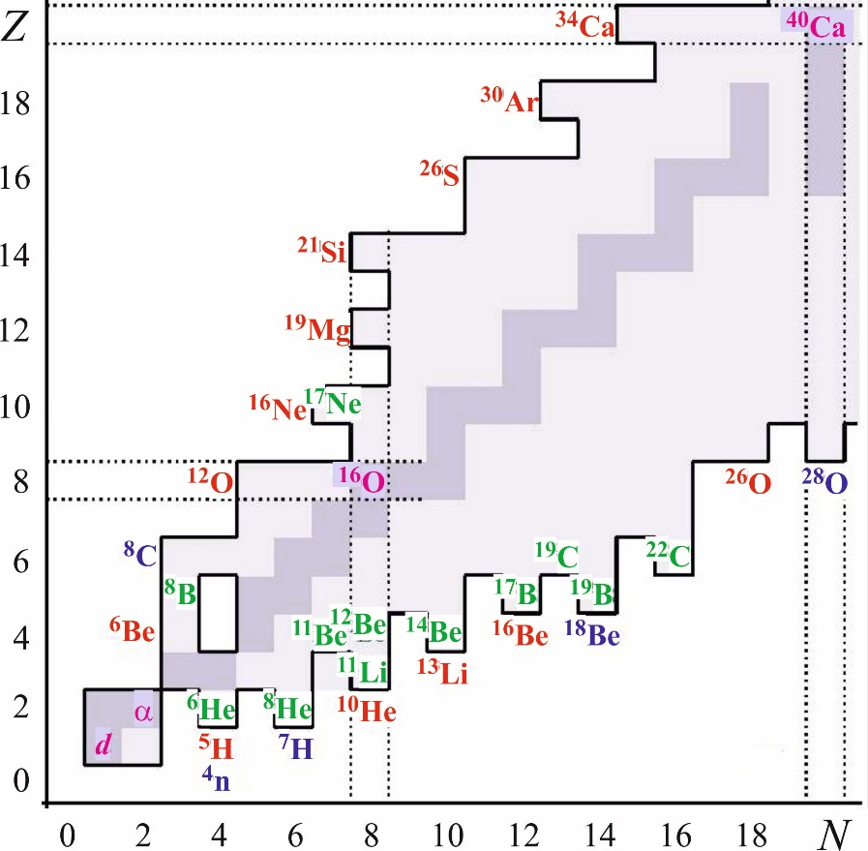

**Fig.1**. The lightest nuclei on the nuclide map. The well established nucleon drip lines are presented with thick solid lines. The stability valley is shown in bluish tone.

The MAVR high-resolution magnetic analyser separates nuclear species from reaction with beam of stable nuclei delivered from the U400 accelerator. The current and near-future goals of the research works to be done in the Flerov Laboratory are marked in Fig. 1. Investigation area discussed here embraces a region of light nuclei where transfer reactions make an effective tool allowing reaching the neutron/proton drip lines. We note that several research groups working at worldwide facilities [Cut07, Spi2, Iso, Gei03, Hau13, Kub92, Kub03] have contributed actively in the production and studies of these nuclei in the last ten years, and that further developments are expected in the next period.

**G.1 Nucleon haloes, neutron skins**

Weakly bound few-body exotic systems show properties very different from the nuclei, which are not too far from the valley of stability. The halo phenomenon is important for a better understanding of nuclear structure close to the drip lines. Examples of known halo (skin) nuclei include 6,8He, 11Li, 11,14Be, 17,19B, 19B, and 19C.

Along the neutron drip line, the relatively small enhancement of the total binding occurring for paired neutrons has important impact. Experiments giving new knowledge about the properties of the interleaving neutron-unbound nuclei should be put into the agenda of the research aimed at understanding the character of neutron-nucleus interaction far from stability, the coupling to the continuum in neutron-rich systems, and delicate structures inherent to the multi-neutron haloes or skins. Studies of the adjacent neutron-unbound odd-N nuclei could yield information on the nucleon orbitals important for the description of the heavier bound nuclei. With regards to the drip-line, nuclei of beryllium, boron and carbon, the spectra of 13Be, 16B, 18B, and 21C are of special interest.

Nucleon knockout and the more conventional transfer reactions are complementary methods While knockout reactions mainly probe hole strengths, the nucleon transfer reactions like (d,p), (t,d), (t,p) and (3He,d) populate particle orbitals. Adding to the arsenal of methods, the nucleon pickup reactions from the RIB projectile nuclei, e.g. reactions of the (d,3He), (p,d), and (p,t) types, one can populate nucleon-hole states in exotic nuclei. The orbital angular momentum quantum numbers, the relative location of single-particle states, and spectroscopic factors are accessible in experiments employing direct reactions. Transfer reactions access many excited states simultaneously, and their strong kinematic matching allows the optimum choice of reactions populating the nuclear states with orbital angular momentum of the interest. Nucleon transfer and charge-exchange reactions, such as (p,n) and (t,3He), offer a robust way to perform through studies of the halo nuclei.

**G.2 Exotic multi-neutron decays (2-nucleon virtual states, 2n- and 4n-radioactivity)**

Beyond the drip lines, we get at the regions of strong nuclear instability. Here, in the region of light neutron-rich nuclear systems, the experimental observations could be especially confusing. In the absence of strong potential barriers the observables becoming typical for the neutron decays, are often sensitive to the reaction mechanism. Also, the appearance of novel dynamics forms is not impossible here. These include the possible existence of hypothetical two-neutron virtual states [Gri08] and two/four-neutron radioactivity [Phu12]. The search for the few-neutron radioactive decays is inspired by the discovery of the two-proton radioactivity [Phu02, Gio02]. In contrast with the situation coming across near the proton drip line, the long-lived one-neutron emitters are practically impossible, while the 2n- and 4n-emitters may have quite long lifetimes, even falling in the radioactivity timescale. The discovery of such a novel type of radioactive decay is a challenging task requiring elaborate experimental approaches. At present time, the studies of nuclear systems with large neutron excess are active in different centres having intermediate-energy RIBs. Different authors published the results of their experiments devoted to the studies of the true two-neutron emitters 10He [Gol09, Sid12, Joh10, Koh12, Mat15, Jon15], 13Li [Aks08, Koh13a], 16Be [Spy12, Tho13], and 26O [Lun12, Cae13, Koh13b, Koh15, Kon16].

Examples of successful experiments dedicated before to the exploration of the topics of 1n- and 2n-emitters beyond the neutron drip line, are the studies of neutron decays of some states in 5H, 8He, 9He, and 10He. Refined data on the 3H(8He,p)10He reaction, obtained at the ACCULINNA separator [Sid12], confirmed the results reported in Ref. [Gol09]. The new data positioned the 10He ground-state resonance at 2.1±0.2 MeV above the threshold of the three-body 8He+n+n decay and revealed the onset of intruder states and changing the spin-orbital interaction as prominent shell-breaking effects in the 10He spectrum. The extension of these works to similar systems is foreseen. The excitation spectra of 7H, 11-13Li, 13-16Be, 16-19B etc. will be a first-priority task for the group of the ACCULINNA-2 separator. The study will include precise determinations of ground-state masses made for these nuclei. It is worth noting that currently none of the neutron separation energies are known to better than 10 % for these nuclei. Transfer reactions of the (t,p) and (d,p) type, studied in inverse kinematical conditions, are the most suitable ones for the precise mass measurements. High statistics data will be accessible for complete kinematic measurements performed for the resonant states of these little-studied nuclei.

**G.3 Soft excitation mode**

The idea of neutron halo became the starting point for the prediction of a low-lying dipole excitation mode, i.e. the so-called soft dipole mode [Ike92]. Its appearance is connected to the suggested low-frequency oscillations of the halo neutrons against the core, giving rise to low-lying dipole excitations. Assuming this hypothesis, large electromagnetic dissociation (EMD) probability was predicted [Han87] for 11Li incident on heavy targets. The large cross-sections expected for the Coulomb dissociations of the Borromean halo nuclei have been confirmed experimentally (see e.g. [Aum99]). It should be noted that, at least for the lightest Borromean halo-nuclei 6He and 11Li, the low-lying dipole excitations are not resonant ones (these are rather ordinary low-lying continuum states). However, it does not mean that these states cannot have resonant character in other halo nuclei.

The study of the soft mode showing up in the 8He spectrum, performed in [Gri09, Fom09], demonstrates how deep one can get into the mechanism of this excitation created by the low-frequency oscillations of the halo neutrons against the nuclear core. In particular, the possible nature of the near-threshold anomaly above 2.14 MeV in the 8He missing mass spectrum was explained by the population of a 1- continuum (soft dipole excitation) with a peak energy value of about 3 MeV.

**G.4 New magic numbers and intruder states**

There are basic problems in the field of exotic nuclei where ACCULINNA-2 operates. One example is the ascertainment of the patterns associated with the closed-shell breakdown at the magic neutron number N=8 and the manifestation of s-d intruder states in the neutron-rich nuclei 9,10He, 10,11Li, 11,12Be. Clarification of filling sequences arising in the s-d neutron shell in a number of neutron-excess nuclei (e.g. 15Be, 16,18B, 17,19C) and the interplay of s- and d- wave states in their even-N neighbours is another basic problem, which calls for thorough investigation. On the proton-excess side, similar phenomena call for the study of the possible two-proton halo structure, with a 15O core, predicted by theory for 17Ne. Of special interest is the termination of the s-d shell occurring in the C, N, O, F and Ne nuclei in the vicinity of neutron number N=16. The 20-30A MeV beams of 24O, 26,27F, 28,29,30Ne provided at ACCULINNA-2 are well suited for studying resonant states of nuclei (e.g. 24-26O) lying near and beyond the drip line.

**G.5 Two proton radioactivity**

The upgrade of the U-400M cyclotron planned for the period 2020-2022 will open ways to the whole series of proton-rich nuclei with Z≤36, lying close and beyond the proton drip-line. These include a number of nuclei predicted to exhibit 2p-radioactivity. Furthermore, great interest is in the dynamics of the 2p decay of resonant states, e.g., of 6Be, 12O, 16Ne, 26S, 30Ar, 48Ni etc. The detection of the 2p-decay branch for the first excited state of 17Ne will clarify the issues related to the Z=8 waiting point affecting the rp-process in the sites of hot stellar burning.

The proton drip line is quite well known for nuclei with Z≤36. Only few isotopes, remaining unknown here, could exist with half-lives long enough for detection by time-of-flight at the end of the fragment separator. Recently, the ACCULINNA group performed dedicated search for the drip-line nucleus 26S produced in fragmentation of 32S beam nuclei [Fom11]. A half-life limit of T1/2<79 ns was set for 26S in this study. Another example is 48Ni, which was studied in 2011 by means of an imaging time projection chamber [Pom11]. As a result, for the first time a 2p decay branch was observed and the half-life of 48Ni was determined to be 2.1 ms. The properties of the neighbour nuclei 21Si, 30Ar and 34Ca with half-lives shorter than 100 ps can be ascertained well due to the excellent choice of RIBs provided by the ACCULINNA-2/U-400M complex. In particular, the rare phenomenon of the β-delayed 3p-decay of 31Ar [Lis15] could be investigated in great details. The quest for 21Si and 26S is challenging because it is very probable that the two-proton emission is the main decay mode of these nuclei. Quite detailed studies of the 2p decay mode will be feasible for the nuclei having lifetime T1/2>50 ps. This becomes realistic because one can produce these nuclei in transfer reactions induced by RIBs. The (p,d) and (p,t) type reactions are favourable to cope with this task. For the 21Si and 26S nuclei, their formation and decay, occurring in-flight, should be verified by the detection of the daughter nucleus and the two emitted protons. The decay time is derived from the distance between the target and the vertex position defined as the intersection point of the momentum vectors of the two emitted protons with the daughter-nucleus trajectory.

The suggested approach works well also when the 2p-decay life times are very short, with a lower limit close to the characteristic nuclear time. This holds for the excited states of the searched 2p emitters. Precision measurements of the 2p- and p-decay characteristics made for a dozen of nuclei with Z≤36, lying beyond the proton drip line, should be included in the research program.

**H Spectroscopy of exotic nuclei**

At ACCULINNA-1, a notable experiment series of transfer reactions via correlation techniques have been performed, and excitation spectra in exotic nuclei have been measured. Such technique has been applied before to identify the spin-parity of excited states displaying the emission of spinless particles. In the experiments performed at ACCULINNA, the method was further developed [Gol04a, Gol05] and successfully was demonstrated in publications [Gol04a, Fom11]. As is well known, highly aligned states are produced in direct reactions. In the rest frame of the exotic nucleus, formed as the reaction product, the highest degree of spin alignment is obtained in respect to the axis parallel to the transferred momentum vector. The decay of the aligned configuration may produce sharp correlation patterns. The interpretation of the observed correlations may appear to be unique, this was the case, for example, with the spectrum of 9He populated in the (d,p) reaction [Gol07]. This "unstable" aspect of this approach depends on such details of reaction mechanism and spectral densities of different states, which one cannot predict in advance.

Typically, the resonance states of light drip-line nuclei (especially on the neutron-excess side) are broad and overlapping, and their correlation patterns are affected by interference. Therefore, even weakly populated states may become apparent due to the contribution made into the interference patterns. The addition of amplitudes acts in this situation as a kind of "quantum amplifier" giving access to the details of the spectrum which otherwise would be too complicated for their revelation. Benefits derived from the correlation aspect of spectra populated in direct transfer reactions are always implied in the consideration of the ACCULINNA-2 research program.

**H.1 Cluster states**

Many nuclei up to the sd-shell are known to have cluster structures in the ground state and at excited states. Rotational bands with a well-expressed molecular structure, characterized by large deformation have been observed. Good candidates for such studies are the heavy isotopes of He, B, C, O, Ne, etc.

The correlation measurements and the complete kinematics studies, discussed above, form the most common way for elucidating clustering aspect of nuclear dynamics. The importance of the Optical Time-Projection Chamber [Mie07, Mia10 Pom11, Lis15, Jan17] should be specially emphasized here. It gives opportunity to make complete kinematics measurements in experiments where the "useful" counting rates are just units and tens of events. This is important for the studies of exotic nuclear systems attainable with low production rates.

A number of related experiments were performed with OTPC at the ACCULINNA-1 separator [Mie07, Mia10, Jan17]. Evidence produced for the neutron emission after the β-decay of 8He to a highly excited 8Li state indicates that the early reported decay scheme of 8He is not complete. The methods making use of OTPC offer unique opportunities for the study of rare decay branches of excited 8He nucleus in, e.g., the α + t + n, 7Li+n, 6He+d \cite{Mia} and beta delayed one-, two-proton emission of 26P, 27S [Jan17].

Another field for the cluster structure-studies concerns the states in 6He with a t+t structure and a possible 5H+t clustering of 8He. Reactions of quasi-free scattering (QFS) are sensitive specifically to the clustering aspect of nuclear structure. In this class of reactions, the selection of a quasi-free knockout channel explicitly defines the clustering partition of the studied nucleus. The quasi-free scattering reactions reported in [Sid10] could be effectively applied for the further determination of the halo structures in 6He, 8He and other exotic nuclei. While typically the valence nucleon is knocked out in the QFS, the (α,2α) knockout of the halo nucleus 6He core was examined in [Sid10] elucidating different aspects of nuclear structure.

**H.2 Reactions with halo nuclei**

Fusion reactions detected with the beams of halo nuclei have been of increased interest from experimental and theoretical points of view. In particular, much effort has been devoted to the subject of near-barrier fusion of light, weakly bound projectile nuclei. Unusual effects are expected here both from the halo structure of these nuclei and from the specific tunnelling mechanism of the composed weakly bound system which is of general interest for quantum theory. One example of this type of effects represents the recent study of the fusion reaction 6He+206Pb carried out at DRIBs-3 [Pen07]. Another example is the study of complete and incomplete fusion reactions of 6He and 6Li projectiles with 165Ho and 116Er target nuclei [Fom12]. The upgraded DRIBs-3 complex will give higher intensity and higher quality beams of 6He nuclei and also a variety of other exotic beams (8He, 9Li, 12Be, etc.) thus offering prospects for new insights into the process of low-energy fusion and multi-nucleon-transfer reactions of light exotic nuclei hitting against heavy targets.

**H.3 Astrophysical applications**

Nowadays, the nuclear astrophysics research is an integral part of the novel forms of nuclear dynamics study. Finite nuclear matter is the only directly accessible "testing ground" for theoretical models that are meant to look into the states of the infinite stellar matter. The following data are required:

i) Masses and level schemes close to the neutron, proton, and alpha breakup thresholds

ii) Electron capture data for determining the β-decay lifetimes

iii) Partial proton, neutron, α, γ widths of low-lying resonances necessary for calculating the resonant radiation capture and (n,α) or (α,n) reaction rates

iv) Electromagnetic E1 and E2 strength functions to calculate the non-resonant radiation capture, extracted from the data on the electromagnetic dissociation of corresponding nuclei.

Nuclear reactions in stars involve short-lived proton-rich and neutron-rich nuclei that can be studied only with radioactive beams. The cross sections of interest have to be obtained indirectly by the study of resonance reactions made via inverse kinematics on hydrogen and helium target nuclei. Transfer reactions allow determining level schemes and spectroscopic properties of nuclear states. Peripheral transfer reactions are suitable for measuring the quantities called Asymptotic Normalization Coefficients (ANCs), determining stellar capture rates. Transfer reactions performed with the RIBs delivered by DRIBs-3, such as (d,n), (d,p), (t,d), (p,d), or (3He,d) can be used to extract the proton spectroscopic factors, ANCs, or neutron spectroscopic factors in mirror nuclei.

Two-proton radiative capture along the rp-process path is poorly understood so far. This process is directly related to two-proton radioactive decay. 2p radioactivity and all complexities of this phenomenon are poorly understood. Of great importance will be experiments around the critical waiting points 64Ge, 68Se, and 72Kr. These waiting points influence the light curves of the X-ray bursts and determine the amount of heavier nuclei produced. The 15O waiting point is also important for the passage of the rp-process. The two-proton capture is a possible alternative to the (α,p) reaction as a pathway for the rp-process allowing the search for a weak 2p decay branch of the first excited 3/2- state in 17Ne. Decay of this state via emission of γ-quanta, yet the two proton decay was also predicted theoretically at the level Γ2p/Γγ ⁓ 10-5 - 10-6 [Gri07]. This assumption is still not confirmed experimentally [Chr97, Chr02, Gol15, Sha17] but might be feasible with the use of intense Z = 8-10 radioactive beams provided by DRIBs-3.

**I Development of the experimental infrastructure**

Within the next 7-year term 2023-2030, experiments on the study of nuclei far from the β-stability valley will have been implemented mainly at the “in-flight” fragment-separator ACCULINNA and ACCULINNA-2 (see Fig.2) and the high resolution analyser MAVR (see Fig. 3). The RIB delivery is possible at U-400M (20-45 AMeV primary beams) well matched with the ACCULINNA and ACCULINNA-2 fragment separators. The separator MAVR is installed at the cyclotron U400, which provides beams of stable nuclei in the energy range 5 – 10A MeV. The recently commissioned ACCULINNA-2 facility yields RIB with intensities 20-30 times larger than the ACCULINNA separator launched more than 20 years ago. The performance of ACCULINNA-2 is analogous to that inherent to the RIPS (RIKEN) or LISE (GANIL) fragment separators, which were the landmark facilities of the previous generation of RIB arrangements. Upgrade/repair of the U-400M driver cyclotron (planned for 2020-2022) will give solid basis to the scientific program at ACCULINNA-2, meaning more stable delivery of a broader variety of primary beams of somewhat larger energy than today.

Fragment-separator ACCULINNA-2 is equipped with a number of supplementary tools to be fully put into operation after repair of the U400M cyclotron planned for 2020 - 2022. A vertically deflecting radio-frequency kicker (RF-kicker) is installed just after the achromatic focal plane F3, providing additional purification of a secondary beam of, e.g., proton-rich nuclei. RF filter has a maximal electrical field amplitude of 15 kV/cm and frequency in a range 15 – 22 MHz. This allows purification of secondary beams of proton-excess nuclei with velocities up to β = 0.32 (50A MeV). For separation of charged reaction products a zero-degree spectrometer is placed downstream of the physical target in the F5 focal plane. This will improve considerably the cumulative energy resolution of experiments with observation of beam-like products (see Fig. 4).

By 2023 we expect to have put into operation a unique complex of a cryogenic gas target that will provide safe operation with gases (helium and hydrogen isotopes including tritium in gaseous or liquid states). The lowest temperature at the target cell should reach 11 K. This technique is very beneficial for the study of nuclei in the vicinity of the neutron drip line. Two-neutron transfer reactions induced by RIBs hitting a cryogenic gas target were shown to be an effective tool in the study of the drip-line, neutron-rich nuclei 5H, 8He, 9He, 10He (e.g. see in Gol05, Did12]). Future experiments of this kind require the use of liquid tritium targets [Yuk03] coming up to 2.5 mm in thickness. The weight of tritium contained in this target will be about 1500 mg, its activity making about 15 Ci. Rare modes of decay of nuclei far from the stability line (two-proton radioactivity, β-delayed decays) are to be explored with a unique Optical Time-Projection Chamber (OTPC), allowing to get 3D reconstruction of the decay of an exotic nucleus to charged particles.

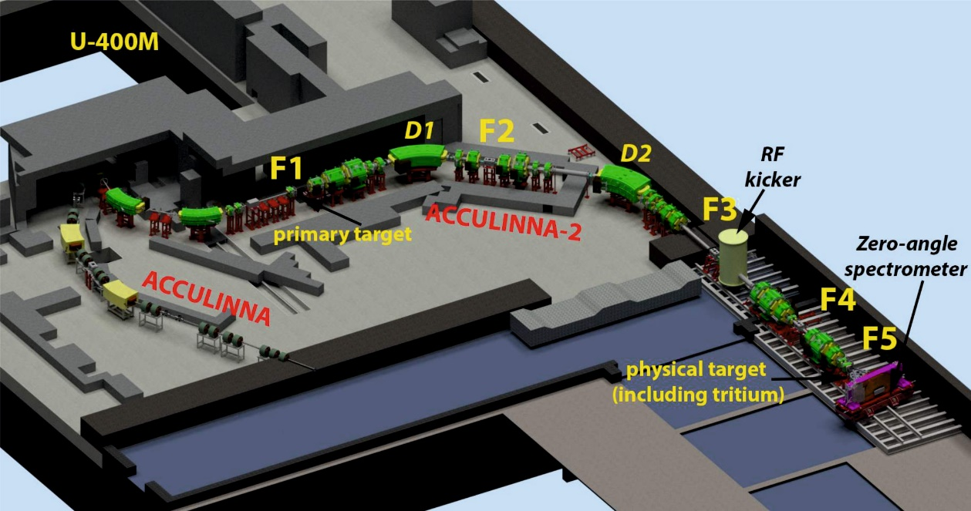

**Fig. 2**. Layout of the fragment-separator ACCULINNA-2 at the U400M cyclotron.

The development of new detector systems and mastering modern digital technologies include:

* New generation of micro-strip silicon detectors dedicated for tracking/spectroscopy experiments [EXP].
* Radiation-hard and extremely fast silicon detectors providing a very good time resolution σ ⁓ 50 ps) for TOF measurements and beam diagnostics [Ere17].
* A multi-module array of neutron detectors on the base of stilbene crystals [Bez18], scintillation fibers and conventional multi-layer plastic scintillator arrays [EXP] for experiments on the study of decay correlations of neutron-rich nuclear systems.
* Arrays of CsI, LaBr3 etc. crystals for the charged-particle and gamma-ray detection [EXP].
* New 4π detection system DEMAS-MULTI comprising 90 3He neutron counters, CeBr3 scintillators and γ-clovers.

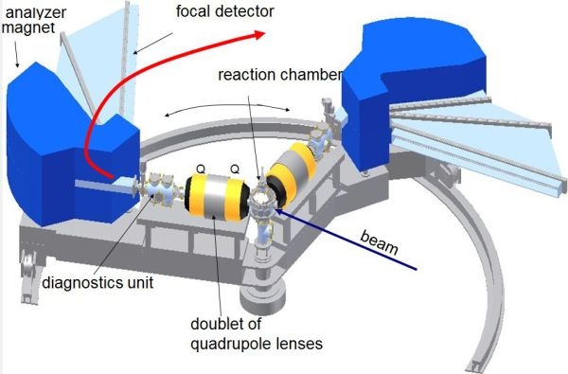

**Fig. 3**. Layout of the MAVR analyser.

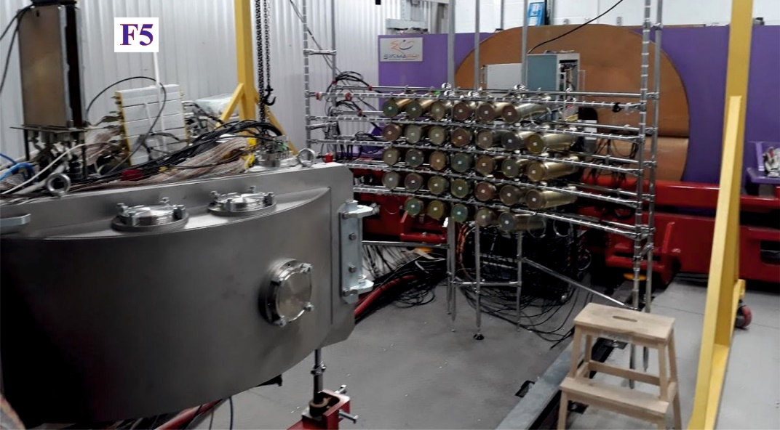

**Fig. 4**. View of equipment at the final focal plane of ACCULINNA-2 [Fom18]: the reaction chamber with charged particle detectors (inside) and the array of neutron detectors (outside).

Cut07. G. Cuttone et al., Nucl. Instrum. Methods **B 261**, 1040 (2007).

Spi2. SPIRAL2, http://pro.ganil-spiral2.eu.

Iso. ISOLDE, http://isolde.web.cern.ch.

Gei03. H. Geissel \emph{et al.}, Nucl. Instrum. Methods B **204**, 71 (2003).

Hau13. M. Hausmann \emph{et al.}, Nucl. Instrum. Methods B **317**, 349 (2013)

Kub92. T. Kubo, Nucl. Instrum. Methods B **70**, 309 (1992)

Kub03. T. Kubo, Nucl. Instrum. Methods B **204**, 97 (2003).

Gri08. L. V. Grigorenko and M. V. Zhukov, Phys. Rev. C 77, 034611 (2008).

Phu12. M. Pfutzner, L. V. Grigorenko, M. Karny, and K. Riisager, Rev. Mod. Phys. 84, 567 (2012).

Gio02. J. Giovinazzo et al., Phys. Rev. Lett. 89, 102501 (2002).

Gol09. M.S. Golovkov et al., Phys. Lett. B 672, 22 (2009).

Sid12. S.I. Sidorchuk et al., Phys. Rev. Lett. 108, 202502 (2012).

Joh10. H. T. Johansson et al., Nucl. Phys. A 842, 15 (2010).

Koh12. Z. Kohley et al., Phys. Rev. Lett. 109, 232501 (2012).

Mat15. A. Matta et al., Phys. Rev. C 92, 041302(R) (2015).

Jon15. M. D. Jones et al., Phys. Rev. C 91, 044312 (2015).

Aks08. Yu. Aksyutina et al., Phys. Lett. B 666, 430 (2008).

Koh13a. Z. Kohley et al., Phys. Rev. C 87, 011304(R) (2013).

Spy12. A. Spyrou et al., Phys. Rev. Lett. 108, 102501 (2012).

Tho13. M. Thoennessen et al., Acta Phys. Pol. B 44, 543 (2013).

Lun12. E. Lunderberg et al., Phys. Rev. Lett. 108, 142503 (2012).

Cae13. C. Caesar et al., Phys. Rev. C 88, 034313 (2013).

Koh13b. Z. Kohley, et al., Phys. Rev. Lett. 110, 152501 (2013).

Koh15. Z. Kohley et al., Phys. Rev. C 91, 034323 (2015).

Kon16. Y. Kondo et al., Phys. Rev. Lett. 116, 102503 (2016).

Ike92. K. Ikeda, Nucl. Phys. A 538, 355c (1992).

Han87. P. G. Hansen and B. Jonson, Europhys. Lett. 4, 409 (1987).

Aum99. T. Aumann et al., Phys. Rev. C 59, 1252 (1999).

Gri09. L.V. Grigorenko et al., Phys. of Part. and Nucl. Lett. 6, 118 (2009).

Fom09. A.S. Fomichev et al., Eur. Phys. J. A 42, 465 (2009).

Fom11. A.S. Fomichev et al., Int. Journal of Modern Phys. E 20, 1491 (2011).

Fom18. A.S. Fomichev et al., European Physical Journal A 54, 97 (2018).

Pom11. M. Pomorski et al., Phys. Rev. C 83, 061303(R) (2011).

Lis15. A.A. Lis et al., Phys. Rev. C 91, 064309 (2015).

Gol04. M.S. Golovkov et al., Phys. Rev. Lett. 93, 262501 (2004).

Gol05. M.S. Golovkov et al., Phys. Rev. C 72, 064612 (2005).

Fom11. A.S. Fomichev et al., Int. Journal of Modern Phys. E 20, 1491 (2011).

Gol07. M.S. Golovkov et al., Phys. Rev. C **76**, 021605(R) (2007).

Mie07. K. Miernik et al., Nucl. Instrum. Methods A **581**, 194 (2007).

Mia10. S. Mianovski et al., Acta Physica polonica B **41**, 449 (2010).

Jan17. L. Janiak et al., Phys. Rev. C **95**, 034315 (2017).

Sid10. S.I. Sidorchuk et al., Nucl. Phys. A **840**, 1 (2010).

Pen07. Yu.E. Penionzhkevich et al., Eur. Phys. J. A **31**, 185 (2007).

Fom12. A.S. Fomichev et al., Phys. of Part. and Nucl. Lett. **9**, 806 (2012).

Gri07. L.V. Grigorenko and M.V. Zhukov, Phys. Rev. C **76**, 014008 (2007).

Gri16. L.V. Grigorenko et al., Phys. Usp. **59** (4) (2016) 321.

Chr97. M.J. Chromick et al., Phys. Rev. C 55, 1676 (1997).

Chr02. M.J. Chromick et al., Phys. Rev. C 66, 024313 (2002).

Gol15. M.S. Golovkov et al., EXON-2014 Proc. of Int. Symp. on Exotic Nuclei (World Scientific Publishing Co., Singapore 2015) p.171.

Sha17. P. Sharov et al., Phys. Rev. C 96, 025807 (2017).

Yuk03. A.A. Yukhimchuk et al., Nucl. Instrum. Methods A 513, 439 (2003).

Ere17. V. Eremin et al., JINST 12, C03001 (2017).

EXP. EXPERT TDR, <http://www.fair-center.eu/for-sers/experiments/nustar/documents/technical> -design-reports.html

Bez18. A.A. Bezbakh et al., to be published in Instrum. and Experimental Techniques Num. 5 (2018).

**Human Resources**

The current staff of FLNR is about 450 people. Development of the Laboratory projects will require increase of personnel in the next 10 years by approximately 30-50 people.

This increase includes mainly engineering and technical staff. Therefore, close collaboration with leading technical universities and institutes is necessary for sustainable development of FLNR. In this respect, a recently signed agreement between JINR, Bauman Moscow State Technical University and Government of Moscow region on establishment of a higher engineering school in Dubna based on the Dubna State University is of great importance.

Other traditional and efficient methods of training and recruiting of personnel include:

* Supervision of practical, bachelor, master, and PhD works prepared by students studied at scientific and technical departments of universities from the JINR Member.
* Excursions to the facilities and lectures about activity of the Flerov Laboratory for students.
* Planning various supplement schools for students of local universities during scientific conferences organized by FLNR.
* Investing into development of the human capital and training of the employees in the world leading educational centers.

**General summary**

Finally, during the next 7-year period 2024-2030 we plan the following:

1. The first priority of the long-term development of FLNR is synthesis of SHE and their isotopes as well as study of their chemical and nuclear properties at the SHE Factory, including:

* Development of experimental facilities of the SHE Factory.
* Implementation of an experimental program in the field of SHE.
* Construction of a specialized complex comprising radiochemical laboratories of class 1 certification for the manufacturing and regeneration of highly radioactive targets used, first of all, for the SHE research.
* Develop a new 28 GHz ion source in order to, first of all, extend the list of ions available at the SHE Factory up to uranium.

2. Other important tasks of FLNR until 2030 are:

* Reconstruction of the U-400 accelerator complex, including the construction of a new experimental building, the modernization of the cyclotron to U-400R and the creation of new facilities for studying nuclear reactions with heavy ions. Implementation of the experimental program of the U-400R complex.
* Continuation of experimental research in the field of light exotic nuclei located at the borders of nuclear stability on the modernized U-400M cyclotron, using the ACCULINNA-2 fragment separator and the DRIBs complex to produce post-accelerated beams of radioactive nuclei.

International competition ? Uniqueness !

3. Continue discussion of long-term plans for the development of the complex of FLNR scientific and technical facilities.

The total available beam time of three FLNR’s cyclotrons (DC-280, U-400R, and U-400M) is expected to be of about 15 000 hours annually. This will allow us to formulate a user policy and open the FLNR facilities for external users.

The FLNR budget necessary for implementation of the development and research program in the period 2024-2030 is expected to be not less than the Laboratory budget for the current 7-year period.