the scientific program of the Laboratory of Radiation Biology for the period up to 2030
Radiobiological and Astrobiological Research at Charged Particle Beams of Different Energies

Executive summary
Heavy charged particles are an excellent tool to address fundamental problems of modern radiation biology and genetics. In contrast to photon radiation, which uniformly deposits energy within the cell nucleus, heavy charged particles densely release energy along their tracks. It results in complex and clustered DNA damage and determines the particles' high biological efficiency. Therefore, high-charge and energy (HZE) ions of the Galactic Cosmic Rays (GCR) make a great contribution to the health risk to astronauts during manned deep space missions. Furthermore, hadron beams — protons and carbon ions — are beneficial for radiation cancer treatment, especially for deep-seated tumors, due to their depth-dose distribution with a sharp maximum at the end of the particle range (the Bragg peak). Therefore, charged particle tumor therapy and space radiation protection are becoming increasingly urgent fields of modern radiobiological studies.
Astrobiology is studying life in the broadest sense: its origin, evolution, and presence in the Universe. To answer the question of the exogenous origin of life, the early stages of transition "from the inanimate to life" can be reproduced in ground experiments using particle beams as an energy source.

introduction
The research performed by the Laboratory of Radiation Biology at JINR's basic facilities in previous years allowed solving one of the central problems of radiobiology: evaluation of the relative biological effectiveness (RBE) of particle beams, which was shown to depend not only on their physical characteristics but also on the biological factor: the ability of the cell to repair DNA damage. Based on the developed concepts, the mechanisms of radiation-induced mutagenesis in prokaryote and lower eukaryote cells were studied in detail. A new concept to revise the traditional approach to astronauts’ radiation risk evaluation was proposed, which includes the risk of the central nervous system (CNS) disorders [1].
The LRB is currently conducting research on the following Research Projects:
- Molecular Radiobiology
To investigate the molecular lesions induced in DNA by ionizing radiation, immunocytogenetic and immunohistochemical techniques based on fluorescent labeling of proteins involved in the repair of the most severe radiation-induced DNA damage — double- strand breaks (DSB) — have been widely used in recent years at the LRB. It allows the quantification of DNA damage (radiation-induced foci (RIF)) and visualization of repair kinetics — particularly, of clustered DNA damage produced by high-LET radiation. Previously, clustered DNA damage was induced by proton and photon radiation (the Medical Technical Complex, DLNP), by 30–50 MeV/n ¹¹B, ¹⁵N, and ²⁰Ne beams (U400M, FLNR), and by 500 MeV/n ¹²C and 2.5 GeV/n ⁷⁸Kr beams (VBLHEP Nuclotron) and its repair were studied in normal human cultured cells of different origin (Fig. 1).
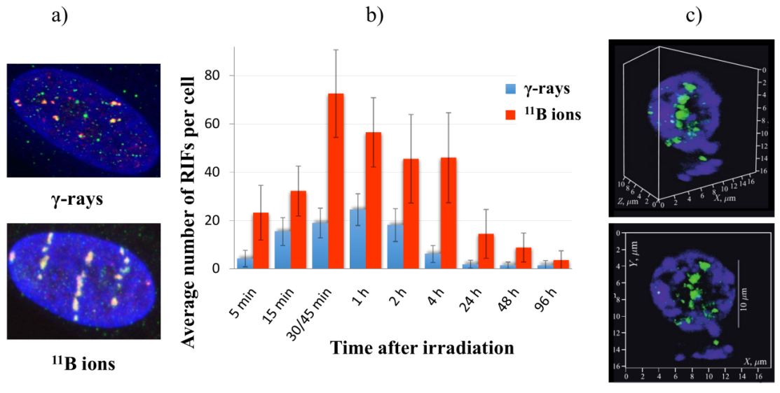
Fig. 1. RIF visualization (a) and their repair kinetics (b) after exposure to γ-rays and 50 MeV/n ¹¹B ions. Clustered RIF induced by 2.5 GeV/n ⁷⁸Kr ions in rat hippocampal cells 1 hour after exposure (c).

- Radiation Cytogenetics
Chromosome aberrations (CA) are considered a sensitive and reliable indicator of radiation exposure. Their assessment in human peripheral blood lymphocytes (PBL) is a valuable method of modern human biodosimetry (IAEA, 2011). Classical cytogenetic metaphase and anaphase methods as well as the chemically-induced PCC (premature chromosome condensation) assay have been widely used at the LRB to evaluate the biological effectiveness of particle beams at JINR's facilities, namely, 150 MeV and SOBP protons? used for patient treatment, 30–50 MeV/n ions from ¹¹B to ²⁰Ne at the U400M ( FLNR), and 400 MeV/n ¹²C ions at the Nuclotron, for investigations of biological effects of low-dose ionizing radiation and adaptive response and for studies of the modifying action of DNA synthesis inhibitors on the biological effectiveness of particle beams.
- Radiation Physiology
To assess the radiation risk to astronauts caused by GCR exposure during deep space flights, morphofunctional changes in the central nervous system of animals irradiated with photons and protons (DLNP) have been investigated. Pathomorphological changes in the CNS have been studied on histological slides of the rodent brain and spinal cord using light microscopy. Functional changes in the central nervous system have been recorded using test systems to assess behavioral responses, such as long-term and short-term memory, emotional reactivity, anxiety level, and motor reflexes.
- Radiation physiology research on primates
The main goal of primate radiation exposure is to investigate and to predict via modeling the human ability to perform under radiation exposure during deep space flights. The monkey is an optimal biological object as it allows not only studying the human-like organisms' responses to irradiation, but also modeling the basic elements of operator activity. Pilot experiments on primate head irradiation by proton beams (Fig.2, DLNP MTC) and carbon and krypton ions (Fig.3, VBLHEP Nuclotron) have demonstrated more pronounced cognitive disorders after heavy ion exposure.
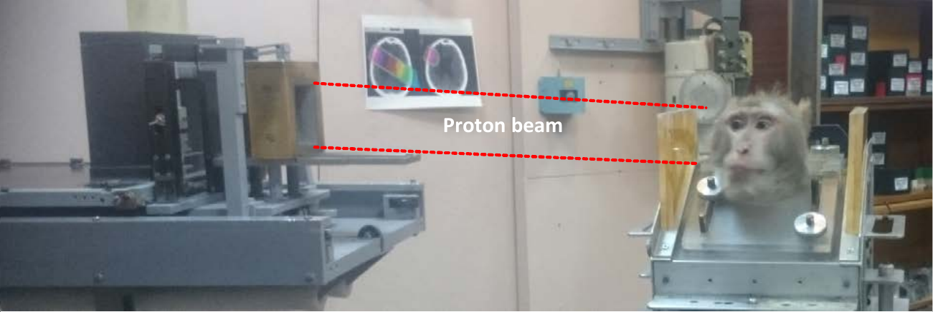
Fig. 2. First experiments on primate irradiation at a medical proton beam.
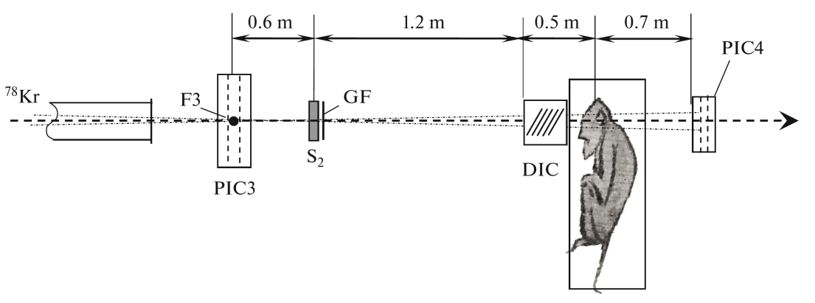
Fig.3. A scheme of monkey irradiation with the ⁷⁸Kr ion beam at the Nuclotron (VBLHEP), showing the scintillation counter (S₂), radiochromic film (GF), dosimetric ionization chamber (DIC), and multiwire proportional ionization chambers (PIC3 and PIC4).
- Molecular radiobiological aspects of radiation therapy
Earlier LRB's research showed that the cell exposure to γ-rays and particles in the presence of DNA synthesis inhibitors cytosine 1-β-D-arabinofuranoside (AraC) and hydroxyurea (HU), which transform non-lethal simple DNA lesions into enzymatic DSB (eDSB), increases the biological effectiveness of radiation. The DNA DSB formation by accelerated proton exposure in the presence of modifying agents increased by a factor of 15 for up to 24 h post-irradiation (Fig. 4) due to the increased eDSB yield, while the minimal yield was observed without modifiers. AraC and HU are officinal drugs used clinically for the treatment of different tumors.
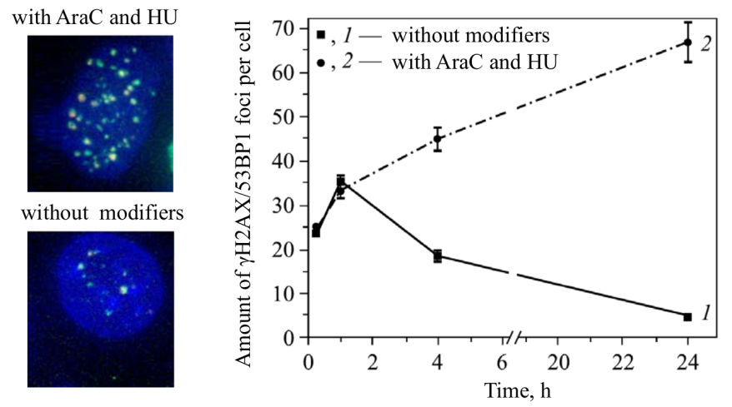
Fig.4 Images of individual RIF (γH2AX/53BP1 foci) after 24 h and the kinetics of their formation and elimination in human cell nuclei after exposure to Bragg peak protons (170 MeV, 1.25 Gy) under normal conditions and in the presence of AraC and HU.
- Mathematical modeling of radiation-induced effects
Mathematical and computer modeling is performed to explain and predict the results of the LRB's radiobiological experiments at the Institute's nuclear physics facilities. The modeling of radiation-induced mutagenesis and Monte-Carlo simulation of energy deposition in particle tracks have been performed. The computation of radiation damage to the CNS structures was recently started and is continued independently by NASA and the LRB.
- Radiation research
The LRB's specialists participate in the design of the shielding of the NICA collider and booster and prediction of the radiation environment at the NICA complex. For the surveillance of the NICA collider's radiation conditions and establishment of zoned radiation monitoring, a portable autonomous multi-sphere neutron spectrometer has been developed.
The LRB is involved in the design of nuclear planetology instruments. Together with the FLNP and SRI RAS (Moscow), an experimental stand with fast neutron generators has been put into operation to test and calibrate planetological neutron detectors, where space equipment is tested on a model of planetary soil.
- Astrobiology
In recent pioneering experiments performed at JINR in cooperation with its Italian colleagues on the irradiation of water solutions of formamide (NH₂COH) with 170 MeV protons and 500 MeV/n carbon ions in the presence of meteorite matter as a catalyst, production of a wide range of prebiotic compounds has been observed, including nucleic bases, carboxylic acids, sugars, and amino acids. These compounds were not found previously in experiments with the thermal factor instead of radiation.

International networking and context
In carrying out research, the LRB collaborates with the following scientific institutions of JINR Member and other countries: Armenia (YSU), Belarus (IRB NASB), Bulgaria (IE BAS, IM BAS, NCRRP), the Czech Republic (CTU, IBP ASCR, NPI ASCR), Italy (UNITUS, UNIUD, La Sapienza Univ.), Mongolia (NUM), Poland (SzU), Romania (IBR, UMF, UAIC), Russia (IBP RAS, IP, MSU, ITEP, IHNAN RAS, IMP, SRI RAS), and Slovakia (CU).
The main advantage of conducting research at the LRB is the availability of multiple radiation sources, including heavy ion beams of different energies. JINR's basic facilities offer an excellent opportunity of modeling the biological action of space radiation. The LRB is one of the world’s few laboratories where it is possible to conduct large-scale in vivo animal exposures, including unique experiments on primates. The use of a primate animal model for the estimation of radiation risks of CNS disorders and carcinogenesis is at present available only at the LRB. In addition, the computational studies of radiation damage to the CNS structures were initiated exclusively by NASA and the LRB. The code developed by the LRB to model energy deposition in neurons has been included in the distribution of Geant4-DNA Monte-Carlo simulation toolkit. For the first time, the synthesis of prebiotic compounds in the “formamide + catalysts” system under exposure to particle beams has been performed at the LRB in collaboration with scientists of the University of Tuscia (Viterbo, Italy) within the framework of research on the Panspermia hypothesis.

Infrastructure
Equipment
The Laboratory of Radiation Biology (LRB) occupies two separate buildings located 2 km from each other. The LRB's main building (Building 113) is home to the Molecular Radiobiology, Cytogenetics, Mathematical Modeling, and Lower Eukaryote Genetics Sectors; the Department of Radiation Research, Laboratory's Directorate, technical and logistic services, and classrooms of Dubna University's Department of Biophysics. At Building 71, the Radiation Physiology and Astrobiology Sectors and a vivarium with support services are located.
Sources of ionizing radiation
JINR's following sources of photon and particle ionizing radiation are used in the radiobiological research conducted by the LRB (Fig.5):
- ⁶⁰Co γ-radiation source at the Rocus-M facility (DLNP MTC)
- 170 MeV and SOBP medical proton beams (DLNP MTC)
- U-400M accelerator (FLNR) equipped with the Genome-M facility for the automatic irradiation of thin biological samples. The experiments were performed with 20–50 MeV/n boron, nitrogen, and oxygen ions.
- Nuclotron (VBLHEP) (Fig.6) with external beamline for irradiation of samples and objects. Experiments were performed with 500 MeV/n carbon ion beams, and a single exposure to 2.5 GeV/n ⁷⁸Kr ions was conducted.
The biological action of particle beams is described in terms of Relative Biological Effectiveness (RBE), defined as a ratio of absorbed doses which produce the same biological effect RBE= D_{γ}/D_{ion} | iso-effect. In our work, ⁶⁰Co γ-radiation is used as reference radiation.
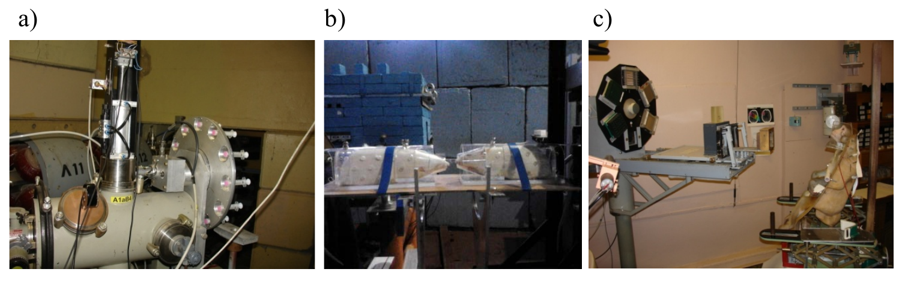
Fig.5 Irradiation of biological objects at JINR facilities: a) The Genom-M facility at the U-400M cyclotron (FLNR); b) Irradiation of rats at a Nuclotron ion beam (VLHEP); c) Irradiation of monkeys at the DLNP medical proton beam.
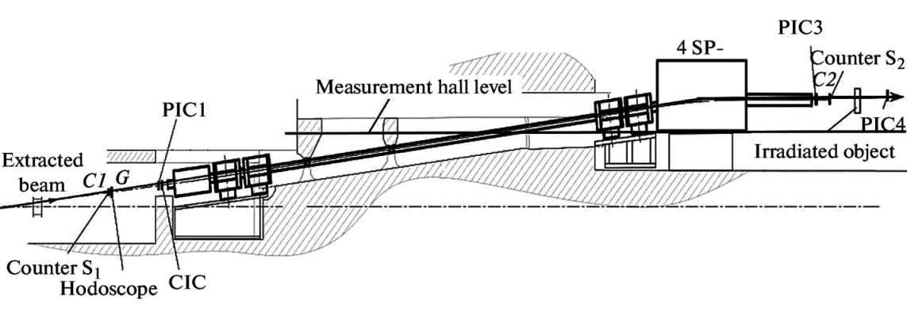
Fig.6 A schematic layout of the Nuclotron beam extraction channel and beam detectors behind the irradiated biological objects.
Education and Personnel policy
The LRB's total staff is 97, approximately a half of them are young researchers below the age of 35.
For more than 20 years, the Department of Biophysics, Dubna State University, has been offering graduate and postgraduate programs, including bachelor's education in nuclear physics and technology (the program Human and Environmental Radiation Safety); master's education in physics (the program Radiation Biophysics and Astrobiology); and postgraduate education in radiobiology. The Department meets the LRB's demand for young staff.
The LRB also participates in the training and educational programs for young specialists and students from JINR Member States and other countries organized by the JINR University Center.

future research projects
The LRB’s radiobiological experiments planned at JINR’s accelerated charged particle beams will be focused on studying heavy ion action at the molecular, cellular, tissue, and organism levels of biological organization. Special attention will be paid to research on ‘experimental animals' CNS disorders because the CNS must be considered a critical system when evaluating the radiation exposure risk for the interplanetary mission crews and considering the possible side effects of the radiotherapy of brain tumors.
- Molecular radiobiology
It is planned to continue at the LRB research on DNA clustered damage induced by densely ionizing radiation and its repair in CNS cells and tissues with a view to evaluating the risk to astronauts associated with GCR exposure during deep space flights, as well as the specifics of DNA repair in radiation-resistant tumor cells in order to search for new approaches to the radiation therapy of cancer.
Main topics of future research
- Evaluation of the induction of clustered DNA DSBs by high-LET heavy ion exposure and their repair kinetics in radiation-resistant U87 glioblastoma tumor cells using the fluorescent labeling of the repair proteins γH2AX, 53BP1, OGG1, and XRCC1.
- Studying the formation and elimination kinetics of clustered DNA DSBs after accelerated heavy ion exposure in the nuclei of human neural stem cells, mature neurons, and glial cells using the immunocytochemical staining of the repair proteins γH2AX and 53BP1 in combination with the cell subpopulation markers NeuN, doublecortin, GFAP, BrdU, and calbindin.
- Studying the pattern of damage formation and elimination in vivo in different rodent CNS structures at different times (up to three months) after exposure to γ-rays and high-LET heavy ions.
- Investigation of the internal structure of clustered radiation-induced foci (RIF) produced by high-LET ion beams using confocal and single molecule localization microscopy (high-resolution nanoscopy).
- The contribution of different repair pathways (non-homologous end joining (NHEJ) and homologous recombination (HR)) to clustered DNA damage elimination in human fibroblasts after exposure to photons, protons, and heavy ions will be determined using the immunocytochemical staining of the repair proteins γH2AX, RAD51 (HR), and 53BP1 (NHEJ).
- Studying apoptosis induction in human skin fibroblasts and mammalian CNS neurons after high-LET heavy ion exposure; studying the kinetics and level of the expression of the genes which encode proteins involved in apoptosis.
- Radiation cytogenetics
A new technique of multicolor Fluorescent in situ Hybridization (mFISH) was recently introduced at the LRB, which allows identification of each pair of human and animal chromosomes and detection of all possible rearrangements between them including complex CA (three and more breaks in two and more chromosomes) (Fig. 7). Complex CA are considered a marker of high-LET radiation exposure and reflect the cluster character of DNA damage formation along the particle tracks. This type of CA was undetectable by routine methods.
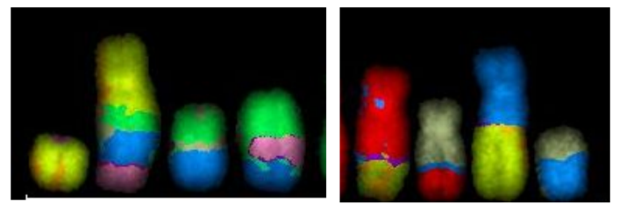
Fig. 7. An mFISH visualization of complex chromosome aberrations
The mFISH method is of much promise concerning the long-term consequences of the organism's radiation exposure since it allows the evaluation of heritable symmetric aberrations: translocations which can persist for a long time after exposure in the progeny of irradiated cells.
Main topics of future research
- mFISH evaluation of the biological effectiveness of therapeutic proton beams (150 MeV and of SOBP proton beams, the DLNP medical technical complex) on human normal (lymphocytes) and tumor (Cal51 carcinoma) cells. The action of accelerated protons on human normal and tumor cells has not yet been studied by the mFISH method.
- mFISH evaluation of the biological effectiveness of 30–50 MeV/n ¹⁴N and other ions at the U400M (FLNR). The action of 30–50 MeV/n heavy ion beams, which have high biological effectiveness, has not yet been studied.
- To contribute to space research-relevant radiation risk assessment, the evaluation of long-term consequences of radiation exposure will be performed. In parallel to in vivo studies of the radiation-induced CNS damage (see Molecular Radiobiology and Radiation Physiology), it is planned (this requires no additional number of animals) to evaluate CA induction in bone marrow and blood cells of animals (mice, rats) at different times after exposure (up to 6–8 months) to γ-rays, protons (DLNP MTC), and 250–800 MeV/n heavy ions (Nuclotron). For this study, mFISH will be combined with the standard metaphase assay.
- The evaluation of CA in primate blood by the standard metaphase assay will be performed within the framework of radiation physiology research on primates along with studying the response of the hematopoietic, immune, and other regulatory systems of the organism to radiation exposure.
- Radiation physiology
It has been shown that heavy charged particle exposure of laboratory animals even to low doses leads to a serious disorder of mental and motor functions [2]. Therefore, the main goal of future radiation physiology research at the LRB will be to contribute to space research and estimate the health risks to the astronauts from radiation exposure to GCR during manned space flights — mainly, the ergonomic risk of CNS disorders.
To clarify the possible mechanisms of radiation-induced CNS damage and cognitive deficit, it is planned to investigate the glial cells' vital role. Demyelination is considered as one of the most probable causes of ionizing radiation-induced cognitive deficit, due to the radiation-induced death of oligodendrocytes [3]. Another probable cause is a chronic neuroinflammation caused by activated microglia [4]. Both mechanisms were recently shown to play a role in different neurodegenerative diseases like multiple sclerosis, Huntington's, Parkinson's, and Alzheimer's. However, no progress has been made in understanding the basis of radiation-induced cognitive disorders.
Main topics of future research
- Morphofunctional changes in the CNS after exposure to sparsely and densely ionizing radiation. To evaluate the damaging action of γ-rays, protons (DLNP), and 250–800 MeV/n heavy ions (Nuclotron) on the CNS structure and functions, it is planned to perform a whole range of histological studies of the rodent brain and spinal cord using light, fluorescent, and electron microscopy. Immunohistochemical methods are going to be used to identify neurodegenerative changes, neuroinflammation, apoptotic and necrotic changes, amyloid growths, and vascular pathologies. Morphometric parameter analysis will be done using scanning systems and the ImageJ program.
- The functional condition of the CNS in these experiments will be evaluated using a whole set of modern zoopsychology techniques and equipment, including test systems for assessing long-term and short-term memory, emotional reactivity, the anxiety level, and motor reflexes. Behavior parameters will be analyzed with modern video tracking tools, the Noldus Ethovision software package, and the newest electrophysiological equipment.
- Suppression of neurogenesis after ionizing radiation exposure of rats in the postnatal period will be studied.
- It is planned to perform in vivo and in vitro exposures to γ-rays, protons (DLNP MTC), and heavy ions (VBLHEP Nuclotron) to evaluate the damage to glial cells.
- Radiation-induced immune response will be studied in mouse brain homogenates and in glial cell culture after exposure to sparsely and densely ionizing radiation. In particular, it is planned to determine the level of the secretion of pro-inflammatory cytokines, including Il-1 beta, Il-6, TNF alpha, and MCP-1, at different times after exposure.
- The influence of sparsely and densely ionizing radiation on the viability of oligodendrocytes and their precursors and on the axon myelination level will be studied. With this aim, it is suggested to do the immunochemical analysis of the brain tissue in histological sections and in cell culture using antibodies to the NG2 and PDGFR proteins (OPC markers) and MBP, O4, and MOG (mature oligodendrocyte markers).
- In a search for radioprotectors, it is planned to test on rodents pharmacological drugs, biogenic amines, and antioxidants or their combinations concerning the prevention and therapy of damage caused by chronic radiation exposure.

- Radiation physiology research on primates
The radiation physiology research on primates will be performed in collaboration with the RAS Institute of Biomedical Problems, RAS Institute of Medical Primatology, RAS Institute of Higher Nervous Activity and Neurophysiology, and Moscow State University. It will include evaluation of the higher nervous activity; studying the response of the hematopoietic, immune, and other regulatory systems of the organism to radiation exposure; studying the long-term effect of exposure on lifetime and cancer development; and estimation of the radiation risk of an interplanetary mission based on the obtained experimental data.
The research will be performed on 3.5–5-year old Macaca mulatta monkeys divided into two groups of the same number of monkeys (the experimental and control ones), 10–15 animals in each.
Main topics of future research
- In deep space flights, of the highest danger will be high-energy heavy charged particles. Therefore, the action of accelerated charged particles (high-energy protons at DLNP; 250–800 MeV/n heavy ions at VBLHEP Nuclotron) on the cognitive functions of monkeys will be studied. Irradiation of specific brain structures requires a narrowly collimated heavy ion beam at the Nuclotron and a special beam line with adequate optics and collimators is foreseen.
- It would be optimal to model the space flight radiation factors using prolonged γ-exposure (chronic) at doses corresponding to the interplanetary flight conditions and periodic high-energy proton and heavy ion exposures.
- Research on the synchronous combined action of anti-orthostatic hypokinesia (AOH) and prolonged γ-irradiation on the CNS functions. It is planned to irradiate monkeys fixed on an AOH table and, immediately during exposure, study learning processes and repeating operator activity skills.
- During these experiments it is planned to study:
a) The cognitive disorders, using an automated computer psychomotor test system for the continuous monitoring of the capacity for mental work, the active wakefulness level, and motivation;
b) The neurochemical mechanisms of higher nervous activity disorders: to evaluate the activity ratio of the neuromediator to neuromodulator brain systems;
c) The electrophysiological changes in different brain structures — based on the electroencephalography and magnetic resonance imaging;
d) The hematological changes (clinical blood test once in two months) and evaluation of bone marrow hematopoiesis (once in four months).

e) Molecular radiobiological aspects of radiation therapy
The biological effectiveness of the particle beam plays an important role in tumor treatment. It depends on many factors, which can be subdivided into two groups: physical (LET, dose rate, etc) and biological — in particular, the cell repair status. The transformation of non-lethal simple DNA lesions into lethal eDSBs by the regulation of DNA repair processes in the presence of special modifiers is a potential way to increase the biological effectiveness of gamma and proton medical beams. A combined application of special drugs and radiation exposure can be promising for radiation therapy as it would bring the area of the therapeutic use of protons closer to that of carbon ions.
Main topics of future research
- Evaluation of the effect of DNA synthesis inhibitors on the survival of normal human cells after SOBP proton and photon exposure (by the criteria of colony formation and apoptosis progress).
- Studying the effect of DNA synthesis inhibitors on foci induction in radioresistant human tumor cells (in particular, glioblastoma) by accelerated protons and γ-rays.
- Studying the effect of DNA synthesis inhibitors on the biological effectiveness of proton and γ-ray exposure in vivo. DNA DSB induction in different parts of the central nervous system by proton and γ-ray exposure with and without radiomodifiers will be studied in experiments on rodents.
- Preclinical animal studies: evaluation of the modifying effect of DNA synthesis inhibitors on the efficiency of proton treatment of transplanted tumors (in particular, melanoma) in mice.

f) Mathematical modeling of radiation-induced effects
Future work will be focused on the development of the hierarchy of models that would allow systematizing experimental data and studying the pathways of how radiation-induced pathologies develop at different organization levels (from the molecule to cell population) and time scales (acute and long-term radiation effects). The supercomputer of the JINR Multifunctional Information and Computing Complex will be used. As the result, this multi-level calculation scheme would allow a theoretical evaluation of the radiation risk.
Main topics of future research
- Monte Carlo simulation of energy deposition events and water radiolysis in the tracks of charged particles hitting brain cells and structures (Fig. 8). It is suggested to model the passage of monoenergetic particle beams and radiation fluxes corresponding to GCR spectra and secondary radiation particles produced in different shielding types.
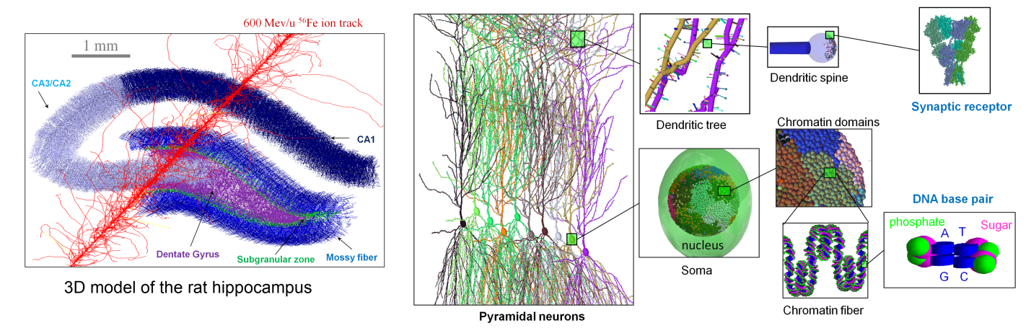
Fig. 8. A Monte Carlo simulation of a 600 MeV/n ⁵⁶Fe ion track structure in a three-dimensional model of the rat hippocampus. Also shown are elements of the pyramidal neuron layer and the main targets at the cellular level.
- Modeling the formation and distribution of the main types (e.g. DNA base lesions, single- and double-strand breaks) of molecular damage in the following targets: the cell nucleus and DNA, cytoskeleton, mitochondria, membrane ion channels, and synaptic receptors. A method to compute the probabilities of bond breakage, ionizations, and chemical modifications of biomolecules is going to be developed.
- Modeling DNA damage repair, and gene and structural mutation formation after accelerated heavy charged particle exposure. The influence of the possible repair pathways and the spatial distribution of lesions on the efficiency of their detection and repair will be studied. A detailed analysis of the most probable mutation types will be performed for selected genes.
- Molecular dynamics studies of the effect of genetic mutations or chemical modifications on protein structures and analysis of changes in their functional activity.
- For modeling radiation-induced oxidative stress emerging as a consequence of heavy charged particle passage through the cell, a nonlinear dynamic model will be developed. The obtained data will become the basis for mathematical models of intracellular transport and signaling disorders.
- Modeling radiation-induced cell population dynamics and neurochemistry, including suppression of neurogenesis and gliogenesis, demyelination, and neuroinflammation, which affect the activity of the brain neural networks.
- Simulating the functional activity of brain neural networks after accelerated heavy charged particle exposure. This will lead to a theoretical evaluation of possible cognitive disorders, which can be compared with observed behavioral reactions, electroencephalography data, and functional magnetic resonance imaging.

g) Radiation research
Main topics of future research
- Improvement of accelerator-based radiobiological experiment techniques
a) Work is underway on the construction of two beam lines at the Nuclotron (VBLHEP) for applied research in materials science and radiobiology at heavy ion beams (250–800 MeV/n carbon, neon, argon, iron, and krypton ions). Emphasis must be given to the needed beam specifications and to the experimental area for handling primate irradiation.
b) The Nuclotron-based modeling of radiation fields generated by GCR inside spacecraft in deep space. An irradiation facility reflecting the hadron exposure in Space with continuous particle energy spectra could be constructed after the completion of the NICA project.
c) The upgrade of the LRB's Genome-M irradiation facility at the U-400M (FLNR) allows for increased energies of accelerated ions up to 100 MeV/n. It will make it possible to irradiate the brain of small laboratory animals (mice and rats) with higher LET ion beams compared to those at the Nuclotron. The highest energy of the ions extracted from U-400M is now about 50 MeV/n.
- Surveillance of the NICA collider's radiation conditions and establishment of zoned radiation monitoring using portable autonomous multi-sphere neutron spectrometers.
- Monte Carlo calculations of radiation transport in matter with the MCNPX, GEANT4, and FLUKA software toolkits for the realistic estimation of astronauts' effective doses for different flight duration, solar activity, and radiation shielding of habitable module.

h) Astrobiology
Astrobiological research will be an attempt to represent a sequence of processes that can result in the formation of a complete, chemically active prebiotic medium. It is planned to continue the experiments on radiation exposure of the formamide+catalysts system to find (I) the optimal conditions for prebiotic compounds synthesis and (II) the conditions under which the oligo- and polymer biomolecules can be assembled.
Main topics of future research
- Studies of the possible sources, ways, and conditions of the formation of the first prebiotic compounds. To find the optimal ways of prebiotic compound synthesis, it is planned to include in research the synthesis of prebiotic compounds from NH₂COH in the presence of catalysts from meteorite material: (I) at different energies of charged particles (50, 155, 500 MeV/n); (II) in combination with thermal and ultraviolet exposure; (III) in the presence of catalysts of terrestrial origin; (IV) in the presence of liquid water; (V) in the presence of components of terrestrial hydrothermal systems. Next steps will be to demonstrate clearly the synthesis of nucleosides from a mixture of a nucleic base and sugar exposed to a 170 MeV proton beam and the synthesis of nucleotides — elements of DNA and RNA — from a mixture of nucleosides and phosphate groups under radiation exposure; as well as to find the conditions under which oligo- and polymer biomolecules can be assembled.
- Micropaleontological studies of meteorites and terrestrial rocks. The LRB performs scanning electron microscopy studies of organic matter and microfossils in meteorites and terrestrial rocks. It is planned to increase the LRB's meteorite collection and prepare microfossil atlases for a number of meteorites.

infrastructure development
Equipment
The LRB's further development requires no new space for equipment and staff. For the development of future research in molecular radiobiology and cytology, it is planned to purchase the following equipment:
- A four-laser flow cytofluorimeter sorter Becton Dickinson FACSAria III with accessories and reagents for genetic engineering (~45–50 million rubles).
- A system of cytogenetic image scanning, processing, and analysis MetaSystems Metafer (~11 million rubles).
- A station for automated cell cultivation and analysis Biostation IM-Q (~6 million rubles).
- A real-time amplifier capable of providing a temperature gradient (~2 million rubles).
- A gel- and chemodocumenting system with a built-in transilluminator (~0.5–1 million rubles).
- A solid state thermostat with cooling and mixing features for conducting restriction and ligation reactions (~350 thousand rubles).
To conduct research in radiation physiology, it is planned to purchase the following equipment:
- A fluorescent tomography system FMT4000 for animal imaging in vivo (~2 million rubles).
- A hematological analyzer of animal blood corpuscles Mindray BC-2800 Vet (~400 thousand rubles).
The infrastructure necessary for the computational experiments will be upgraded to reach performance of up to 5 TFLOPS using a CPU (double precision) and 100 TFLOPS using a GPU (single precision) (~3.5 million rubles).
Required ionizing radiation sources
Accelerator beam-based research will be further conducted at JINR's three laboratories:
- At the 170 MeV and SOBP medical proton beams of the DLNP Medical Technical Complex.
- The 230 MeV superconducting SC200 proton accelerator, which is being created jointly with Chinese specialists as a replacement of the DLNP's Phasotron, will be actively used by the LRB's radiobiologists.
- At the U-400M accelerator (FLNR). The planned upgrade of the accelerator will increase the beams' energies up to 100 MeV/n, and it can significantly broaden the range of their applications (in particular, animal exposures will be possible).
- The key to the successful fulfillment of the 2030 Program is the possibility to conduct radiobiological research at the Nuclotron (VBLHEP) after NICA project completion. Of the greatest interest for fundamental and applied radiobiological research will be carbon, iron and iron-group beams with energies of 250–800 MeV/n.
- At all JINR accelerators with LRB plans for irradiation, needed radiobiological irradiation facilities must be designed and produced with proper beam optics and monitoring, as well as an adequate experimental target area for irradiation of samples, objects and animals. Support of engineers and technicians from the accelerator laboratories is needed, but training and creation of LRB staff in these technologies is foreseen.
The demand for beam time for radiobiological experiments at each accelerator is about 200–250 hours per year. In the future, after FAIR project completion at the GSI, it will be highly practical to conduct similar radiobiological experiments there with the LRB's colleagues from other countries.
International Cooperation
The LRB's staff participation in the development of applied packages for the GEANT4-DNA modeling software toolkit will be continued as closer work with the GEANT4 Collaboration — in particular, as participation in the organization of specialized workshops. As promising area of cooperation in neurophysiology is joint work with the LRB's partners in Cuba (CAS, CEA, CNEURO). The LRB is a member of the recently formed International Biophysics Collaboration, which coordinates radiobiological and medical research at NICA, FAIR, RAON, ELIMED, FRIB, and other facilities. This will ensure closer collaboration with GSI (Darmstadt) and elaboration of the program of joint research at NICA and FAIR beams.
Human resources development
The Department of Biophysics, Dubna State University, meets the LRB's demand for young staff, and this practice must be continued in the future. To solve the top priority tasks set in the Program, attraction of highly qualified specialists is needed. For this purpose, JINR seeks outstanding postdoctoral fellows and announces calls for applications for a number of vacant positions in the framework of the Distinguished Postdoctoral Research Fellowship Program. In addition, positions for a small team of specialized beam technicians, engineers and physicists will be opened in order to meet the need for proper operation of the complex irradiation programs.

summary
The great advantage of conducting research at the LRB is the availability of numerous radiation sources, including heavy ion beams of different energies. JINR's basic facilities offer an excellent opportunity of modeling the biological action of space radiation. The LRB has proposed a novel Nuclotron-based technique of modeling of radiation fields with continuous particle energy spectra generated by GCR inside spacecraft in deep space.
Another major advantage is an excellent opportunity to perform large-scale in vivo animal exposures in collaboration with leading experts in this field — first of all, with RAS Institute of Biomedical Problems. The worldwide unique experiments on primates for the estimation of radiation risks of CNS disorders and carcinogenesis are in progress at the LRB.
A new method of the enhancement of low-LET ionizing radiation’s biological effectiveness by the transformation of non-lethal DNA damage to lethal has been invented and recently patented by the LRB. The method has been tested in vivo and in vitro, which makes it very promising for radiation medicine.
The LRB develops the hierarchy of mathematical models to simulate radiation-induced pathologies at different organization levels and time scales. In addition to the traditional Monte Carlo technique, the LRB's approach involves computational methods from different knowledge areas (molecular dynamics and simulation of brain neural networks). The computation of radiation damage to the CNS structures was initiated and is continued by NASA and the LRB.
For the first time, the synthesis of prebiotic compounds in the “formamide + catalysts” system under exposure to particle beams has been performed in collaboration with Italian universities within the framework of research on the Panspermia hypothesis.
All of the above provides confidence that the LRB will become an essential part of the International Biophysics Collaboration and will be an important player in the field of modern radiobiology.
The key to the successful fulfillment of the 2030 Program is the possibility to conduct radiobiological research at the Nuclotron (VBLHEP) after NICA project completion.

[1] Grigoryev A.I., Krasavin E.A., Ostrovsky M.A. On the evaluation of the risk of the biological action of galactic heavy ions during an interplanetary flight. Russ J Physiol 99 (2013) 273.
[2] Britten R.A., Davis L.K., Johnson A.M., et al., Low (20 cGy) doses of 1 GeV/u 56Fe-particle radiation lead to a persistent reduction in the spatial learning ability of rats, Radiat. Res. 177 (2012) 146. DOI: 10.1667/rr2637.1
[3] Piao J., Major T., Auyeung G., et al. Human embryonic stem-cell derived oligodendrocite progenitors remyelinate the brain and rescue behavioral deficits following radiation. Cell Stem Cell. 16 (2015) 198. DOI: 10.1016/j.stem.2015.01.004
[4] Lumniczky K., Szatmari T., Safrany G. Ionizing radaiation-induced immune and inflammatory reactions in the brain. Front. Immunol. 8 (2017) 517.
DOI: 10.3389/fimmu.2017.00517

