Version: June 2019
STRATEGIC LONG-RANGE PLAN FOR HEAVY ION AND SPIN PHYSICS

Executive Summary:
From the beginning of the relativistic heavy ion research in the early 1970’s, JINR has been an important player with its on-site program at the Synchrophasotron, and then Nuclotron , and its participation in the heavy ion program at the CERN-SPS first in WA98, and NA49, then in ALICE. The Spin physics was also a key program at the Synchrophasotron and has been expanded at the Nuclotron. Both these research areas have been the source for the Mega-Science project NICA and the Long Range Plan presented below. The dominant tasks in the near and long-term future are:
- The timely completion of the construction of the NICA project, its commissioning and a smooth operation
- Completion of the detectors, the BM@N and the MPD and SPD at NICA and successful data collection over the decades to come
- After several years of running in the start version of MPD, an Upgrade of the MPD detector is foreseen, responding to a possible increase in luminosity of NICA, and by adding detectors in the forward rapidities as planned in the original layout of MPD.
- Studies of possible future extension of NICA for acceleration of electrons, opening new physics potential via e-p and e-A collisions.
To operate the infrastructure of the NICA accelerator complex, it is planned to increase the number of staff of the laboratory to 1,000 employees. The total estimated number of scientists and specialists involved in conducting of the research at the NICA complex will reach 3000 by 2035.
Furthermore, of strategic importance is the JINR participation in fore-front external experiments off-site, like, e.g., at existing facilities, like at LHC, SPS, RHIC and STAR, and at facilities under construction, like, e.g., the international FAIR-facility in Germany, or in planning, the proposed electron-ion collider (EIC) facility in the USA
The JINR strategy for cooperative research at other accelerator centers will be linked closely to the updated European Strategy for Particle Physics, expected to be available in 2020.

The NICA project
For the next two decades, the principal focus in heavy ion physics and spin physics, that will influence to a large extend the JINR strategic development as a whole, is the completion and full exploitation of the mega-science project NICA. NICA is the JINR flagship facility in high-energy heavy ion and spin physics. The project has been approved by the JINR Committee of Plenipotentiaries and has been supported by a separate agreement between the government of the Russian Federation and the JINR “For construction of the basic configuration of the Nuclotron-based Ion Collider fAcility (NICA)”.

The aim of the NICA project is to create a world-class experimental base for conducting fundamental research in contemporary High Energy Physics (HEP) as well as applied research in microelectronics, medicine and biology making use of accelerator and beam technologies.
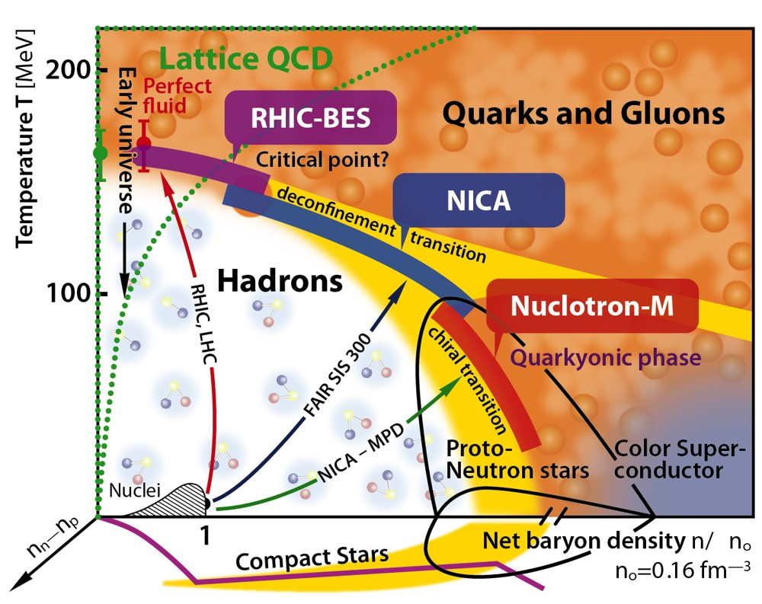
Figure 1. QCD phase diagram

The main goals comprise investigation of hot and dense strongly interacting matter, search for a mixed phase and critical point in the QCD phase diagram (see fig.1) in the poorly explored region of high baryon chemical potential and clarify the basis of QCD in the non-perturbative regime and other theoretical approaches for the description of strongly interacting matter. The NICA energy range (√s_{NN}=2-11 GeV for heavy ion collisions) is believed to be particularly interesting because it covers the region of maximal net baryon density at the time of “freezing”. In this regime, the system takes a maximum amount of space-time in the form of a mixed phase of quark-hadron matter where hadron and quark-gluon phases coexist. The NICA scientific program could shed light on key questions in the field of strong interactions, namely how to further probe the quark-gluon plasma and its two fundamental characteristics, deconfinement and chiral symmetry restoration, whether there is a first-order phase transition at high baryon density and what do we know about the multidimensional internal structure of the nucleon (distribution of charge, mass, spin...) and how to extract it.

The scientific program of the NICA project is included in the European Particle Physics Strategy plans as a part of the global European strategy.

The NICA facility shall be open not only to JINR and member state scientists but also to the international scientific community at large. The exploitation of the science at NICA is foreseen to be carried out in the framework of international collaborations centered around the three currently planned experiments, MPD and SPD at the Collider and BM@N at the Nuclotron.

JINR is committed to provide adequate facilities and infrastructure for outside users carrying out research at the NICA complex. This refers to short-term visitors as well as students and young scientists expected to spend extended periods of time at the laboratory. As such, the NICA facility shall play an important role in enabling the next generation of scientists in high-energy heavy-ion physics making new discoveries in physics.

The major components of the NICA complex are listed below:

1. Accelerator complex: It is composed of the upgraded superconducting synchrotron Nuclotron including extraction and transport beam lines; the injection complex (new heavy ion source, source for polarized particles and linear accelerator injectors); the new superconducting synchrotron Booster; the Collider consisting of two superconducting storage rings with two interaction points where collisions of heavy ions and polarized particles can be studied (see fig.2).
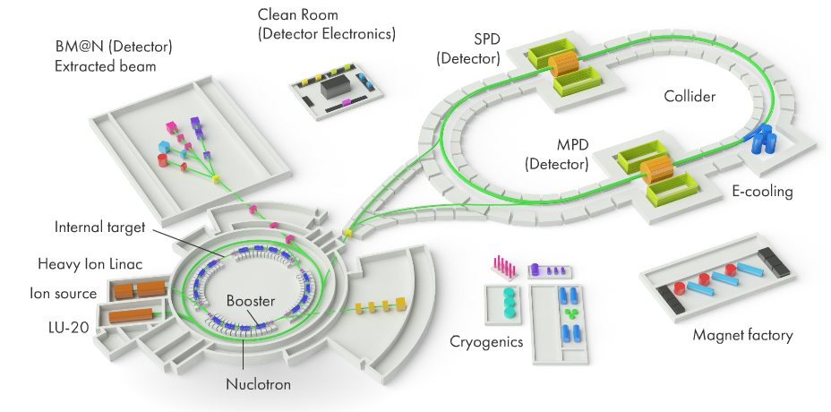
Figure 2. The NICA accelerator complex

2. Three experimental facilities:
BM@N – to study dense baryonic matter in fixed target experiments using extracted beams from the Nuclotron (see fig.3);

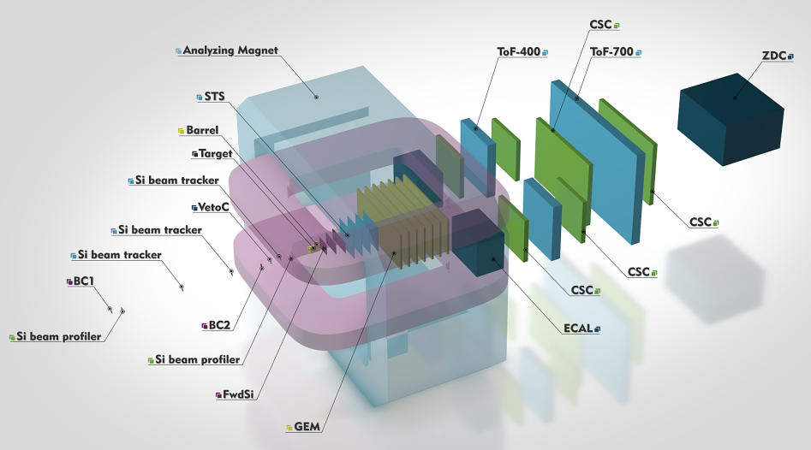

Figure 3. The BM@N experimental setup

MPD – to study dense baryonic matter created in heavy ion collisions in the Collider (see fig.4);
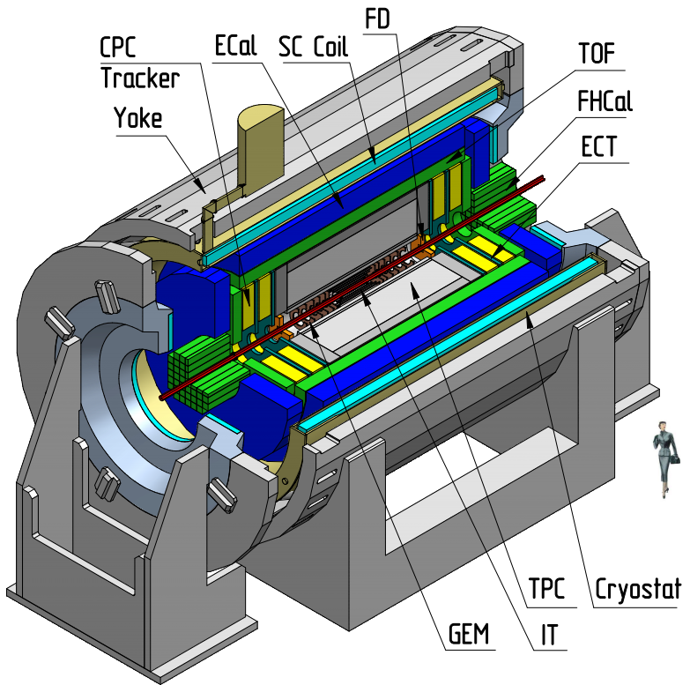
Figure 4. The MPD experimental setup

SPD – to study the nucleon spin structure and polarization phenomena by performing experiments with colliding polarized proton and deuteron beams (see fig.5);
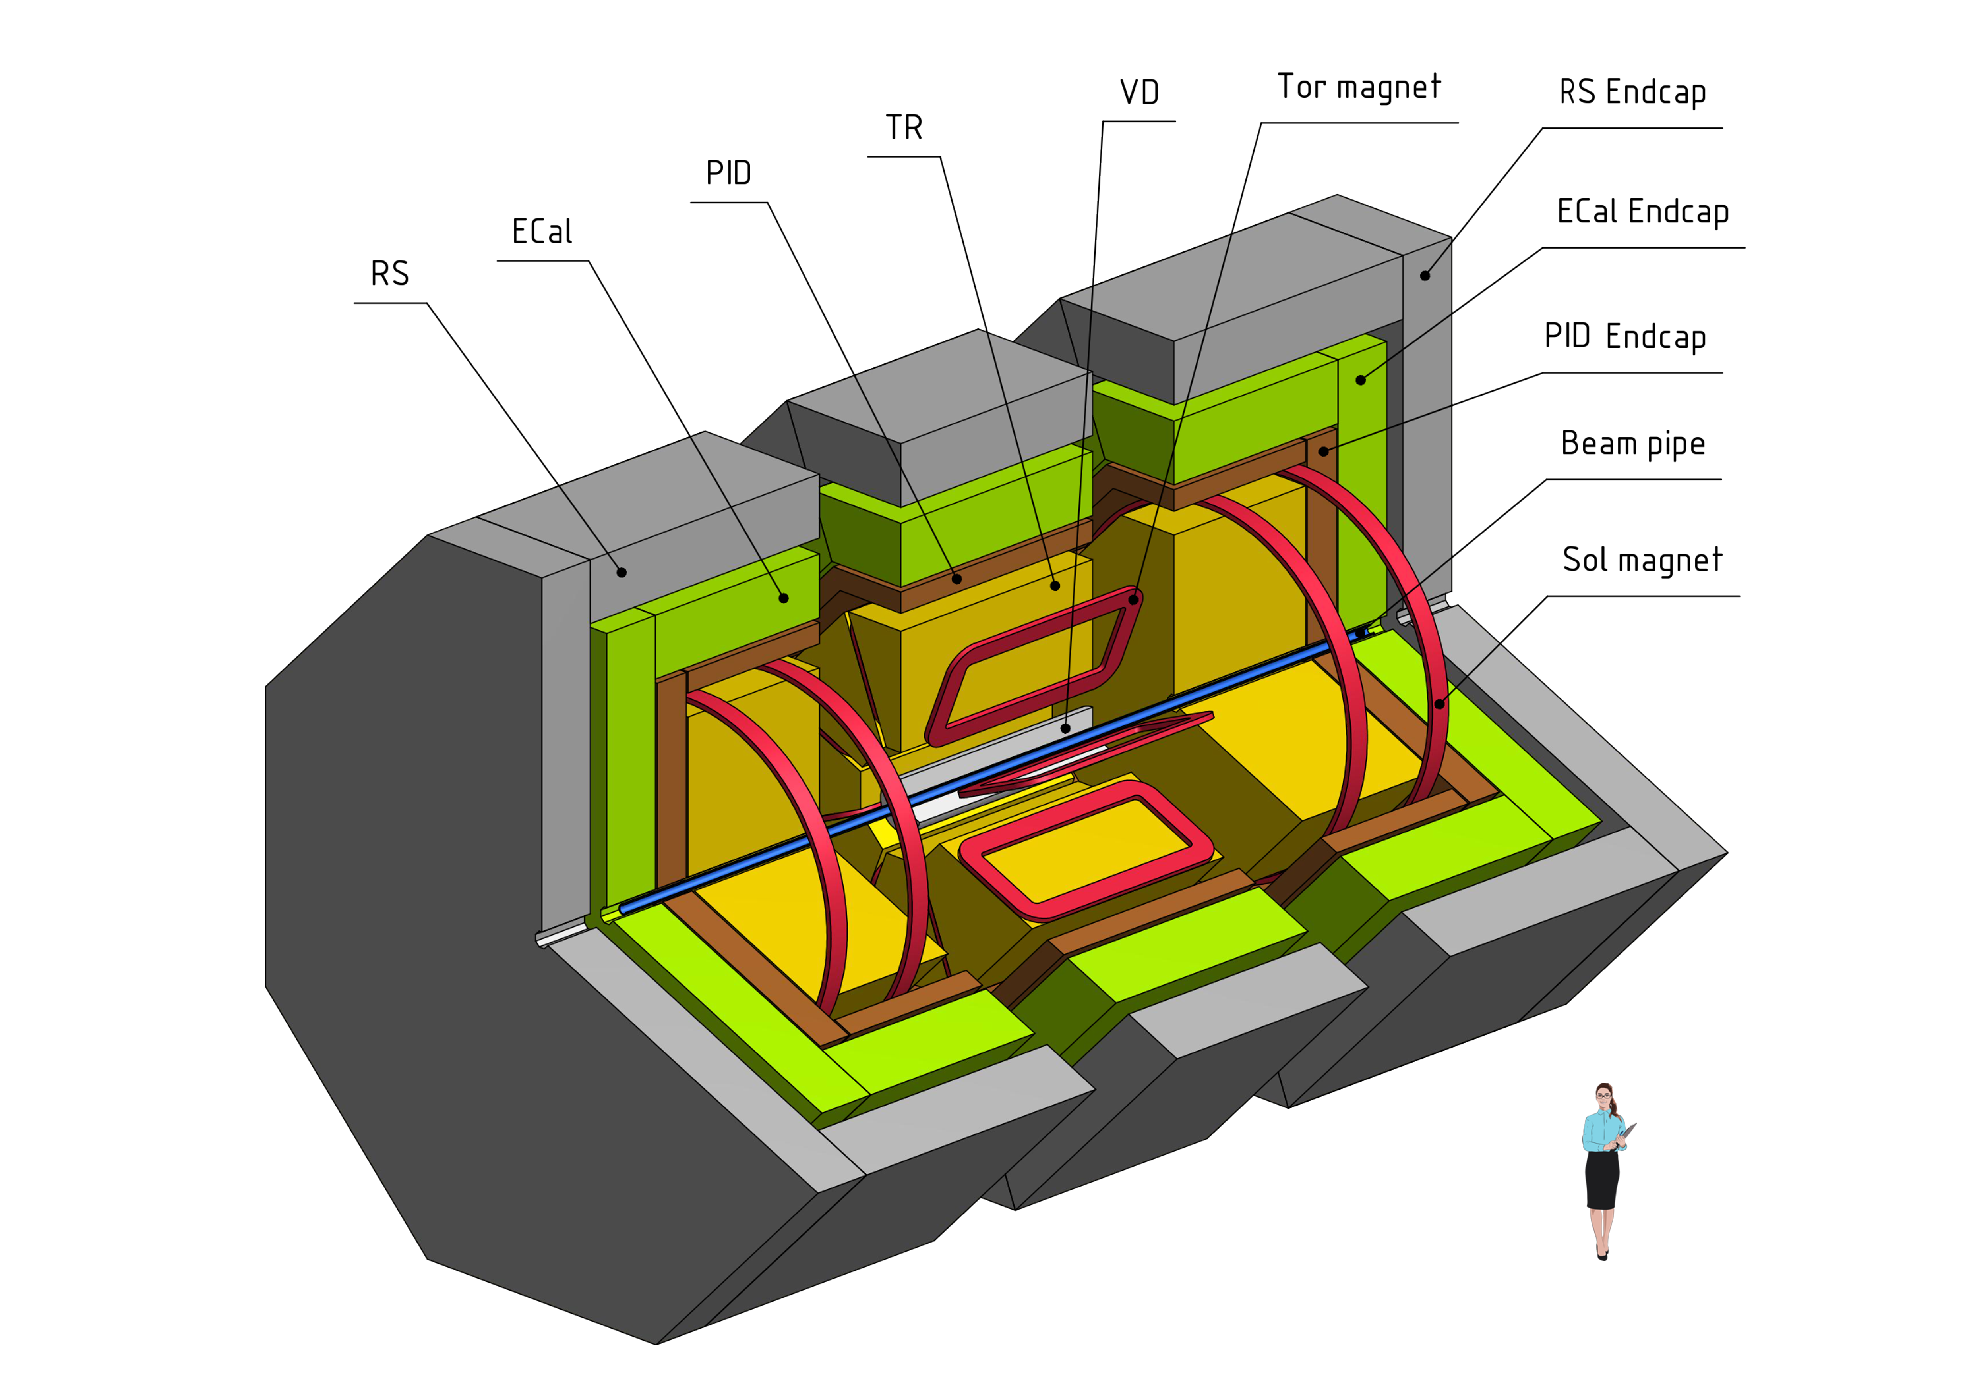
Figure 5. The SPD experimental setup

3. A complex of buildings: including the Collider complex and experimental halls for MPD and SPD detectors; NICA Innovation Center (see fig.6); experimental hall and areas for applied research; cryogenic complex building; buildings for energy supply systems, etc.;
4. Innovation block: including transfer channels and areas for innovation and applied research at the linear accelerators and with extracted Nuclotron beams;
5. Computing and information block: including an IT center with its respective networking infrastructure and a set of IT services for storing, processing and analysis of experimental data.

General information for the NICA complex is available at http://nica.jinr.ru. Detailed info is available at http://nucloweb.jinr.ru/nica/CDR.html. For the scientific program see the “White Paper” at: http://mpd.jinr.ru/wp-content/uploads/2016/04/WhitePaper_10.01.pdf. For the designs of the BM@N, MPD and SPD detectors look at http://nica.jinr.ru/files/BM@N/BMN_CDR.pdf, http://nica.jinr.ru/files/CDR_MPD/MPD_CDR_en.pdf and http://spd.jinr.ru/wp-content/uploads/2019/03/PAC_Text-ProjectSPD-NICA.pdf, respectively.

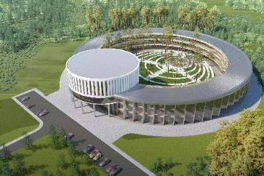
Figure 6. Artistic view of the NICA Innovation Center

According to the adopted Seven-year plan (2017-2023) for the development of the JINR the construction of the basic configuration of the NICA complex as well as the process of commissioning of its main components are expected to be completed by 2021 and the regular operational phase should start right after that.

A comprehensive report on the progress in construction of all the elements of the NICA complex achieved as of 2018 is available at http://nica.jinr.ru/docs/Report_NICA_SB_(12)_short.pdf

In the next 25-30 years, the potential of the NICA accelerator complex should be fully exploited and further developed. During the next ten years, this is foreseen as follows:

The commissioning of the basic Collider configuration and the first stage of the MPD facility should start at the beginning of the next decade. Right after that, studies of symmetric heavy ion collisions with luminosity L ~ 10²⁵cm⁻²s⁻¹ would become possible. Next, the completion of the MPD barrel part in its full configuration and commissioning of the full-scale BM@N set-up should be accomplished.
During the second half of the decade, the luminosity shall be increased to its design value of ~10²⁷cm⁻²s⁻¹. The MPD detector shall be supplemented with end-caps. Polarized proton and deuteron beams will be made available at NICA and experiments with them will start with the Spin Physics Detector (SPD) situated at the second interacting point of the Collider. The luminosity is expected to be in the range of 10³⁰-10³²cm⁻²s⁻¹. An interesting addition to the physics programs of both MPD and SPD would be the study of ultra-peripheral nuclear collisions.

Meanwhile, the upgrade of the Nuclotron beam extraction channels based on superconducting technology is foreseen. It will be supplemented by the construction of a superconducting magnetic energy storage device (SMES). R&D and project preparation for upgrading the magnetic system of the Nuclotron using, in particular, high-temperature superconductor is also envisaged.

Future lines of development of the NICA accelerator complex

In order to formulate strategic plans beyond 2030, four directions have been identified that are scientifically promising, technically feasible, and can be seen as natural extensions of the planned NICA program:

– Upgrading of the NICA rings to obtain asymmetric heavy ion collisions with luminosity L ~ 10²⁷ cm⁻²s⁻¹ and collisions of polarized protons with polarized deuterons with L ~ 10³² cm⁻²s⁻¹;

– A feasibility and design study for the acceleration of twisted states of particles and of states with large orbital momentum; experiments with such states;

– A feasibility and design study for an electron accelerator at a few GeV energy and, possibly, for a high-energy photon beam. The latter could be based, for example, on backward Compton scattering of a laser beam off a few GeV electron beam.

The study of ep and eA collisions, in particular with polarized beams, offers the possibility of conducting numerous studies on the internal structure of the nucleons and nuclei, and to understand the emergence of the global properties of the nucleon from its constituents. The study of deuterons will have an impact on the flavour decomposition of nucleon parton distribution functions, shed light on nuclear wave functions, and unravel correlations inside the nucleus. The study of heavier nuclei can improve the determination of nuclear parton distribution functions: they are essential ingredients also for the interpretation of heavy-ion physics and remain, at the moment, still poorly constrained.

The inclusion of polarization will offer the possibility to study crucial aspects of hadronic and nuclear structure beyond the reach of most present-day facilities. For instance, the possibility of running with polarized beams of deuterons, due to their spin-one nature, generates a rich set of measurable structure functions. Most of them are presently unexplored and contain qualitatively different information compared to the standard spin-half ones.

A broad program to study the multidimensional structure of the proton is going on in several facilities worldwide (e.g., CERN, BNL, and JLab). Of particular relevance in this program is the study of single-spin asymmetries, which implicitly require going beyond the mono-dimensional and leading order description of hadronic structure. One of the crucial aspects of a future NICA program would be the possibility of comparing p-p and e-p collision results in order to test the peculiar universality properties of multidimensional parton distribution functions (e.g., the sign change of the so-called Sivers function, one of the mechanisms generating single-spin asymmetries). Moreover, the inclusion of e-A collision data will make it possible to extend these investigations to the multidimensional structure of the nuclei and the mechanisms generating nuclear single-spin asymmetries.

The γ-p beams may allow to study the photo-production of J/ψ and ϒ, the latter being presently studied with limited statistics or in symmetric systems such as p-p, preventing an unambiguous rapidity, and hence Bjorken-x, determination. Depending on the proton beam energies, these studies could contribute to shedding light on the J/ψ and ϒ formation at threshold and on the gluon structure of the nucleon.

In addition, the production of di-lepton pairs in e-A and γ−A interactions is of great interest, allowing studies of the electromagnetic interactions in the region of strong fields. The coupling Z√α is large, so conventional perturbative calculations of the processes are questionable and higher-order terms may become important.

Thus, after 2030, the functional and physical program of the NICA complex can be significantly expanded by creating research opportunities in collisions of electron and photon beams with protons and heavy nuclei. This would make JINR one of the unique accelerator centers in the world.
– A feasibility and design study for the search for the proton and deuteron electric dipole moment (EDM) with the NICA rings.

A few attempts have been made recently to search for EDM of protons and deuterons at accelerator facilities, in particular at BNL and FZU. Unfortunately, the necessary sensitivity was not achieved. An interesting proposal has been announced at Jefferson Lab to use the proposed electron-ion complex JLEIC for such a search.

The NICA collider rings are very suitable for attempting those measurements on the proton and deuteron due to the possibility of transforming the two storage rings into an 8-shape accelerator structure and use of the so-called spin transparency (ST) mode, also known as spin-frozen mode, for the spin control. The ST mode is thought to be one of the possible technical solutions for polarization control at NICA. The idea of the EDM measurement is to create additional precession of the particle magnetic moment (the EDM is parallel to it) by the high-frequency accelerating electric fields in the NICA arcs. A scheme that introduces additional electric fields for deflection of the beam from one ring to the other that would also create a precession is another option.

Search for the proton and deuteron EDMs could be tried after the first round of experiments with the MPD and SPD.

Involvement in external experiments

Traditionally, the HEP scientific program of JINR includes participation in experiments at accelerator centers around the world (CERN, BNL, DESY, GSI) that provide unique conditions to perform studies in the fields of high-energy heavy-ion physics and spin physics. The key factor here is a mutual benefit from the exchange of new scientific information and methodological and technological know-how.

The continuing participation in the experiments NA61 and COMPASS at SPS, ALICE at LHC and STAR at RHIC is foreseen, since it is complementing the on-site research in line with the JINR culture of participating in fore-front research off-site. These activities have been of invaluable importance for the development of JINR in the last decades and for the preparation and realization of the physics and technical program at the NICA complex. However, JINR participation will depend on discovery potential of the experiments.

Strategically important is the JINR participation in experiments at the future electron-ion collider (EIC) facility to be built in the USA and in fixed-target experiments at the international FAIR-facility.

The EIC is of extreme importance for determining the initial conditions related to the saturation of the soft-gluon density (colour glass condensate) and required to understand the behaviour and accompanying phase transitions of the excited (quark-gluon) matter produced in high-energy heavy-ion collisions. Besides, the coverage of the soft-gluon (low-x) region allows for a decisive reduction of the existing uncertainty in the gluon contribution to the proton spin.
The FAIR, thanks to the higher event rates and to the availability of an antiproton beam, will provide complementary data, not accessible at NICA, encompassing study of extremely rare signals of e.g. exotic hadron states.

The experiments at the CERN’s LHC have a unique potential for measuring the polarization effects with non-polarized proton beams like decay angular distributions of known or newly discovered particles to determine their spin and discrete symmetry properties. In addition, spin measurement is crucial in distinguishing major scenarios of TeV scale new physics if, and when, it would be discovered at the LHC. This is the case for R-parity preserving super-symmetry, Little Higgs models with T-parity, extra-dimensional models with KK-parity, and a large class of similar models and scenarios.
JINR physicists are also interested in exploration of the spin structure of the electroweak interactions by measuring the lepton angular distribution coefficients in Drell-Yan processes, including study of forward-backward asymmetry, Lam-Tung relation breaking, and constrains of the electroweak mixing parameter, as well as non-direct searches for signals from new physics beyond the Standard Model.

The JINR strategy for cooperative research at other accelerator centers will be linked closely to the updated European Strategy for Particle Physics, expected to be available in 2020.

Human resources
To operate the infrastructure of the NICA accelerator complex, it is planned to increase the number of staff of the laboratory to 1,000 employees, the total estimated number of scientists and specialists involved in conducting the research at the NICA complex will reach 3000 by 2035 (see diagram).

For collision of polarized protons and deuterons the energy ranges are √s_{pp}=12-27 GeV and √s_{NN}=4-13 GeV respectively.
Both NICA rings operate with equal magnetic rigidities.
The energy storage device is placed between the high-voltage network and the superconducting load (the Booster and Nuclotron magnets). It allows to significantly decrease the power consumption from the network as well as the influence of the accelerators on the network stability and, vice-versa, the network influence on the accelerators. As a storage device we propose a high-temperature superconducting magnet with stored energy of 3 MJoules.
The Nuclotron magnetic system has been in operation since 1993. Soon it will come to a state where an upgrade will be mandatory. It is proposed to start R&D, prototyping and manufacturing of new magnets (possibly using high-temperature superconductors) with the aim to replace the overaged ones.
The NICA storage rings operate with different magnetic rigidities.
https://europeanstrategyupdate.web.cern.ch/

