On the Long Term Strategy for Elementary Particle Physics at JINR

Preface

I) Introduction:

Elementary particle physics takes an important place in the JINR research programme due to its fundamentality .It has impact on all research topics, worked on at JINR, ranging from studies on quarks, nucleons, and nuclei to molecules and entirely new materials. Particle physics stimulates the work of the JINR scientists in such related fields as information, communication, and computing technologies; radiochemistry, polymer, condensed matter, and complex compound physics, radiobiology, genetics, etc.
A strategic goal of elementary particle physics (together with astrophysics and cosmology) is to find the laws that govern the behaviour of matter and its fundamental constituents, free from “disadvantages” of the modern Standard Model of weak, electromagnetic, and strong interactions.
The Standard Model cannot be considered as a consistent fundamental theory. It is only the “low-energy limit” of a more fundamental theoretical concept valid at all energy scales, including the Planck scale (10¹⁹ GeV) Fig. 1 and 2 Therefore, the main sources of the decisive information for creating a new understanding of elementary particles (new picture of the world) are now considered to be the following:

- Search for manifestations of new physics at the energy frontier (supersymmetry, extra dimensions of space, new forces, new particles, etc.), first of all at the Large Hadron Collider (LHC) and later at new-generation accelerators and colliders (ILC, FCC, etc.).

- Astrophysical Studies (through neutrinos and multi-messenger astronomy) (Fig.3and 4).

- Clarification of the nature of the dark matter and dark energy (Fig.5).

- Indirect search for manifestations of new physics, in particular by high-precision studies of lepton and hadron transformations breaking (flavour) family symmetry, and precision neutrino physics (Fig.6, 7, 8).

- Of great importance is the matter structure problem, which is now supposed to be solvable within nonperturbative quantum chromodynamics (Fig.9, 10).

II) Search for manifestations of new physics at the energy frontier: (super-symmetry, extra dimensions of space, new forces, new particles, etc.), first at the Large Hadron Collider (LHC) and later at new-generation accelerators and colliders (ILC, FCC, etc.).
The nonperturbative component of QCD is that extraordinary component of the Standard Model which is meant to explain from the first principles (e.g., by lattice calculations) the dynamic breaking of chiral symmetry (which generates over 98% of the visible baryon mass of the Universe), confinement effect, and entire nuclear physics. It is necessary to understand how hadrons (pions, kaons, protons, neutrons) are formed, mutually interacting, on the basis of quarks and gluons and how they form the diversity of atomic nuclei.
The JINR Particle Physics program has been dominated in the last 25 years by the participation of JINR teams in international centres outside of JINR, e.g., in the LHC and SPS programs. Large hardware contributions have been made to the LHC experiments and to the accelerator complex. However, obtaining an adequate recognition within the collaborations is a continuously difficult task.
The CERN collaborations are requesting JINR to continue supporting these experiments with large resources. Here the problem of choice is aggravated by low interest of the Member States in investigations at future facilities “through JINR”. Member states that have their own association with CERN, do see no need to support JINR scientist going to CERN, unless there is a clear added value for them to join a JINR led group. One should keep in mind that “JINR shares” at CERN are high now, mainly due to an appreciable contribution from JINR to the LHC machine and detectors. However, since CERN is never contributing to experimental programs in other laboratories, the JINR management must have good and convincing reasons to pursue that exciting research at the LHC and elsewhere. Joint efforts in accelerator technology research and development are a most recognized win-win situation for many institutes working with CERN in this field.
From the scientific viewpoint, HIGGS physics cannot be investigated at JINR, but through analysis of data from elsewhere. Therefore, JINR scientist can only obtain data e.g., through full-scale participation in the international ATLAS, ALICE or CMS experiment at the LHC collider, and thus access to fundamentally important results concerning the nature of the Higgs boson, properties of elementary particles (top quark), structure and main characteristics of quark–gluon QCD matter, existence of new physics at the TeV energy scale, such as supersymmetry, extra dimensions of space, and new types of particles and interactions. The discovery potential of the LHC is very far from being fully exploited, especially in view of the future High-Luminosity LHC.

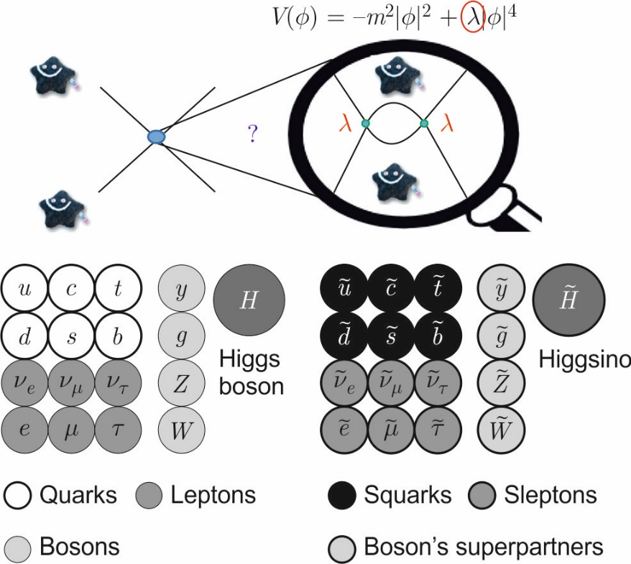
Fig.1. The main tasks of the LHC (Run-II): the study of the properties of the Higgs boson Standard model (top) and particle composition minimally supersymmetrically extended model (below)

If the JINR management decides to continue its participation in the LHC program, then any contribution of JINR, e.g., to the High-Luminosity LHC project must be a leading project with great impact within the chosen experiment so that the JINR group gets international recognition respecting its contribution. In this way, many JINR member states could be in a position, which they could never reach through their individual contribution. They could see clear advantage and benefit from investment of financial and human resources into this ‘Outside JINR’ program.
Of great importance for JINR is that its contribution is of state of the art technology, which will require more modern technology development at Dubna than exists today, more know-how in the analysis of data, and more strength in carrying the responsibility for new physics results.
Thus, one must recognize that a future JINR participation in CERN experiments at the highest energy frontier is competition at its best and will push forward the expertise at JINR in many domains of science and technology. Doing experiments outside of JINR, the scientist must however assure that they create inside of JINR a vivid and creative centre of this physics, so that it is attractive to the worldwide community. .

In the longer term (after the LHC, beyond 2030) the JINR objective in the field of ultra-high energy particle physics is double faceted.

1) Looking for fundamentally new methods for production of particles with extremely high energies, with the aim of constructing an entirely new advanced accelerator complex for record man-made energies on its territory (after FCC and ILC). This will ensure high attractiveness of JINR for both the Member States and the whole world.

2) Ensuring the effective and visible participation in the top-level international projects at new colliders and new experimental facilities at CERN, in China, United States, Japan, etc. Here the problem of choice is aggravated by low interest of the Member States in investigations at future facilities “through JINR”(see also text above). One should keep in mind that “JINR shares” at CERN are high now, mainly due to an appreciable contribution from JINR to the LHC machine and detectors, but also through the earlier JINR-participation in the planning for the ILC (International Linear Collider).

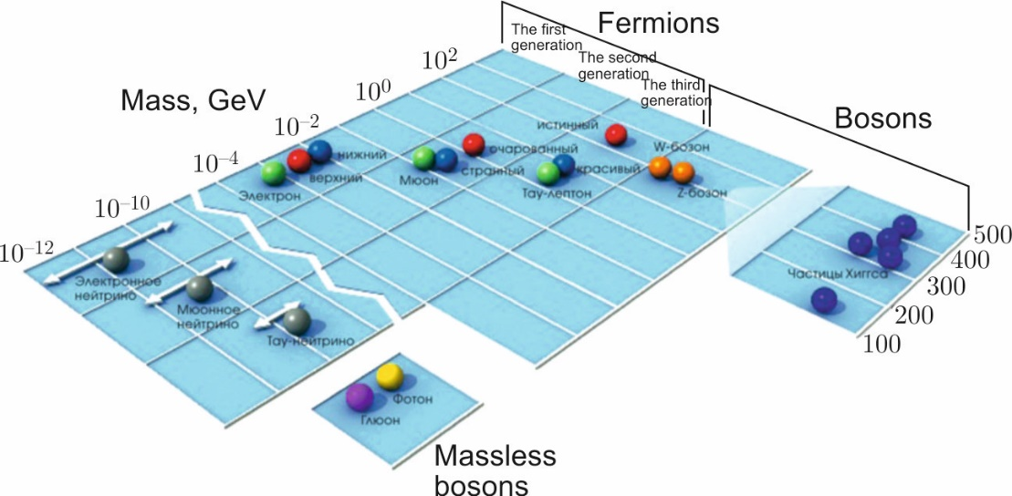
Fig.2. The spectrum of masses of the fundamental particles of the Standard Model is a mystery for the "new" physics

- Astrophysical Studies (through neutrinos and multi-messenger astronomy) (Fig.3, 4).

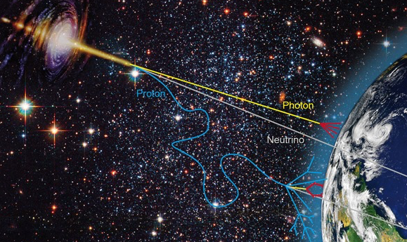
Fig.3. Apparently, only in the neutrino channel the most distant aliens will be able to send us your signal

The JINR Neutrino Programme’s main objective is to ensure the leading position of JINR in neutrino physics and astrophysics, the most fundamental and rapidly developing area of modern physics, both through the astrophysical researches at the unique BAIKAL–GVD neutrino telescope (Fig.3) and multifaceted (basic, applied) investigations with antineutrino beams at the Kalinin Nuclear Power Plant and through creation of the advanced research infrastructure in Dubna

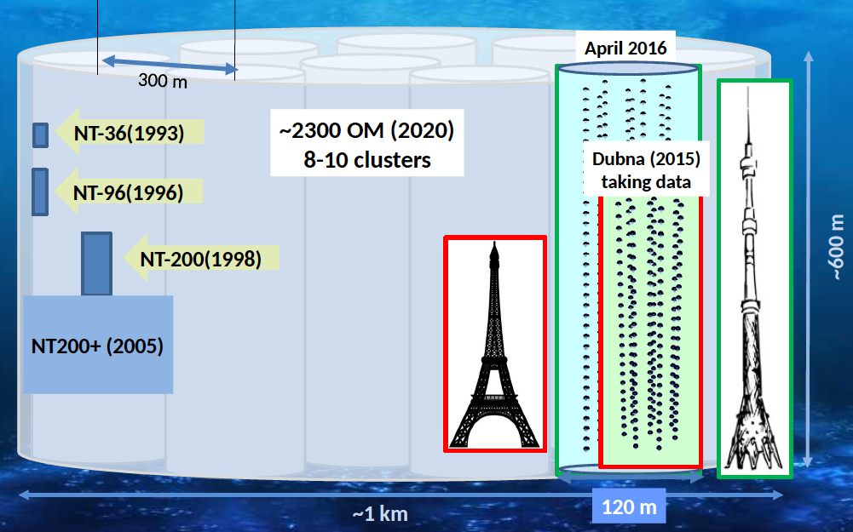
Fig.4. Stages and prospects of development of the Baikal-GVD project

More specifically, there are a few strategic objectives standing out:

Organization of a real collaboration – GNN (Global Neutrino Network) – between the Baikal project and other large experiments in this field (IceCube, KM3Net) with developing the data exchange protocol and algorithms, holding joint workshops, and creation on this basis of a global network for monitoring space in the neutrino channel with ensuring stable operation of this information channel within the multi-message investigation of space.
After being constructed, the Baikal–GVD kilometre-scale neutrino telescope will be used, due to its multifunctional infrastructure, not only for astrophysical objectives within the project, such as determination of ultrahigh-energy comic ray sources and generation mechanisms, but also for a wide range of geophysical, geological, applied, ecological, and other scientific economic objectives.

Special efforts are needed to develop an ambitious scientific programme (with absolutely new ideas, projects, etc.), which could effectively use unique potential of JINR neutrino infrastructures at Baikal Lake and at the Kalinin Nuclear Power Plant in connection with new opportunities.
TEXT Missing, New Projects Missing, Summary and Timescale missing

- Clarification of the nature of the dark matter and dark energy (Fig.5).

TEXT Missing, New Projects Missing, Timescale missing

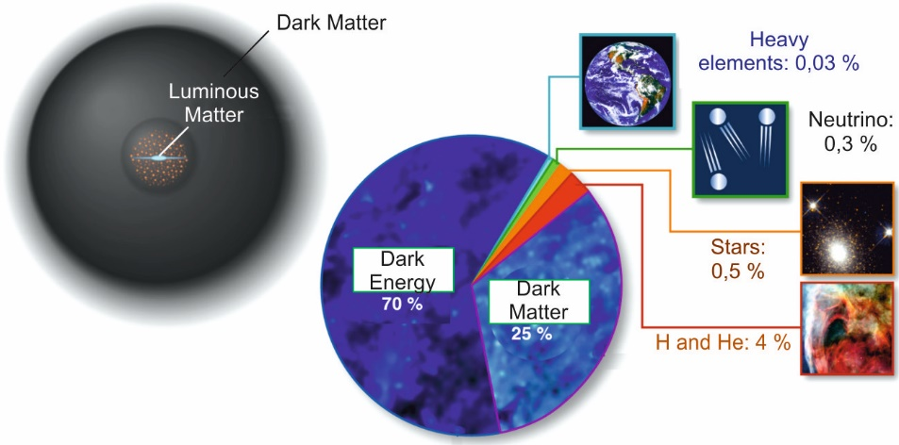
Fig.5. Dark matter forms a (spherical) halo of the galaxy and affects distribution of rotational speeds of luminous stars in it (left). Substance energy and energy balance of the universe (right)

V) Indirect search for manifestations of new physics, in particular by high-precision studies of lepton and hadron transformations breaking (flavour) family symmetry, and precision neutrino physics (Fig.5).

This also concerns participation in the most ambitious international experiments aimed at studying hadron, nuclei, and spin structure of hadrons (COMPASS, BES-III, PANDA (Fig.6, 7)), continuation of basic research in neutron physics, including measurement of fundamental beta decay parameters of the neutron (its lifetime and electric dipole momentum), and verification of the equality of the inertial and gravitational neutron masses both within the international collaborations at external ultra cold neutron sources and at the IBR–2M pulsed reactor (and/or its successor).

It looks conceivable to dream about a completely new paradigm for “individual” hadron-hadron interaction study, instead using particle beams, when, for example, a direct access could be available to an event where one well-separated (ultra cold) neutron interacts with another (ultra cold) neutron or proton, producing together, say, a new hydrogen nucleus, or destroying a DNA molecule.
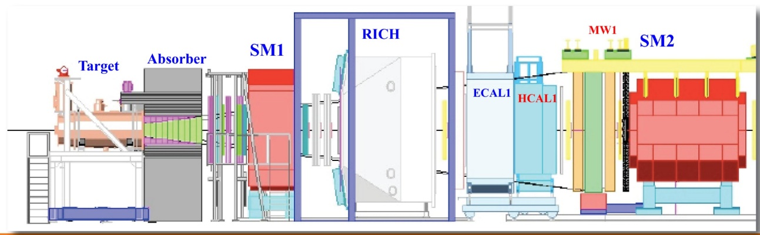
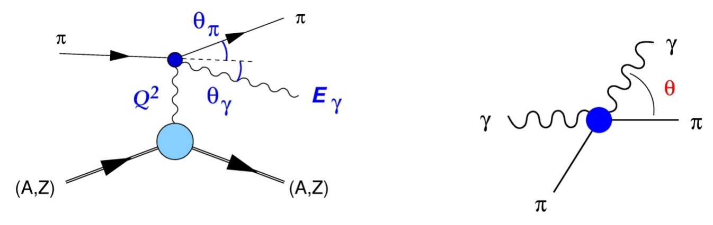
Fig.6. COMPASS installation diagram (top); Primakov effect diagrams, allowing measuring the polarizability of pions (below)

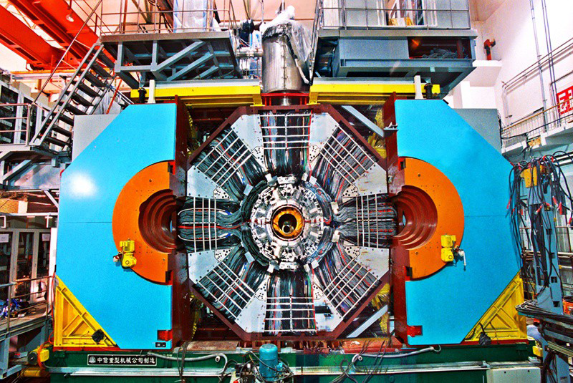
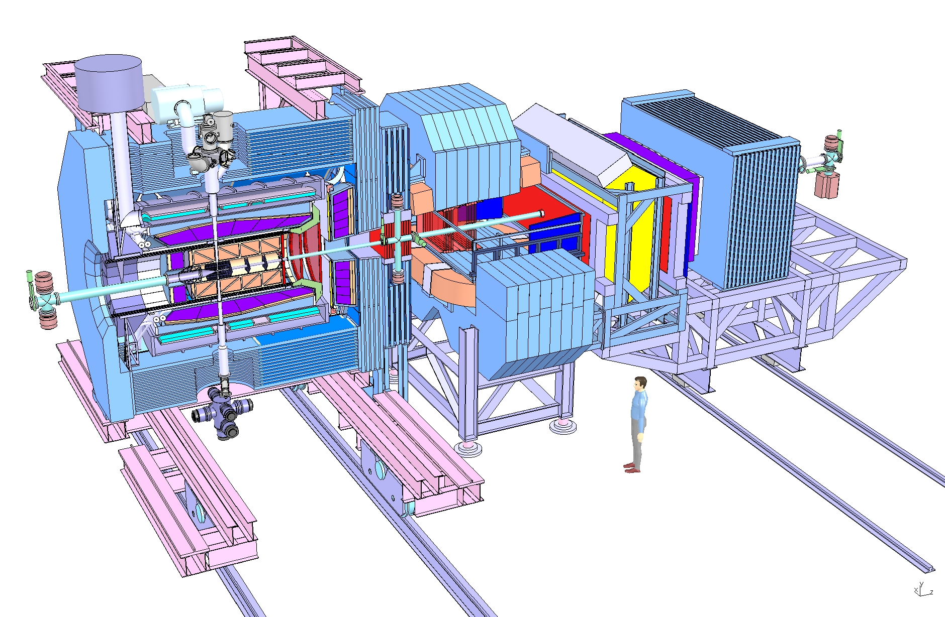
Fig.7. BES-III setup (top) and PANDA installation diagram (below)

Contribution of JINR scientists to the advanced international experiments (JUNO (Fig.8), EUREKA, DUNE, etc.) and creation of the advanced research infrastructure in Dubna can be envisioned.
The Charged Lepton Flavour Violation (CLFV) phenomenon is traditionally under investigation at JINR, it is deeply connected with modern neutrino physics, in particular in the common direction of new-physics-search experiments.

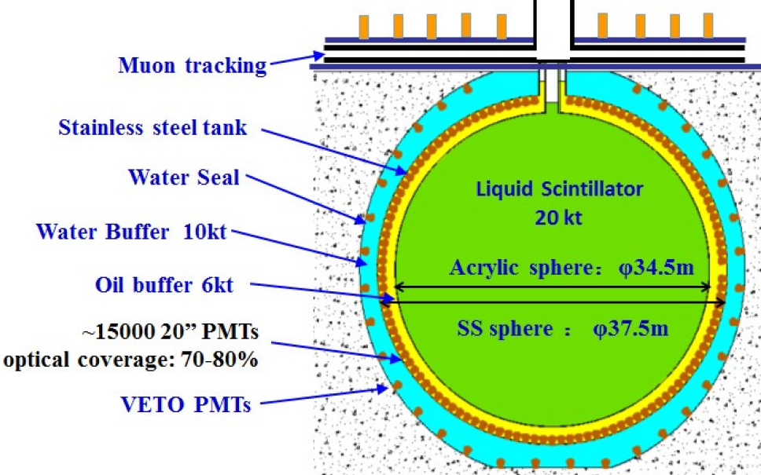

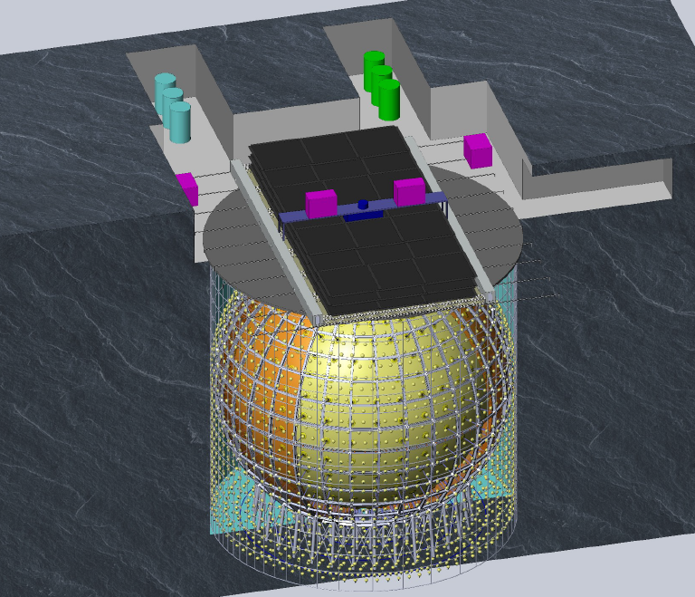
Fig.8. The scheme (above) and graphic design (below) of the new multifunctional antineutrino detector JUNO

The Charged Lepton Flavour Violation (CLFV) phenomenon is traditionally under investigation at JINR, it is deeply connected with modern neutrino physics, in particular in the common direction of new-physics-search experiments.
Therefore, a strategic goal of JINR could be to gain advantages from simultaneous participation in the COMET (Japan) and Mu2e (USA) projects both (via rather different ways) aimed at muon-to-electron conversion on nuclei. Two very different JINR teams with absolutely different scientific trajectories came to the same idea – search for the mu-to-e conversion in nuclei. This additionally proves importance of the idea and guarantees that JINR will not miss the world important result of this study. Furthermore, a competition between these teams together with availability of results of g-2, mu-2-e-gamma, and mu-2-3e searches will allow reliability of the study. There is also a general possibility for the Mu2e experiment to measure muon-to-positron conversion (violation of lepton number equals 2 unities), which gives direct access to the absolute neutrino mass scale.

TEXT Missing, New Projects Missing, Leading role?, Summary and Timescale missing

VI) Of great importance is the matter structure problem, which is now supposed to be solvable within nonperturbative quantum chromodynamics (Fig.5).

NICA is the JINR flagship facility in high-energy heavy ion and spin physics. The project has been approved by the JINR Committee of Plenipotentiaries and has been supported by a separate agreement between the government of the Russian Federation and the JINR “For construction of the basic configuration of the Nuclotron-based Ion Collider fAcility (NICA)”.

The aim of the NICA project is to create a world-class experimental base for conducting fundamental research in contemporary High Energy Physics (HEP) as well as applied research in microelectronics, medicine and biology making use of accelerator and beam technologies.

The main goals comprise investigation of hot and dense strongly interacting matter, search for a mixed phase and critical point in the QCD phase diagram in the poorly explored region of high baryon chemical potential and clarify the basis of QCD in the non-perturbative regime and other theoretical approaches for the description of strongly interacting matter

The nonperturbative component of QCD is that extraordinary component of the Standard Model which is meant to explain from the first principles (e.g., by lattice calculations) the dynamic breaking of chiral symmetry (which generates over 98% of the visible baryon mass of the Universe), confinement effect, and entire nuclear physics. It is necessary to understand how hadrons (pions, kaons, protons, neutrons) are formed, mutually interacting, on the basis of quarks and gluons and how they form the diversity of atomic nuclei

The future plans of NICA include Spin physics with polarized beams, e—A collider, allowing investigations to the multidimensional structure of the nuclei and the mechanisms generating nuclear single-spin asymmetries.
JINR scientists from the particle physics community are involved in this world-class onsite facility.

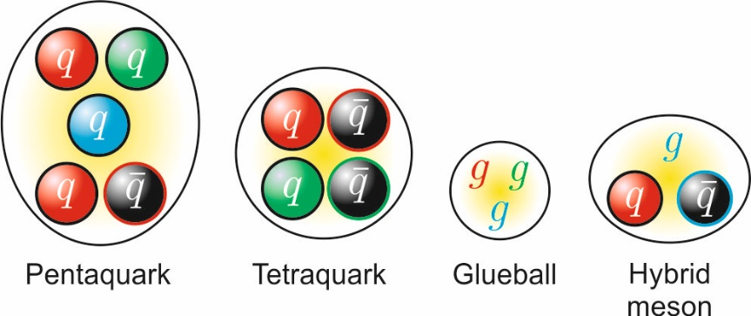
Fig.9. Examples of multi-quark and exotic hadron-like states

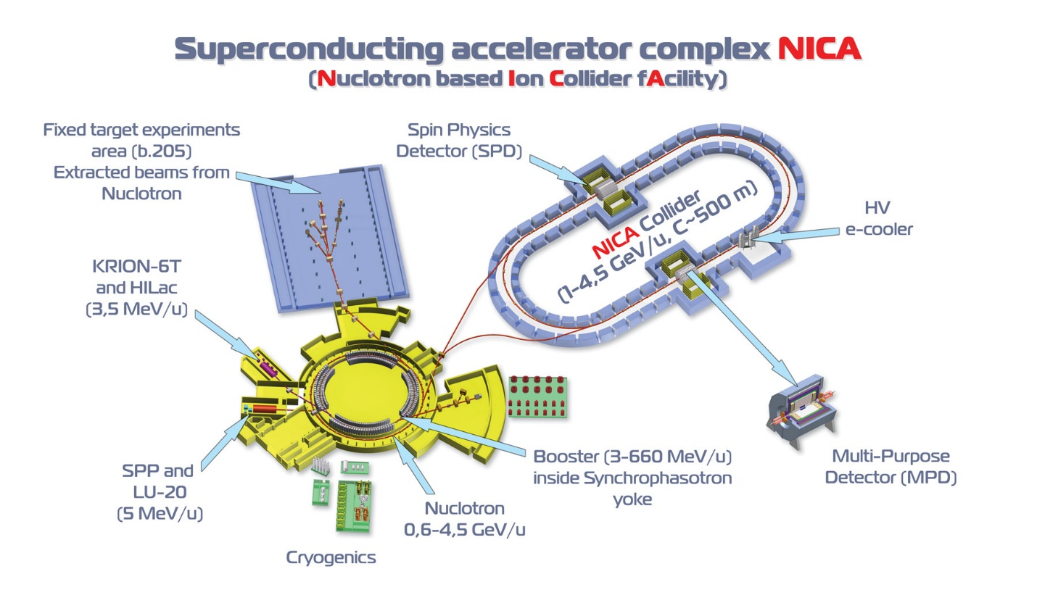
Fig.10. Schematic view of the entire NICA complex on the territory of the Laboratory High Energy Physics JINR

TEXT Missing on Contribution for NICA, New Projects of pp Missing, Summary and Timescale missing

VII) Partnership for elementary particle physics outside of JINR
JINR scientists have been heavily involved since the 90’s in experiments outside of DUBNA. At the beginning, this was a clear reflection of the difficult situation of the JINR institutes at that time. Since then JINR has seen a great development of the in-house infrastructure and research potential. Therefore, on-going and new partnerships have to be looked very carefully in view of the mission of JINR for their member states. Advisors argue, that an organization like JINR must participate in a variety of important experiments elsewhere. This must be looked at for each laboratory individually. Particle Physics has no own large research infrastructure but is a welcomed partner in the construction of detectors. It is of great importance that JINR’s effort finds a balanced return.
- CERN
a) Past and Present
CERN and JINR share a long and successful history of collaboration, extending back to the earliest days of their existence. Most recently, the JINR collaborations at CERN have been under the umbrella of the 2010 Co-operation Agreement covering further development of scientific and technical co-operation in their respective research projects.
CERN and JINR have concluded an important number of protocols for the implementation of their co-operation, covering areas of particle and heavy ion physics, accelerator physics and technologies, educational programmes, administrative and financial tools, publication policies. The 2010 Co-operation Agreement is directly addressing the desirability of developing a global network of accelerator laboratories.

Currently, a significant number of countries are member states of both CERN and JINR (Figs.9, 10). There are also examples of member states of JINR being associated members of CERN and vice versa. This “overlap” has a clear tendency to further extension, and results in a certain pressure from these JINR member states to consider carefully where collaboration with CERN through JINR is beneficial for the member states of JINR.

In 2014, CERN and JINR took a decision on the reciprocal granting of the Observer Status to each other in their supreme bodies – the CERN Council and the Committee of Plenipotentiaries of JINR.

Over last years, JINR has taken a number of steps to become integrated, with its projects and facilities, into the European Research Infrastructure within the framework of the ESFRI rules and procedures.

b) Future:
Taking into account all the above and considering the great challenge of building up a next major facility in Europe - the Future Collider at CERN, it looks strategically important to grant the Future Collider at CERN and the Future Developments at JINR after NICA phase 1, the status of partnership projects of the two international centres, CERN and JINR, through a reinforced cooperation agreement which increases the visibility of JINR at CERN and of CERN at JINR. This will allow using material and human resources of these centres in the most effective way and also make groundless discussions of the necessity to choose between the two organizations and lay a solid basis for the long-term development of Particle Physics at CERN, JINR, and their partners

- Common development and common operation of research facilities and infrastructures (when it is profitable) in JINR Member States. SOLARIS (Poland), Modane LSM (France), and ELI (Extreme Light Infrastructure, Europe) are good examples (so-called Octopus-idea).

- Participation of JINR in the implementation of the international flagship multipurpose neutrino project DUNE (USA) or in another DUNE-scale project (together with CERN).

VIII). Consolidation and attractiveness of JINR
The JINR Particle physics groups have a good comparison with other excellent laboratories in the World. Therefore the following remarks are from their heart and should be taken as constructive criticism of the present situation:
- The outside participation of JINR groups must be critically evaluated and should lead to a reduction of JINR participation in low-scale and low-importance projects in the field.
- It is obvious that despite several great projects, JINR needs to be continuously developing. Very modern, attractive, new, and forward looking image, with clear prospects of obtaining important results, especially for young employees, should be achieved.

A list of these general steps could be the following:
- Maximum use of the potential of the available basic facilities and those under construction and their integration into the European and global research infrastructures.
- Conversion of JINR into an open international centre concentrating highly intellectual human resources of the world standard and providing adequate working conditions and social infrastructure.
- Enhancement of attractiveness of JINR as a research and education centre for JINR Member States by, for example, direct fusion of science and education, introduction of scientific studies into the educational process, invitation of highest-level scientists for work at JINR and participation in the educational process.
- Priority development of the information, communication, and computing infrastructure for maximum effective attainment of currently important objectives of JINR and physics research centres of its Member States.
- Establishment of a laboratory/centre for novel and interdisciplinary research (radiobiology and medicine, power engineering, etc.) and implementing the results in the Member States
- Access, under certain conditions, to the experimental data from the applied and innovative researches at the JINR facilities and to the technologies developed at JINR
- Take special efforts to reduce the path from JINR basic research and new findings to their applications and use in industry and education

Executive Summary !

